Salahaddin University - Erbil

College of Agricultural Sciences Engineering

Food Technology Department

Third year

Cereal Technology (Practical)

2021-2022

**Lab 2**

**Objectives:**

1. Sampling
2. Testing quality for grains (physical tests) include
3. Weight of 1000 kernel
4. Hectoliter test
5. Determination of Impurities percent
6. Smelling test
7. Transparency test
8. Flow test
9. Porosity and grain size

**Sampling**

**A sample** is a portion, piece, or segment that represents the whole.Sampling is the most significant source of error in applying Standards. The sampling process its necessary during determination of grains quality (physical and chemical analysis results) accordingly the grains price will be estimate especially during import and export.

Some related terms:

1. Delivery: amount of sent grains by straight away within the area or dealing between sender and receiver.
2. Lot: defined as a certain amount of grains which supposed be similar in characteristics, and its part of Delivery.
3. Elementary sample: a small amount of grains which take it from certain places of lot.
4. Global sample: amount of grains resulting from homogeneous collecting of elementary sample

**Boerner Divider**

A Boerner Divider is used in the inspection laboratory to break down the representative sample into smaller sized portions for factor determinations. Each time grain passes through the divider, it divides the sample into two approximately

equal portions.

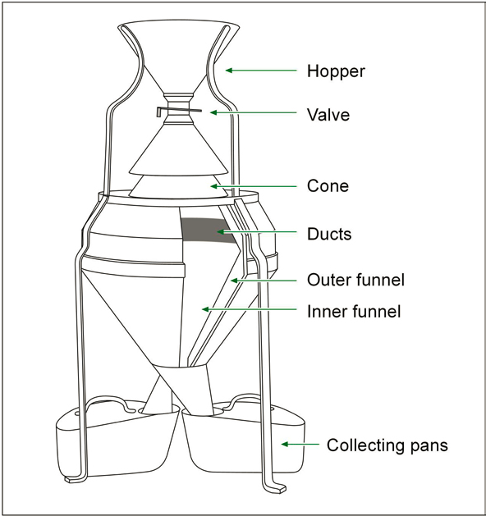

**Sampling Methods**

A large percentage of grain, as it travels from the farm to the final consumer, in several ways cars, ships or trains. the packaging (filling) will be Bagged or Bulk and sample taken by these tools.

**Methods and equipment of sampling**

1. Probe sampling is the only approved method for obtaining samples from stationary lots. If probe sampling is performed correctly, the samples drawn will consistently be representative.
2. Stick or sleeve
3. Bin sample: suitable for taking sample form silos.
4. Nobbe Trier: fitting for takeoff sample from Bags.

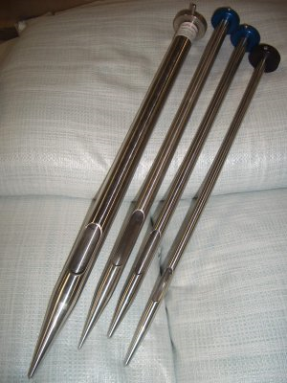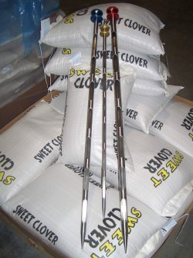

**Sleeve**

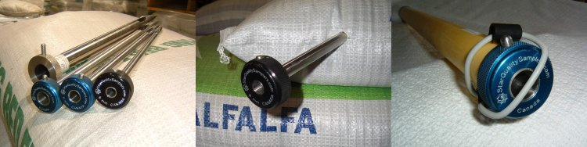

**Nobbe**

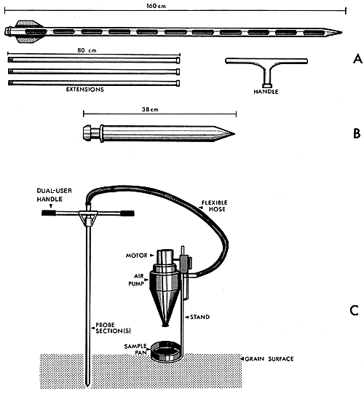

**Bin Sample**

|  |  |  |
| --- | --- | --- |
| **COMPOSITE SAMPLE SIZE** | | **NO. OF**  **PROBES** |
| 10 Tonnes or less | **3 liters** | 3 |
| Over 10 Tonnes and up to 20 Tonnes | **4 liters** | 4 |
| Over 20 Tonnes and up to 30 Tonnes | **5 liters** | 5 |
| Over 30 Tonnes and up to 40 Tonnes | **6 liters** | 6 |
| Over 40 Tonnes and up to 50 Tonnes | **7 liters** | 7 |
| Over 50 Tonnes and up to 60 Tonnes | **8 liters** | 8 |
| Over 60 Tonnes and up to 70 Tonnes | **9 liters** | 9 |
| Over 70 Tonnes and up to 80 Tonnes | **10 liters** | 10 |

**Impurities**  
 The impurities defined as all plant parts (chaff, straw ,spike, whiteheads, … etc.) and foreign materials ( stone, dust ,metals …etc ) as well as portion of animal animals, insects, broken seeds, green seeds, damaged seeds, Over-Dried Damaged, frost damaged, field fungi affected ….etc. that found with target grain. The quality of the finished products largely depends on the cleanliness of the grains. Thus, the grains free from above foreign material and parts of the nodes and rachis make the best milling material for processing into various products, as well as determine the grain or lot price. The purity may be determined by purity tests after separating out various materials present in the bulk or bags of grain. The purity percent may be worked out by calculating the relative part of pure grains out of the bulk sample taken and multiplied by hundred:

$$\text{Purity Percent}=\left(\frac{\text{Weight of pure grains}}{\text{Weight of bulk sample}}\right)× 100$$

**The Procedure**

1- Weight 300 gram of sample.

2- Clean and remove the large foreign materials by hand.

3- Shake the sample by suitable sieve for 45 second to remove all the dust and anther small parts.

4- Weight the pure grains and apply above equation.

**Weight of 1000 kernel**

The 1,000 kernel (1,000 K) weight is a measure of seed size. It is the weight in grams of 1,000 seeds. Seed size and the 1,000 K weight can vary from one crop to another, between varieties of the same crop and even from year to year or from field to field of the same variety.

|  |  |
| --- | --- |
| **Crops** | **Weight of 1000 kernel** |
| **Wheat** | **20-60** |
| **Yellow corn** | **500 – 1100** |
| **Barley** | **22-50** |
| **Oats** | **20-45** |
| **Rice** | **18-35** |
| **Millets** | **4-8** |
| **pea** | **60-200** |
| **Lentils** | **20-60** |
| **Bean** | **45-1300** |
| **Soya** | **45-400** |

**Test Weight (Hectoliter)**

**“Test Weight”** is a measure of **density**. It measures how much a volume of grain weighs and is expressed in kilograms per hectoliter, (i.e. how much a hundred liters weighs). Density is used in determining storage and transport requirements; it is also referred to as the **stowage factor** in shipping.

For example:

In shipping, the **stowage factor** indicates how many cubic meters of space one metric ton of a particular type of cargo occupies in a hold of a cargo ship.

wheat 1.27 m3/ton

Iron ore 0.40 m3/ ton

This test is conducted usually on the grains-free of impurities completely, and the benefit of this test is given an idea on degree of filled grain by comparing the weights of a fixed-size samples of grains, hence inferred high or low the exact expected when grinding or milling grains, there are a special equipment used to measurement of test weight (hectoliter).

**The procedure:**

**

1. First of all, the grains sample divided by (**Boerner Divider** fig **:1)**

to two equal parts then to four even reach around quarter liter.

1. Filling the upper container with grains.
2. Remove the cutter bar swiftly so that the grain falls from the upper container into lower container.
3. Remove the excessive grains on the surface of lower container.
4. The lower container with sample or (just the sample) will be weighted.
5. The weight multiply by 4 to convert the weight to liter.
6. But for convert weight to hectoliter multiply 4 and then 100