Introduction
The term ‘baked products’ is applied to a wide range of food products, including breads, cakes, pastries, cookies and crackers and many other products, and it can be difficult to identify a common thread linking the members of such a diverse group. The most commonly-identified link is that they all use recipes that are based on wheat flour.
This definition, though, would need to be expanded to include baked goods such as gluten-free products, used by people with coeliac digestive disorders, or rye bread, which are still considered to be baked products even though they are based on cereals other than wheat. However, the same leniency of definition could hardly be extended to include meringues, which contain no cereal-based material at all, let alone wheat flour, their main components being sugar and egg white. It may be more appropriate to consider that baked products are those products which are manufactured in a bakery, that is the place of manufacture defines the product rather than some ingredient, recipe or process feature.

Baked products are foods manufactured from recipes largely based on or containing significant quantities of wheat or other cereal flours which are blended with other ingredients, are formed into distinctive shapes and undergo a heat-processing step which involves the removal of moisture in an oven located in a bakery.

Traditional basis for classifying bread and fermented goods,
cakes, pastries and biscuits

Given that baking has such a long history and so many traditions associated with it, how have the various groups of baked products come to be defined? Unlike botany or zoology there has never been an attempt to develop a specific taxonomy of baked products. In part this may be because of the long, local traditions associated with the manufacture of baked products and therefore the difficulties associated with translation from one tongue to another of the terms and descriptors used for the products and their associated baking processes.

To some extent, this nomenclature problem has persisted to the present day. For example, in English the term ‘biscuit’ is commonly used for describing a low moisture, hard-eating, sweetened, thin product with a long shelf-life, that is eaten as a snack. In the USA, however, it commonly refers to a sweetened product of intermediate moisture, commonly eaten at breakfast along with savoury foods. The UK biscuit is closer to the US cookie while the US biscuit is closer to a UK scone. To increase the confusion, the French biscuit refers to a low moisture, dry-eating, long-shelf-life, sponge-type cake with an aerated structure. The closest UK product to the French biskuit is indeed a sponge cake, though with higher moisture content.

An introduction to the methods used to characterize baked products:

Take any baked product and you will observe that it has a number of different textural and sensory attributes. Even the matrix of a loaf of bread is not as homogenous as it first appears. Starting from the outside, we would see a light- to dark-brown surface which, when fresh, is hard to the touch and has a dry and crisp eating character.

The inside of the loaf, however, has a sharply-contrasting appearance. It is white or light brown (depending on whether white, brown or wholemeal flour has been used in its preparation) and has an expanded and cellular structure. By comparison with the crust, the crumb is soft to the touch and may well spring back after compressive forces are removed. The sensory properties in the mouth will be dominated by softness and chewiness. The degree of variation depends very much on the bread recipe and the process employed, especially in the dough making, but there will almost always be a contrast between the surface and interior properties of the loaf. A range of texture and sensory variations is also experienced when base cakes, pastries and biscuits are examined.

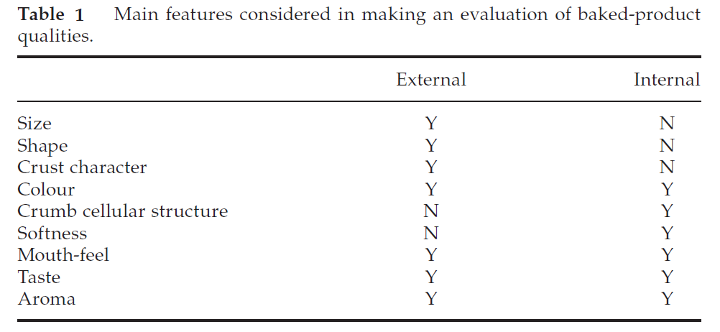

Methods for evaluating the character of baked products

Brief descriptions of methods that might be used in the evaluation of baked products, with some appropriate references, are given below. Subjective scoring sheets Bread quality score sheet:
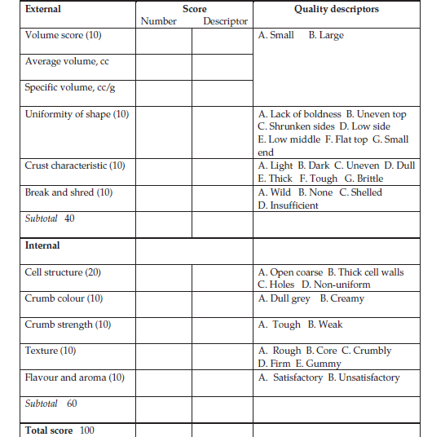

Numbers in brackets refer to proportion of score for the characteristic being assessed Cake quality score sheet:

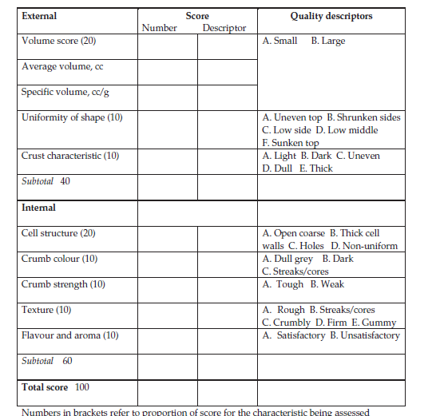

Pastry quality score sheet:

