Methods of Bread Production
A large number of baking methods exist around the world. Furthermore, each country has its own traditions and practices handed down over generations, producing a wide variety of types of bread. In practice, these methods can be classified into two main processes: (a) bulk fermentation (BF) and (b) mechanical dough development, or the Chorleywood bread process (CBP).

1-Bulk Fermentation
The major traditional bread making process is the bulk fermentation process. All the dough ingredients are mixed slowly into an even mix. The dough is left to ferment in bowls for a set period of time, usually 2– 3 hours.
After mixing, the dough is a rough, dense mass which is not extensible and does not retain gas, but as the dough ferments it transforms into smooth, extensible dough with good gas retention. The dough is then divided into loaf-sized quantities, given final rising and baked.

Setting up a recipe for BF bread requires the adjustment of four main variables, which are all ultimately linked:

1. Yeast quantity – The size and type of proofer will set an upper limit on proof time. General practice dictates that a minimum yeast level is used with maximum proof time suitable for the bakery conditions. There will be a practical upper limit to proof time and this will vary with the type of bread and processing conditions.

2. Fermentation Time (Dough time) – Timing is usually set based on the plant capabilities, such as number of bowls available and the size of the dough room. Increasing dough fermentation time increases the dough maturity at the divider.

3. Dough temperature – The longer the fermentation period of the dough the cooler it must be. A dough should be 26.5ºC at the divider. Yeast fermentation and oxidizing agent action are accelerated by heat so hot dough may be sticky and difficult to handle. Increasing dough temperature increases the activity of yeast and oxidizing agents which will affect dough maturity and proof time.
4. Oxidizing agent – Also called maturing agents, they are added to bread dough to improve the strength of the gluten structure in the dough to allow it to hold more carbon dioxide produced during fermentation. Oxidizing agents ensure that well risen, fine, even textured loaves are produced. Increasing the quantity of the oxidizing agent increases the dough maturity. Ascorbic acid is an example of an oxidizing agent.

2. Mechanical dough development or (Chorleywood Bread Process)

The modern commercial process used in commercial bakeries in the UK and many other countries is known as the Chorleywood bread process (CBP), which was developed in 1961 by the Flour Milling and Baking Research Association at Chorleywood.
A short or no time bread making process where the dough is mixed at very high speeds and this energy is used to shear the gluten structure and allow reformation. The amount of time the dough needs to rise is reduced from 2 hours to 10 minutes due to the development during mixing. Not only does the CBP save considerable time in the baking process, which helps keep down the production costs and delivers cheaper bread, but it also produces bread which is better in respect of volume, colour and keeping qualities. CBP is now by far the most common method used throughout all sectors of the bread baking industry.

There are many types of bread
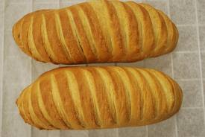
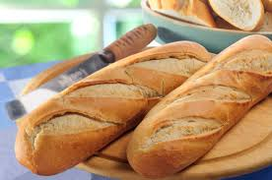

Roll bread bloomers bread French bread

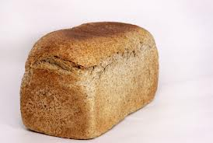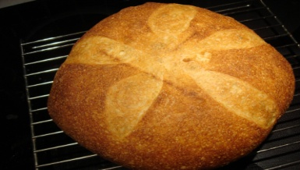
Soft roll whole meal bread hearth bread
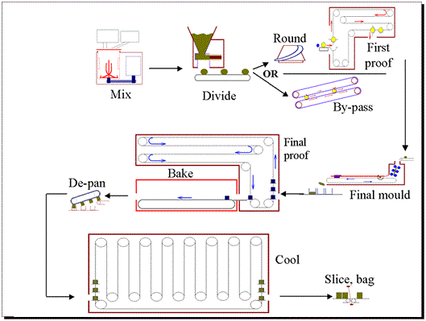
Fig: The Chowhound bread process

Ingredient mixing, which combines all the ingredients into a uniform mass which promotes development of a strong gluten network and air cells.
Dividing, where dough is scaled into correctly sized pieces.
Intermediate proof allows the dough to relax and recover after dividing.
Molding is when the dough is formed into shape, which often involves flattening and rolling.
Final proof, during which the dough is placed in a warm, humid environment and allowed to rise.
Baking enables the final structure of the dough to be set by heat.
Slicing and wrapping prepare the finished product for sale.

PROCEDURE

1-100g of flour were mixed with water according to farinograph water absorption, with 2% salt, 2% dry yeast, on flour weight basis, the flour and other ingredients mixing for 8 min.
2- The dough left for fermentation at 26°C ±1 for 105 minutes in a controlled fermentation cabinet. The dough punched and left for 15min at 26°C ±1 fermentation. The dough maybe divided into part. Pieces round and sheeted then rolled and panned.
3- The proofing almost was at 35°C with 75-85 relative humidity for 50 min, The panned dough after proofing bake with thermostatically controlled temperature oven at 200±4 °C for 20 minutes.
4- The baked loaf cooled at room temperature for at least one hour. Bread loaf volume measured by a grain displacement (using lentil grains) weight of loaf also measured for calculation of specific loaf volume by following equation:

