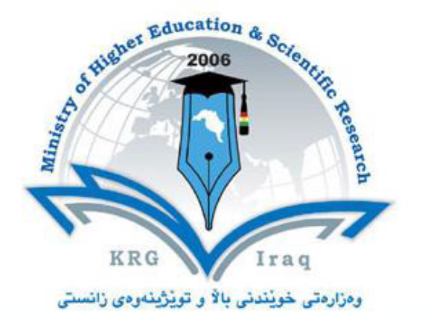

Department of English
College of Basic Education
University of Salahaddin
Subject: Academic Skills
Course Book – (1)
Lecturer's name: Dastan Abdullah Saeed, MA
Academic Year: 2022-2023

Course Book
1. Course name | Academic Skills (previously known as Academic Debate)
2. Lecturer in charge | Dastan Abdullah Saeed
3. Department/ College | English/ College of Basic Education
4. Contact | e-mail e-mail: dastan.saeed@su.edu.krd  dastan.abdullah14@yahoo.co.uk  Tel: (optional)
5. Time (in hours) per week | For example Theory: 1  Practical: 2
6. Office hours | Monday
7. Course code
8. Teacher's academic profile | - Holds BA in English Translation, Salahaddin University-Erbil, 2008  - Certificate of Higher Education(English for Postgraduate Studies Program), Aston University, Birmingham, United Kingdom, 2012  - MA in Translation Studies, Aston University, Birmingham, United Kingdom, 2014  Academic Interests:  - Advanced Grammar and Lexis  - Speaking and Writing skills  - English for Academic Purposes  -English for Specific Purposes  -Computer-Assisted Translation Tools for English language  - Applied Linguistics  - Teaching Translation  - Research Writing  - Text Analysis  - Translation Profession  - Spoken and Written Discourse Analysis
9. Keywords | Academic debate, critical thinking, study skills, communication skills, presentation, plagiarism, academic poster, citation, academic report
10. Course overview:
The present course is an attempt to enrich students' minds with the skills of holding debates, seminars, presentations, and discussions. The materials that are taught are valid, fresh, vital, significant as well as inspiring. Students are encouraged to be on stage, think 'out of the box'; performing several activities that are expected to widen their minds and innovations. Moreover, the teacher explains for them the various shapes of creativity, confidence and ethics. The whole curriculum moves around teaching academic debate skills as well as encouraging critical views. Students are motivated to see every phenomenon in double scales.
11. Course objective:
- This course is aimed to:
- enrich the students' motivations and appetites of learning.
- enlarge the students' capabilities of critical thinking and individual perceptions.
- strengthen the student's skills of communications, presentations, and articulations.
- implant, instil and empower the spirits of mutual respect and moral standards amongst the students.
- provide the learners of the faculty a great amount of self-confidence and credibility.
- widen the students' abilities of analysis and interpretations towards the problems of the society.
12. Student's obligation

- Attendance fully.
- Showing respect to the classroom.
- Politeness in speaking
- Active participation
- Performing the projects efficiently.
- Showing zest of learning and following the teacher’s instructions.

13. Forms of teaching
Discussions
Hand-outs
Classroom group debates
Debating challenges
VIDEO PROJECT DISCUSSIONS
Seminar presentations

15. Student learning outcome:
By the end of the course:

- Students will be confident.
- Students will be familiar with the arts of debating politely.
- Students will be able to argue, give seminars, and record video interviews.
- Students will be better English speakers.
- Students will gain better academic up-to-date skills.

16. Course Reading List and References‌:

There will be a lecture blog or a Moodle platform for hand-outs on internet and he students will get access to it for their tasks.

There will be slides about the arts of debating on the blog.

Students are expected to check out:
Rasool. Bukhari, Abdullah. Think Outside The Box: Towards Better Teaching Academic Debate and Critical thinking. 2019.

Also:

Donna T. Andrew, "Popular Culture and Public Debate" in The Historical Journal, Vol. 39, Issue 02 (Cambridge University Press, June 1996), p. 406.

17. The Topics: |  | Lecturer's name
At the beginning of the course, the students will be taught how to acquire these skills in theory and practice:  - Students’ rights and responsibilities  - Study skills  - Note-taking  - Time management Skills  - Communication Skills  - Seminar presentation Skills  - PowerPoint Presentation  - Plagiarism  - Citation  - Academic Report  - Academic Poster  - Argumentation and persuasion  - Critical Thinking  - Academic Debate  In the debates and classroom activities, we will focus on these topics:  1- Should the death penalty be allowed?  2- Is Homework Beneficial?  3- Should students have to wear school uniforms?  4- Are social networking sites good for our society?  5- Is the use of standardized tests improving education in Kurdistan?  6- Should tablets replace textbooks in universities?  7- Do drama series broadcasted in Kurdistan local channels contribute to violence?  8- Is it money that primarily makes humans happy?  9- Creativity: is it the result of nature or nurture?  10- Is Marking is an outdated way of evaluating student knowledge?  11- Home-schooling: is it better than studying at school?  12- Should enrollment at university be based on standardized marks?  13- Is online study more effective than traditional?  14- Are movies good tools for education?  15- Is protecting environment, nature, and the wild life based on the government of people’s sense of responsibility?  16- Is it law that makes us avoid the evil or it is our ethics and awareness?  17- Are the government universities more effectively educational or the private ones?  18- Should the language of our schools be English or Kurdish?  19- Fast food should not be in the menu of the schools.  20- For cultural reasons, our schools should avoid sexual education.  21- Birth prevention should be supported.  22- Media coverage (broadcasting) of social accidents is harmful. (Bayan vs. Medical)  23- Is Poverty due to injustice (Medical) or ignorance (Tishk) ?  24- Should abortion be legal?  25- Should animals be used for scientific and commercial testing?  26- We should support Miss Kurdistan event.  27- students should have an after-school job.  28- Single-gender schools are better for students.  29- Is television an educational tool for shaping our children’s minds?  30- Using cellphones during class should be banned.  31- Cell phone radiation as a cause of cancer.  32- Should sodas and sugary snacks be banned from schools?  33- Are violent video games contributing to violence in the world today?  34- Do Hollywood movies have a bad influence on the world?  35- Students should never be forced to repeat a year of school.  36- Should there be restrictions on free drama or movie?  How to Do a Successful Presentation? (Theory and Practice)  "Money is a good slave, a bad master"  Does Money Make us Happy?  "Readers of Today, Leaders of Tomorrow"  Does Reading Books Bring Any Good to My Life?  Who is Responsible for Environment Pollutions?  Imagine One Day Life without Water!  Imagine One Day Life Without All Technology!  Imagine One Day Life Without Family, Friends, Relatives, and People!  Why Do We Need Others?  Imagine One Day Life Without Poverty!  How can We Help the Poor?  Imagine One Day Life without Anger!  Why Do We Become Angry in Life?  Imagine One Day Life without Illness!  How Do you Keep your Body Fit and Healthy?  Imagine One Day Life without The Evil!  What Does Make People to Be Morally "Evil"?  Does Love at First Sight Work Successfully?  Imagine One Day Life as a Boss!  What is Your Dream Company?  Imagine One Day Life As a Teacher!  Who Is a 'Good' Teacher? & Who Is a 'Bad' Teacher?  Imagine What Would Life Be Without Science?  Has Science and Knowledge Made Humans Happy? |  | Dastan A. Saeed
19. Examinations:
It is not exam-based. It is project-based. The only exam will be the final debate exam that will be a debate based on a topic previously given to the students.

Assessment Tools

- Daily Activity 10 marks
A: book discussion (e.g. Think Outside the Box)
B: Video Project (discussing an issue in group)
C: Daily talks (ticks)
E: Class Debates
F: Speech Competition
Note: a student can do only 2 of them.
- Academic Report 10 marks
- Presentation 10 marks
- Quizz 10 marks
- Poster 20 marks
- Final Debate 40 marks

20. Extra notes:

21. Peer review پێداچوونه‌وه‌ی هاوه‌ڵ

