Academic Curriculum Vitae
Personal Information:
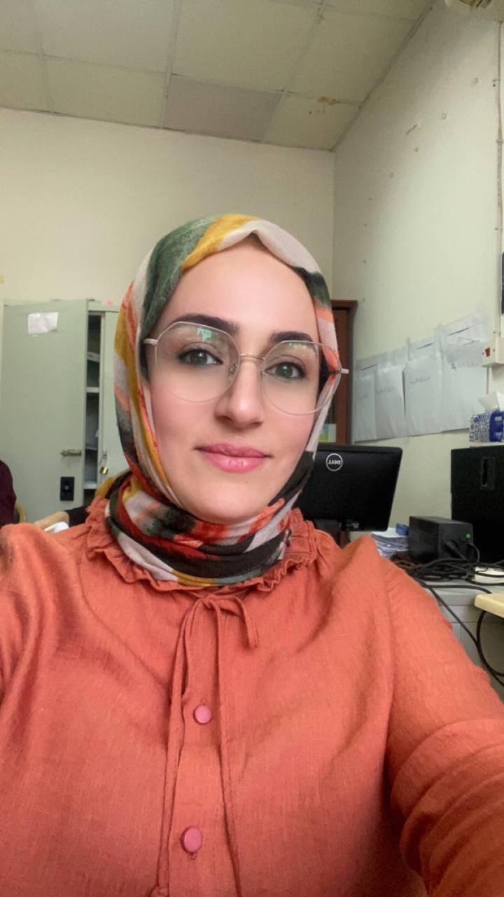
Full Name: Deeman Musheer Mawlood
Academic Title: Assistant Instructor
Email: deeman.mawlood@su.edu.krd
Mobile :07504824127

Education:
University: BA in English Language /Salahaddin University/ Erbil (2005-2006) MA in English Language and Applied Linguistics/ Salahaddin University/ Erbil (2012)

Employment:
-I got employed by Salahaddin University- College of Basic Education on April 22nd , 2007,
as an assistant researcher.
- On June 25th, 2012 I obtained my MA in English language and Applied linguistics from
the same university, College of Basic Education. Then, I started teaching in 2013 at College of
Basic Education as an assistant Instructor until now.

Qualifications
- Graduated from pedagogy course, Salahaddin University 2012.
- Participated in the joint international conference entitled “Capacity Building in Teacher Education And Research” held by Salahadin University in Cooperation with Friedrich-Alexsander University, Erlangen-Nuremberg in 2017.
- Participated in a training course in Ibn Sina E learning center (2018).
- E-Learning and Moodle / 2020/ College of Basic Education / Salahaddin University
- -Participated in the online environment course entitled (Developing Environmental Leaders) in the training hall of (Green School) in Telegram(2021).

Teaching experience:
Started teaching at College of Basic Education/Salahaddin University in 2013 till now. I mainly taught subjects related to English language and applied linguistics. I taught Vocabulary, Measurement and Evaluation, Listening Speaking, Advanced Reading Comprehension and furthermore I taught General English for University Students.
-Supervised fourth-year under-graduation projects.

Research and publication
I have three Registered researches;
1- The Impact of Teachers’ Wellbeing on their Performance at Salahaddin University.
2- Examining E-Readiness of Teachers in EFL Classes
3-Exploring the Issues Demo0tivating EFL students to Speak the Target Language at University; A Case of Class Dismissal Situation.

