verb + to + infinitive

I love to go home as soon as possible.
We all like to have more English classes.
I want (to do) something
They prefer to start a business together.
I enjoy to turn the lights off.
I hate to do my homework before dinner.
subject pronouns
are those pronouns that perform the action in a sentence. They are I, you, he, she, we, they, and who. Any noun performing the main action in the sentence, like these pronouns, is a subject and is categorized as subjective case (nominative case). English grammar requires that the subject come before the verb in a sentence (except in questions).
I make cookies every Sunday for my co-workers.
- I like London.
- You have eaten the chocolate.
- He plays football.
- She hates mushrooms.
- It was cold.
- We are French.
- They are going home.

Object pronouns are those pronouns that receive the action in a sentence. They are me, you, him, her, us, them, and whom. Any noun receiving an action in the sentence, like these pronouns, is an object and is categorized as objective case.*
- John knows me.
- Amanda kissed you.
- The dog licked him.
- David hugged her.
- The teacher dropped it.
- The children love us.
- Luke helped them.

I give they cookies every week. Incorrect
I give them cookies every week. Correct
She gave Jim and I extra cookies. Incorrect
She gave Jim and me extra cookies. Correct

She and I went to the movies. Correct

If you have any questions, you can ask either her or me. Correct

She and me are old friends. In Correct

I went to the movies. Correct

Me went to the movies. In Correct

She and I went to the movies. Correct

Her and me went to the movies. In Correct

In English grammar, indefinite pronouns are substitute words for things that cannot be or simply are not wanted to be named exactly. So, they can be used instead of them or, more precisely, they can ‘substitute’ them.
Indefinite pronouns referring to persons
If persons are referred to, indefinite English pronouns mostly end in ‘-body’ or ‘-one’. The person to be substituted can then be male or female. All in all, there are no differences in meaning between these two variants.
- Typical pronouns that can replace a person are: everybody, everyone, nobody, no one, etc. Everybody/everyone = all the people
  - Everybody likes chocolate.”
  - There's nobody at the door
  - No one is happy

We use if to introduce a possible or unreal situation or condition. We use when to refer to the time of a future situation or condition that we are certain of:

You can only go in if you’ve got your ticket.

When I’m older, I’d love to be a dancer.

Compare
If Giles comes back to the office, can you tell him I’ve gone home.

The speaker does not know whether Giles is coming back to the office. It is possible, but not definite.

When Giles comes back to the office, can you tell him I’ve gone home.

The speaker is certain that Giles is coming back to the office.

To talk about situations and conditions that are repeated or predictable, we can use either if or when + present verb form:

You can drive if you’re 17.

If you don’t add enough wood, the fire goes out.

When we go camping, we usually take two tents.

She gets out of breath easily when she’s jogging.

Q1// Join the phrases with when or if to write true sentences about yourself.
1. have a fever/ take medicine.
---------------------------------------------------

Q2// Use simple present or present continuous from of the verbs.
1- ---------------------------- you ---------------------- (like) to play sports?
Not really, but my wife and I ------------------------------ (enjoy) swimming every day.
The expression be going to, followed by a verb in the infinitive, allows us to express an idea in the near future:
I'm going to talk to him. Very soon I will talk to him.
Several employees are going to be promoted next month. Several employees will be promoted next month.
Be going to can also express a conviction or a certainty:
It's going to rain. For sure, it will rain.
I'm not going to fail. I definitely will not fail.

Subject | + to be (conjugated) | + going | + infinitive
She | is | going | to leave.
I | am | going | to stay.

Using "going" for plans and intentions
- Is Freddy going to buy a new car soon?
- Are John and Pam going to visit Milan when they are in Italy?
- I think Nigel and Mary are going to have a party next week.
- We are going to have dinner together tomorrow.

Using "going" for predictions

Examples
- He's going to be a brilliant politician.
- I'm going to have a hard time falling asleep.
- You're going to be sorry you said that.
- Is it going to rain this aftern?
Jim is going to see his friends.
Susan and Eve are going to do some shopping.
I'm going to read a book.

Past time expressions
In English, we use the simple past to talk about when things happened. There are a number of words and phrasesthat are often used to show when an action or situation happened in the past. We call them time adverbials. Here are some of the most common ones.

Time adverbial: ago
We use time reference + ago to show how far back in the past something happened:
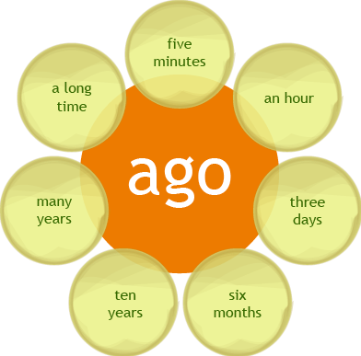
Examples:
- The movie ended five minutes ago.
- The plane landed two hours ago.
- My son was born six months ago.
- Her husband died ten years ago.
- I took that photo many years ago.
- I came to this city a long time ago.
Time adverbial: last
We use last + time reference to mean the most recent or nearest to the present day time:
Examples:
- I saw a game on TV last night.
- My parents traveled to Japan last month.
- Michael arrived in Mexico last January.
- Last Christmas I got a lot of presents.
- My girlfriend and I met at the beach last summer.
- Last year Jake and Jill got married.
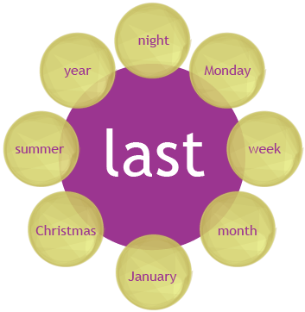
NOTE: We say last night, last month, last year, etc. NOT the last night, the last month, the last year, etc.
Time adverbial: yesterday
We use yesterday or yesterday + morning / afternoon / evening to talk about the day before today:
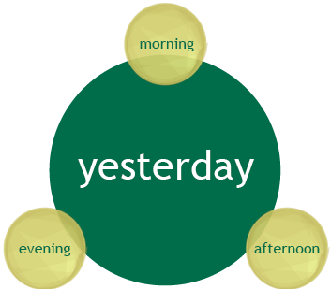
Examples:
- Charles wore a suit to work yesterday.
- We got up early yesterday morning.
- She left the hospital yesterday afternoon.
- Yesterday evening Joel called me.
NOTE: We use last night NOT yesterday night.
We also use the expression the day before yesterday to mean "two days ago".
Example: I played soccer the day before yesterday.

Prepositions: in / on / at
We also use the prepositions in, on and at to say when something happened.
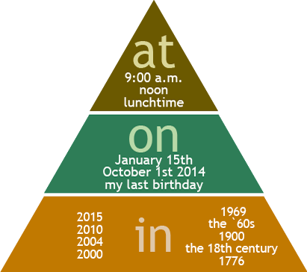
Click on each button to display the content
- in
We use in with years, decades, and centuries.
Examples:
  - Nelson Madela died in 2013.
  - Mario Vargas Llosa won the Nobel Prize of Literature in 2010.
  - Mike Zuckerberg started Facebook in 2004.
  - In 2000, Sydney hosted the Summer Olympics.
  - The first man walked on the moon in 1969.
  - The Beatles were a popular band in the 60's and 70's.
  - Oscar Wilde died in 1900.
  - The Industrial Revolution began in Great Britain in the 18th century.
  - The U.S. declared independence from Great Britain in 1776.
Saying years in English (English Number, 1900)
We tend to read four-digit years as a pair of two-digit numbers. For example, 1969 is nineteen sixty-nine, but there are other ways to say them:

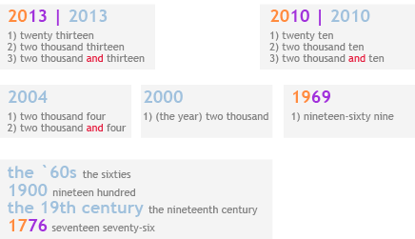
We use on with specific dates.
Examples:
- Martin Luther King was born on January 15.
- Martin Luther King was born on January 15, 1929.
- On my last birthday I had the best party ever.
We use at with times.
Examples:
- We had breakfast at 9:00 a.m.
- We went for a walk at noon.
- We talked about the problem at lunchtime.
FOR
“For” is used in time expressions to talk about the duration of an action. “I have worked in this company for 11 years”
Until as a preposition means ‘up to (the time that)’:
We played chess until midnight. (up to midnight)
The film didn’t end till eleven o’clock.
We use from with until or till to talk about when something begins and when it ends:
I worked out at the gym from 6 pm till 7.30 pm.
The road outside our house will be closed from 6 am until 6 pm tomorrow.
We use long as an adverb in questions and negative clauses to talk about duration:
Marco didn’t stay long at the party.

