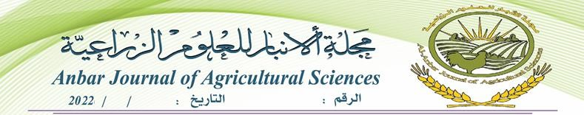
8 30
153

Certificate of Acceptance
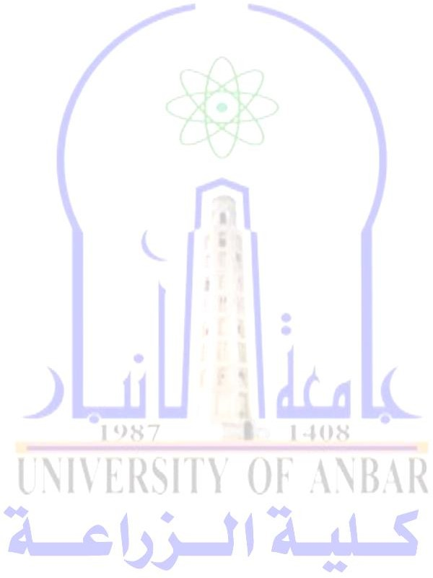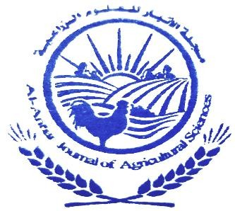Title of Paper: Effect Of Dietary Supplement Ginger And Turmeric Powder On Japanese Quail (Coturnix Coturnix Japonica) Performance,Carcass Traits And Blood Parameters.
Authors: A. J. Khalil, D. D. Maulod and S. M. Ahmed

The Editorial Board of Anbar Journal of Agricultural Sciences (AJAS, P-ISSN: 1992-7479, E-ISSN: 2617-6211) hereby states with
great pleasure that following the reviewing process, your above indicated manuscript has been Accepted for publication in 2022 Volume 20, issue2 . We would like to thank you for your submitted paper.

Regards,

Editor-in-chief
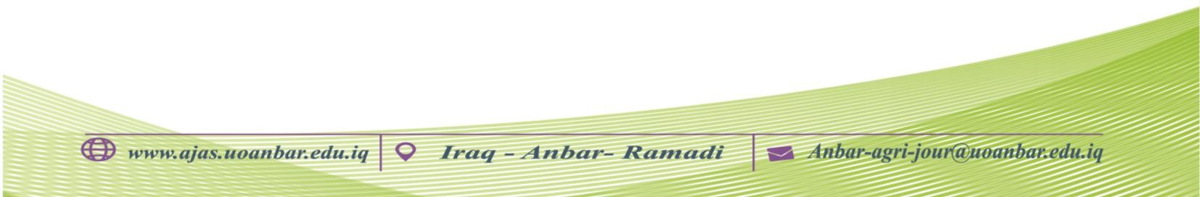
Prof. Dr. Thafer T. Muhammed

