**Blood cells**

Blood cells include:

* **Erythrocytes** = Red blood cells (RBC)
* **Leukocytes** = white blood cells (WBC)
* **Thrombocytes** = similar to platelets in mammals
* All are nucleated in birds, but in mammals RBC and platelets are not nucleated

**First - Erythrocytes (Red Blood Cells) RBC:**

* Red blood cells in birds are oval in shape
* It contain nucleus inside duration it life that unlike in mammals.
* Formed in bone marrow as well as liver, spleen, and thymus at times in bird’s life. Life spans 28-35 days (cf. 120 days in human).
* RBCs size is bigger in birds than mammals
* The number of RBC ~3million/ mm3 bloods
* RBC and platelets is biconcave disc in mammals but football shaped in birds.

**\*RBCs number is affected by several factors:**

**1. Age**: The number of RBCs is change at progress of bird’s age.

**2. Sex**: The number of RBCs in males higher than females.

**3. Hormones:** In males the influence of testosterone and androgens hormone increase the production of RBCs and estrogens in females decrease RBCs formation.

**4. Hypoxia:** lack of oxygen (O2) called hypoxia, this case push birds to adaptation themselves by increase the number of RBC in the blood, these cases are evident in birds that live in areas of high-rise and high above sea level with a low percentage of O2 in the atmosphere.

**Avian RBC maturation:**

* the younger cells are smaller, rounder and have a more basophilic cytoplasm. Mature erythrocytes are oval with eosinophilic cytoplasm.
* The nuclear size decreases and the amount of cytoplasm increases as the cell mature.

**Anemia:**

Is a reduction in circulating RBC numbers or a deficiency of hemoglobin in blood, there are 4 types of anemia:

1. **Hemorrhagic** = excessive blood (RBC) loss
2. **Aplastic** = due to drugs, irradiation. Too much coccidiastat common in older animals
3. **Pernicious** = bone marrow doesn’t make RBC, Lack of Vit. B12 in diet or absorption of B12
4. **Hemolytic** – intravascular explosion of RBC. Genetic, recessive trait made worse by high temp, poor diet, and toxins.

* Pathological status or in term Physiopathological.

**Polycythemia:**

1. **Polycythemia:** meansexcess the RBC numbers in blood.
2. Not pathological.
3. Occurs as a result of need for oxygen.
4. Adaptation that occurs when animals are reared at high elevations.

**Normal Polycythemia**

 

.

**Second- White blood cells (WBC) or Leukocytes:**

**Leukocytes:** A **CBC test** measures the total number of white cells in the blood. **CBC with differential test** measures the number of each type of these white blood cells:

* Cells of the immune system which fight infections.
* Defend the body against infectious diseases and foreign materials
* Derived from a multipotent cell known as a hematopoietic stem cell
* Found in the blood and lymphatic system
* ~ 20,000 per mm3 – if healthy
* Produced by:
  + Bone marrow
  + Liver
  + Lymphoid tissue
  + Bursa of Fabricius
* Spleen
* Thymus
* Gut Associated Lymphoid Tissue (GALT)  and lymphoid follicles (Peyer’s Patches)

**White blood cell or Leukocyte Types:** There are five major types of WBCs:

1. **Granulocyte cells are:**

**1. Heterophil :** 10-35% in rate of the total WBC, nucleus is many lobules.

**2. Eosinophil (acidophil):** include up to 13%.circular in shape.

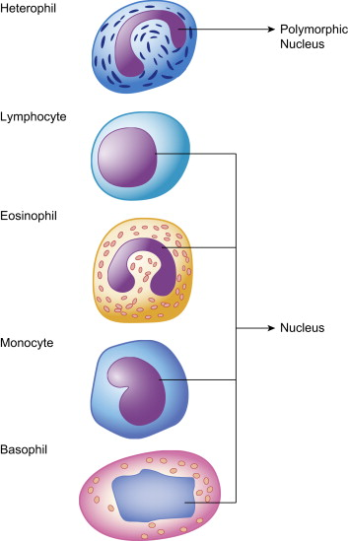

**3. Basophil:** Represents 2-4%, Nucleus spherical or oval, or lobed.

1. **Non-Granulocyte cells are:**These cells do not have granules, they can be difficult to differentiate, especially if the stain used does not give good clarity and definition to the cell nucleus.

**1. Monocytes:**  the nucleus is not round and large with irregular shape, rate of 1-10%.

**2. Lymphocytes:** There are two different sizes of lymphocytes, small and large. they have a round large nuclear. 60-80% in rate.

* cells are two types: T-Lymphocyte and B-Lymphocyte.

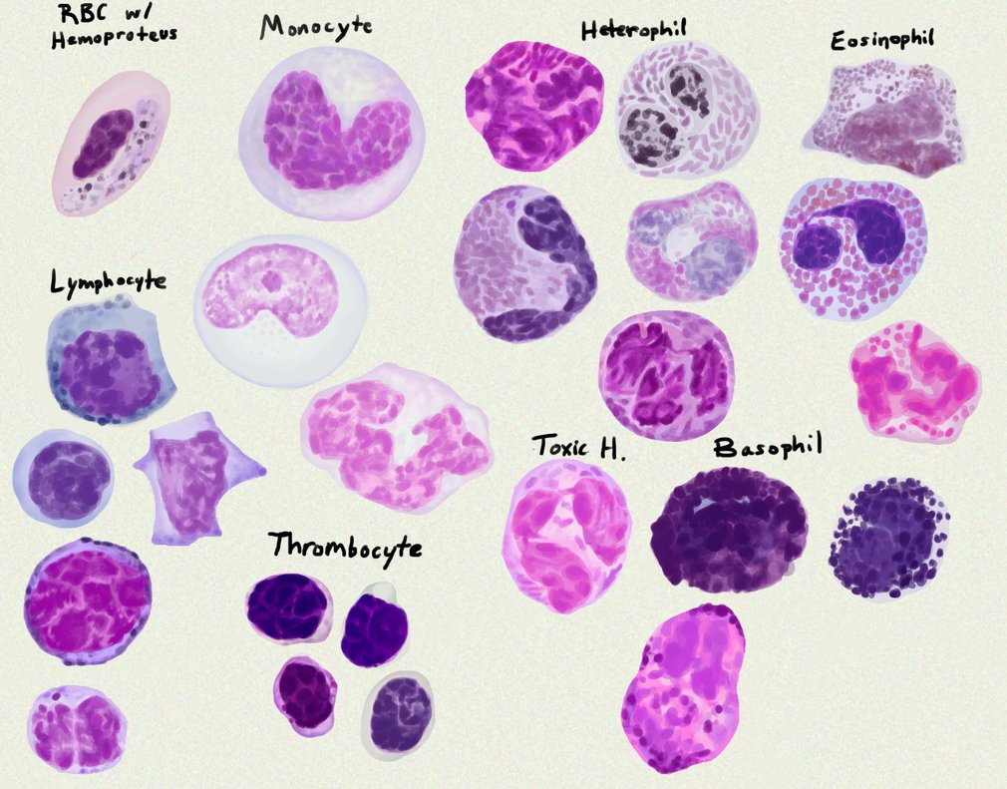

**\* The numbers and types of WBC in birds influenced by several factors:**

Gender - Age - food - environment - hormones and medicines - Diseases - type - activity and strain.

* The **most common** type of WBC is not affected by the **natural conditions** experienced by birds are **lymphocytes** and **heterophil** numbers change as a result, believes that these two types of cells have the ability to resist or **ingestion** of **infectious** material or **exotic**.
* **Heterophil** numbers **increase** and fall **heterophil** numbers of cells in the blood of animals susceptible to fatigue stress.
* The number of WBC in females **higher** than males and because the hormone **estrogen** leads to higher total number of WBC.
* **Increase** the number of WBC with age since **hatching**.
* Vary the number of WBC per **day diurnal variation** noted researchers to rise in the hours **2-4 pm** and as a result of **increased** activity of birds in these hours.
* **Nutrition** affects the numbers of WBC, where lack of **vitamin Riboflavin (B2)** and **Thiamin (B1)** leads to **higher** heterophil and lymphocytes.
* The **disease** also affects cells of the WBC as the **Leukemia** disease in chickens caused by the **high** **lymphocytes** cells, while the **white diarrhea Pullorum**, **typhoid** and **tuberculosis** and **blue comb cells** caused by the **increases** of **monocyte**.

**Thrombocytes**

**Third - Thrombocytes (platelets):**

The vary number of thrombocytes significantly in domestic birds at range 35-40 thousand plate /ml blood, in the quail numbering about 132 thousand plate /mm3 blood.

* Smaller than RBC
* Nucleated
* **Clotting and inflammation:** Thrombocytes in birds contains **Serotonin** at **high** concentration, also they participate in blood coagulation also contain **thromboplastin** in small amounts, they not appear their participation at the beginning of coagulation process.
* **Phagocytize** foreign particles which occur only in **embryos** of domestic fowl.
* Note that they are small, usually more rounded than RBCs, and have clear cytoplasm.