Blood collection

Blood collection
Blood collection can play an important role in determining the cause of morbidity (sickness) and mortality (death loss) experienced in flock. In addition, flock health monitoring can be achieved by obtaining serum samples. A procedure provides the samples needed for laboratory diagnostic testing. Three types of blood samples can be used for diagnostic testing: Whole blood, plasma, and serum.
Whole blood samples are usually used by the veterinarian or flock specialist to examine, by microscopy, the condition of the erythrocytes, leukocytes and thrombocytes. Plasma samples are often used by the chemical profile of the bird’s blood. Serum samples are used by the antibody titer levels present to determine flock exposure agents disease.

What Will You Need to Collect Blood?

- Syringes (1 mL = 1 cc).
- Needles (the smaller the diameter of the needle). 1 inch length is preferable for most birds.
- Blood collection vials (tubes).
- Mini cooler (for transportation of blood samples to the laboratory).
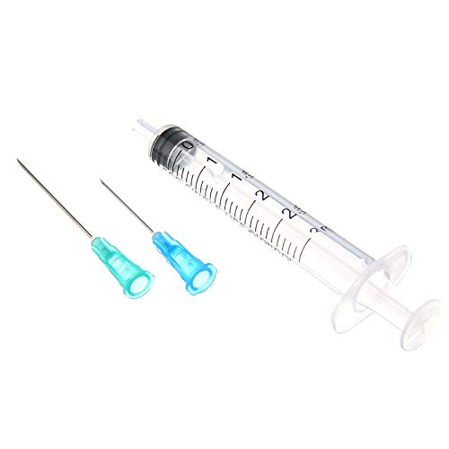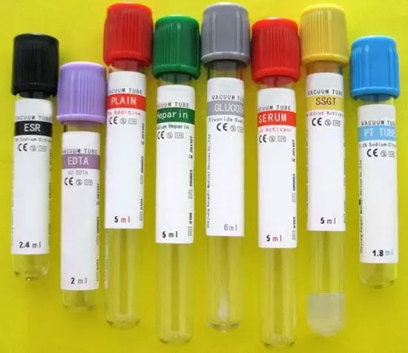
Needles and syringes Note the colored caps/plugs identifying commonly used to bleed the type of blood vials.

Blood tubes | Contents | Collection Sample
Red | None / No additives Blood clots on its own; this allows serum to separate from cells | Serum
Yellow  SST tube | SST tube, Gel separator, Centrifugation causes the gel to separate insoluble material (cells) from serum
Green | Heparin-anticoagulant Contains polysaccharides that inhibit blood clotting by preventing release of coagulating factors | Plasma
Purple  EDTA tube | Anticoagulant EDTA (ethylenediaminetetra-acetic acid) Binds calcium salts in blood by chelation to preserve cells | Whole Blood and Plasma

How Much Blood Can One Collect?

The amount of blood that can be safely collected from a clinically healthy bird is 1% of its body weight, in grams. For example, the maximum amount of blood to take from a 500 g bird is 5 mL (5 cc) of blood.

Blood Collection Sites:

A-The large vein under the wing (brachial vein):

- Place the bird on a table, setting it on its side.
- Lift up the wing with one hand and part the feathers along the wing. Water can be used to help keep the feathers separated.
- Place the needle at a slight angle, bevel up, against the vein on the underside of the wing. Insert the needle into the vein and slowly withdraw blood.
- Remove the needle and apply pressure to the vein for a few seconds. This will help to minimize the development of large hematomas, which can be common with poultry. Fill the appropriate vial 1/3 to 1/2 of its full volume. Allow the vacuum in the vial to empty the syringe, rather than pushing on the plunger, as this will prevent hemolysis (rupture of red blood cells). This volume is needed to ensure enough blood is collected to obtain an adequate sample.

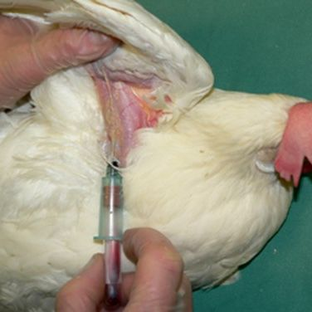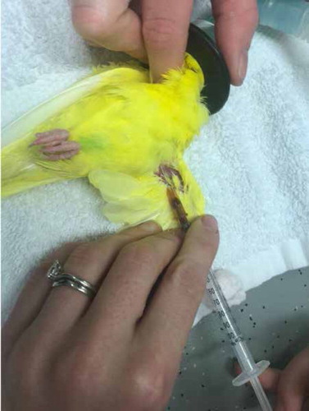

B- The vein on the side of the outstretched neck (jugular vein)

- Place the bird on a table, setting it on its side.
- Stretch out the neck with one hand and part the feathers along the neck. The right jugular vein is usually larger.
- Place the needle at a slight angle, bevel up, against the vein.
- Puncture the vein and slowly withdraw blood.
- Remove the needle and apply pressure to the vein for a few seconds. Fill the appropriate vial 1/3 to 1/2 of its full volume.

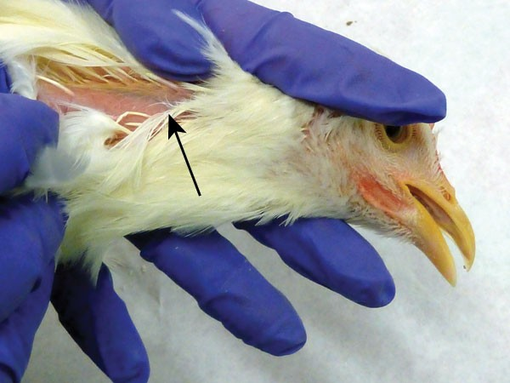

C- The vein on the inner leg, above the hock (medial metatarsal vein)

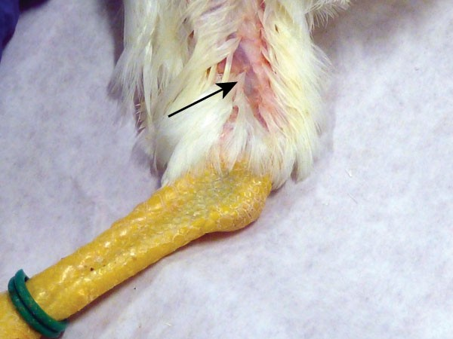
- Place the bird on a table, setting it on its side.
- Stretch out the leg with one hand and part the
feathers along the hock joint.
- Place the needle at a slight angle, bevel up, against the vein.
- Puncture the vein and slowly withdraw blood.
- Remove the syringe and apply pressure to the
vein for a few seconds. Fill the appropriate vial
1/3 to 1/2 of its full volume.
The vein on the inner leg, above
the hock (medial metatarsal vein)
What Should Be Done After the Blood Is Collected?
- To obtain whole blood and plasma, gently mix the drawn blood by inverting the tube a few times. This will ensure proper mixing of the anticoagulant with the whole blood.
- To obtain serum, place the blood tube on a slanted surface for 10 to 15 minutes to allow for clotting.
*The plasma and serum samples can now be spun by centrifugation. Tubes containing the blood samples (serum, plasma, or whole blood) should be refrigerated and sent to a diagnostic laboratory as soon as possible.

