Method of RBC and WBC count in birds:
Using the same method of counting in mammals except for the type of diluents' solution, where it is used in birds dilute solution called Natt & Herrick. Because of the RBC in birds contain nucleus, while there is no nucleus in mammals, therefore when you use the solution used for the mammals in birds will lead to the adhesion of the cell nucleus.
Method of counting:
1. Put the cell counting chamber or Heamocytometer in the microscope for the purpose of access to the squares where there are 5 squares high dedicated to the red blood cells RBC and four other dedicated to the white blood cells WBC for the squares, the large central consists of 5 medium squares, each medium square consists of 16 small squares, the method of measurement are not taken to measure all the squares, but is measured in a random sample of medium squares which is the upper right and upper left, the box center and lower right and lower left, and measured in 5 squares are represented by the sum of the medium squares, in this case we have no equivalent to the measurement of RBC is the same used in the method of mammals.
2. The fresh blood diluted with Natt & Herrick solution, the amount of RBC diluting 200 times by taking 0.5 ml of fresh blood that added anti-coagulant in a special tube to RBC (red bead) and then complete the diluted solution to the mark 101 mix the blood with the solution in the bulb.
3. Placed a drop of solution on a Heamocytometer smear and then count the number of cells.
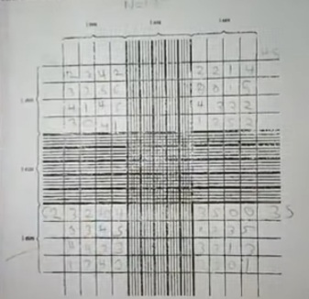
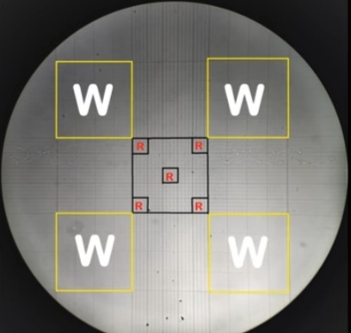
No. RBC = -------- × 400 × 200 × 10
80
shorten the equation to:
X
No. RBC = -------- × 25 × 200 × 10
5
X = total number of red blood cells calculated from the five squres.
400 = total number of squres (80 × 5) the number of squares of the five (5 × 16) = 80
200 = Number of dilution times
10 = high relief from the podium lens (concave lens)

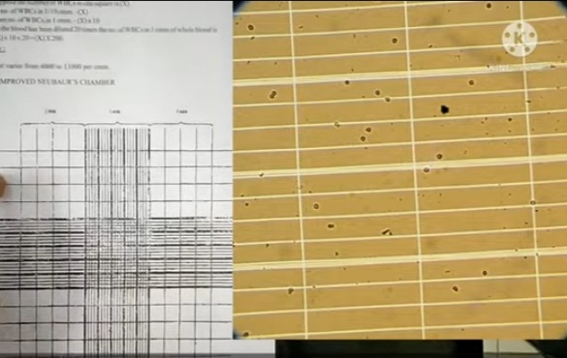
5. In the same way is WBC measured ml of fresh blood with adding anti-coagulant by special tube of WBC (with a white bead) and then clothe fresh blood diluted with a solution of Natt & Herrick: the amount of diluent WBC is 20 times, by taking 0.5 ml the solution diluted to the mark 11 to mix blood with the solution in the bulb.
According to the equation:
X
No. WBC in 1 ml = -------- × 20 × 10
4
X = total number of white blood cells calculated from the four squres.
4 = number of large squares that have been counting the WBC
20 = the number of times dilution.
10 = height of the platform for the lens (concave lens)
2.5 * N * 20(dilution) = 50 * N WBCs in 1mm³ blood
Blood smear & White Blood Cells Differentiation :
The count of white blood cells differentia to take bloody smears on a clean slide after fixed it with Wright-Giemsa stains.
1. Blood is withdrawn from the birds and put a drop of blood on one of the edges of slide and pulled the smear (a drop of blood) by Slade another clean slide quickly with an angle 45° while avoiding the conglomerate cells.
2. Leave the smear to dry
3. Covered the smear with Wright-Giemsa stains, that the stain covers all parts of smear for 2 minutes for the purpose of the fixation.
4. Added distilled water drop by drop, then leave the smear for 15 minutes and will show material floating evidence brilliant green color of mixing of the stain.
5. Than wash the smear with currant taps water until the smear emergence of the pink color.
6. leaves the smear or slide to dry and then examined under a microscope and account from each: (granulocytes: Lymphocyte and Monocyte) and (Non-Granulocyte: Heterophil, Eosinophil and Basophil) and then take the percentages of them.

