PCV test, HB count

Packed Cell Volume (hematocrit): (PCV)
Include the size of blood cells are arranged PCV of all blood cells, but primarily RBC and then white blood cells WBC which are 1-1.5% and are isolated blood cells collect blood in tubes of capillary and placed in a centrifuge and the speed of 12-13 thousand cycles / minutes for a period of not less than 10 minutes.

Factors that affect the size of the PCV:
- Strain breed: egg strains characterized by low numbers of RBC and therefore the proportion or the size of the PCV.|
- Sex: male-male advantage of high volume of PCV, which resulted from higher numbers of RBC in the blood of female reverse the link above, where the value of PCV in males 30-45% and in females 20-30%.
- Season: the size of PCV increases in the winter and lower in summer due to frighten the case for blood as a result of hemodilution to increase drinking water.
- Nutrition: the lack of chicken diets of some elements such as iron, copper, reduces the size of the PCV; this is because these elements are essential for cell formation RBC.

Erythrocytes Hemoglobin (Hb):

Hemoglobin in birds contains four units on a container sub-Heme iron. And combine units Heme with globins to form single molecule of Hb container on the four polypeptide chains. Vary level of Hb in the blood of birds as reported (20-80) g / 100 ml blood cause differences may be due to several factors located in the Hb estimation method and found that the best way is cyanomethemoglobin.
- Made by RBC and not bone marrow
- 8-12 g/dl in chicken blood
- The concentration of Hb higher in males than females due to the fact that males of most bird species contain larger numbers of RBC and to the hormone androgen, while the hormone estrogen lowers the concentration of Hb and also the height above sea level, is working to raise the Hb.
- The research found a low concentration of Hb in the blood of laying hens compared with non-laying chicken.
- Also Hbs functions is breathing, where it combines with the O₂ to be the compound Oxy-hemoglobin, is associated with Co₂ as compound carboxy-hemoglobin, the power of Hb link with Co₂ stronger by about 200 times of the correlation of Hb with O₂, that the link Co₂ with Hb unstable compound, when its concentration raise in blood cause of asphyxia because HbCo₂ change a nice moisturizing respiratory Hb inside the structure.
- Hb destruction process occurs in the liver, thus uses the heme part in the formation of bile pigment called bilverdin (green color).
- Mean corpuscular hemoglobin (MCHb) =Amount of Hb in RBC = 50 pg/cell

- Mean corpuscular hemoglobin concentration (MCHC)=Relative volume of RBC that is Hb = 25%

Hemoglobin (Hb) Structure:
- 4 heme molecules + 4 polypeptide chains (globulins)
- Each heme molecule contains one Fe molecule
- Each Fe molecule can carry one O2 molecule
- Therefore each hemoglobin molecule carries four O2 molecules

Estimation of Haemoglobin:
We can estimate the haemoglobin by two methods:
1-Sahli’s Method:
Principle: this method based on conversion of hemoglobin to acid hematin, which is brown in color.
Hemoglobinometer consists of:
1. Comparator block containing color standard.
2. Capillary pipette marked to contain 0.02ml (20µl 0.2c mm).
3. Small graduated tube.
4. Very fine glass rod.

Procedure:
1-Fill the graduated tube to the mark 2 with 0.1N HCl.
2-By Hb pipette suck blood till the specific mark 20µl (0.02ml).
3-Add it to HCl, mix and wait for 5-10 minutes.
4-Add distilled water drop by drop and keep mixting until you have the same color with brown glass standard provided.
5-Read the lower level of fluid meniscus on g/ml.
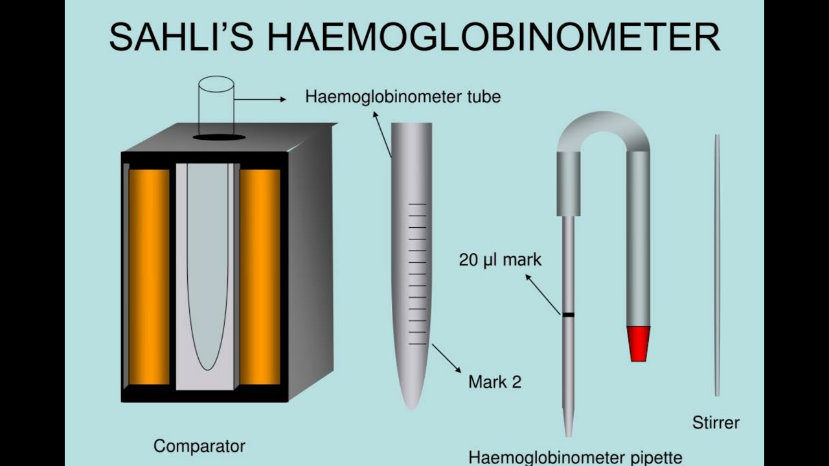
2- Spectroghotometric Method
This method depend on diluting the blood with Drabkin's solution (containing potassium cyanide and potassium ferricyanide). Haemoglobin, Methaemoglobin and carboxy haemoglobin all are convert to ciyano methemoglobin, then the density of ciyano methemoglobin will be read by using spectrophotometer.
Clinical application:-
Normal Ranges:
- In men 14 -18 g/ dl =16gm / dl, In women 12 – 15 g/ dl =14gm / dl, In new born 12.5 – 24.5, Cattles 12g/dl, sheep11g/dl, chicken 8-12 g/dl
*Low Hb indicates anemia
*High Hb indicates polycythemia

