Animal genetic Second stage Miss Dilger Maghded
Pedigree analysis
- What is a pedigree?
  - Definition
  - Uses
- Constructing a pedigree
  - Symbols
  - Connecting the symbols
- Interpreting a pedigree
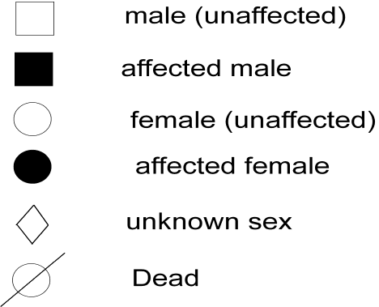
A pedigree is a chart of the genetic history of family over several generations. Scientists or a genetic counselor would find out about your family history and make this chart to analyze it.

Basic patterns of inheritance
1. Autosomal, dominant Inheritance
2. Autosomal, recessive Inheritance
3. X-linked, recessive Inheritance
4. X-linked, dominant (very rare)
5. Y-Linked Inheritance
6. Mitochondrial Inheritance

Interpreting a Pedigree Chart
- Determine if the pedigree chart shows an autosomal or X-linked disease.
If most of the males in the pedigree are affected the disorder is X-linked
If it is a 50/50 ratio between men and women the disorder is autosomal.
Is it Autosomal or X-linked?

- It is autosomal because it is 50/50 men to women, if it was X-linked most of the men in the diagram would have the disorder.
- Make sure you count the number of men with the disorder and the number of women with the disorder. In this pedigree, 3 men and 3 women have the disorder.
- Determine whether the disorder is dominant or recessive.
If the disorder is dominant, one of the parents must have the disorder.
If the disorder is recessive, neither parent has to have the disorder because they can be heterozygous.

It is dominant because a parent in every generation have the disorder. Remember if a parent in every generation has the disorder, the disorder has not skipped a generation. If the disorder has not skipped a generation the disorder is dominant
- Dominant or Recessive?

It is recessive because a parent in every generation does not have the disorder. Remember the disorder can skipped a generation if the disorder is

Recessive
- Y-Linked Pedigree
- Here, parents of the first family have one affected male member in the F1 generation and two affected males in the F-2 generation. We discussed earlier that in the Y-linked trait, an infected male member transfers the disease to all the male members in the family.
- The second family in the F-1 generation has an unaffected father, so the disease will not transfer to the male individual of the next generation. Then, look into the interrelationship between individuals of the F-2 generation.
- Individual number 3 and 4 indicates a couple, where an affected father transferred the disease to his sons in the F-3 generation. You can only see the affected males in this pedigree, which indicates a sex-linked inheritance.
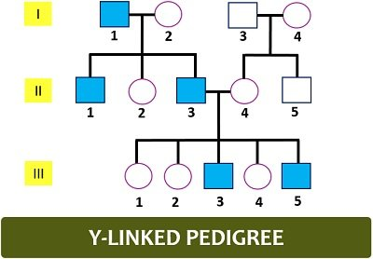
MITOCHONDRIAL INHERTANCE
- both males and females are affected
- the condition is transmitted through the female to her offspring
- if a male has the trait and his spouse doesn’t, their offspring won’t have the trait

