

**Subject:P. Molecular GeneticsStage:2Time: 1 hour**

**Date: 8/5/2022**

**Salahaddin University –Erbil**

**College of Agricultural Engineering Sciences**

**Animal ResourcesDepartment**

**Second Monthly Examination,SecondSemester - 2021-2022----------------------------------------------------------------------------------------------------------------**

**Q1/answer the questions A and (B or C)**(10 Marks)

**A/** The following is the DNA sequence of Gene K that you want to amplify using the polymerase chain reaction (PCR) design a pair of primer to this amplification.

5’CTCGAGGTGAATATGAAAG---- ----CATTTGGCGCGTAATCGATA3’

**Gene K**

3’GAGCTCCACTTATACTTTCC---- ----GTAAACCGCGCATTAGCTAT5’

B/ What are the components using in PCR reaction? Explain in short.

C/ What are the steps of PCR amplification? (**In brief**)

**Q2/A/**You are given the DNA shown below. (14 marks)

5’ ATTGAGGAGCTCCGTAATGGTCCCCGCGGCGCTCCACG 3’

3’ TAACTCCTCGAGATTACACGGACGGCGCCGGCAGGTGC 5’

Restriction Enzymes X1, cleaves after the T, and X2 cleaves after the second C. Do cleavage by X1, and X2 result in a 5’ or 3’ overhang? If this DNA was cut with them how many DNA fragment would you expect? Write out the sequence of these double-stranded DNA fragments for each restriction enzyme, and then ligate the two shortest fragments together.

If you know the recognition site for X1 is 5’ CCGCGG 3’ / 3’ GGCGCC5’ ,

and for X2 is 5’ GAGCTC 3’ / 3’ CTCGAG 5’

**B/ Suppose that the following is the DNA sequence of Gene F (462bp) that you want to genotype using the RFLP technique.**

1

2

3

52

254

156

410

5’…... ... TCCGGCGGAATTCCAAGGCCTATGGTGTGTATCGTCGACTCCG....... 3’

3’……...AGGCCGCCTTAAGGTTCCGGATACCACACATAGCAGCTGAGGC.….. 5’

When this gene faced to the X restriction enzyme the three genotypes are obtained

FF: was cut in the 1 arrow

ff: was cut in the 1 and 2 arrows

Ff: was cut in all arrows

**Show your results use agarose gel electrophoresis.**

**Q3/ What kind of inheritance pattern? Why?**(16 Marks)

**A B**

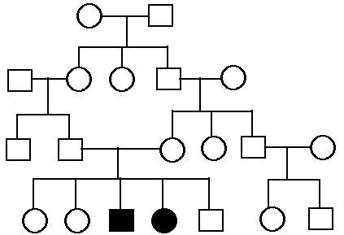

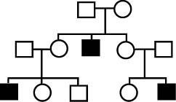

**C D**

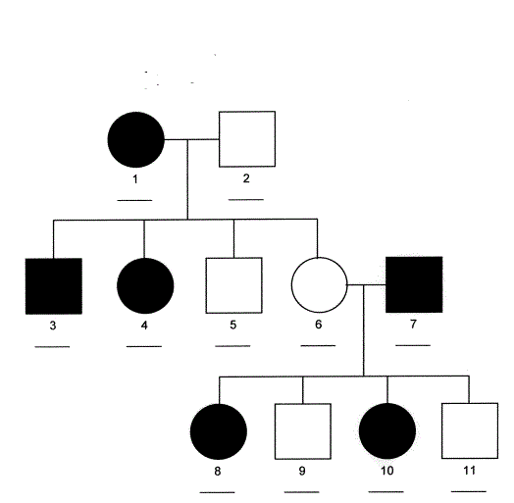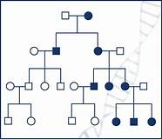

**Asst. LecturerLecturer**

**DilgerMaghdidKhdrKamaran Mustafa Taha**