What is PCR?
The polymerase chain reaction (PCR) was originally developed in 1983 by the American biochemist Kary Mullis. He was awarded the Nobel Prize in Chemistry in 1993 for his pioneering work.
PCR is used in molecular biology to make many copies of small sections of DNA or a gene, and it is possible to generate thousands to millions of copies of a particular section of DNA from a very small amount of DNA. PCR is a common tool used in medical and biological research labs.
Application of PCR:
PCR used in medical and biological research labs for a variety of applications. These include;
- Functional analysis of genes.
- Detection of mutation
- Diagnosis of hereditary diseases.
- The detection and diagnosis of infectious diseases.
There are three main stages:
- Denaturing – when the double-stranded template DNA is heated to separate it into two single strands. During this stage the cocktail containing the template DNA and all the other core ingredients is heated to 94-95⁰C.The high temperature causes the hydrogen bonds between the bases in two strands of template DNA to break and the two strands to separate. This results in two single strands of DNA, which will act as templates for the production of the new strands of DNA . It is important that the temperature is maintained at this stage for long enough to ensure that the DNA strands have separated completely. This usually takes between 15-30 seconds.
- Annealing – when the temperature is lowered to enable the DNA primers to attach to the template DNA. During this stage the reaction is cooled to 50-65⁰C. This enables the primers to attach to a specific location on the single-stranded template DNA by way of hydrogen bonding (the exact temperature depends on the melting temperature of the primers you are using).
  - Primers are single strands of DNA or RNA? Sequence that are around 20 to 30 bases in length.
  - The primers are designed to be complementary? in sequence to short sections of DNA on each end of the sequence to be copied.
  - Primers serve as the starting point for DNA synthesis. The polymerase enzyme can only add DNA bases to a double strand of DNA. Only once the primer has bound can the polymerase enzyme attach and start making the new complementary strand of DNA from the loose DNA bases.
  - The two separated strands of DNA are complementary and run in opposite directions (from one end - the 5’ end – to the other - the 3’ end .This step usually takes about 10-30 seconds.
- Extending –
During this final step, the heat is increased to 72⁰C to enable the new DNA to be made by a special Taq DNA polymerase enzyme which adds DNA bases. Taq DNA polymerase is an enzyme taken from the heat-loving bacteria? Thermus aquaticus. This bacteria normally lives in hot springs so can tolerate temperatures above 80⁰C.The bacteria's DNA polymerase is very stable at high temperatures.
These three processes of thermal cycling are repeated 20-40 times to produce lots of copies of the DNA sequence of interest.
The new fragments of DNA that are made during PCR also serve as templates to which the DNA polymerase enzyme can attach and start making DNA.The result is a huge number of copies of the specific DNA segment produced in a relatively short period of time.
After PCR has been completed, a method called electrophoresis can be used to check the quantity and size of the DNA fragments produced
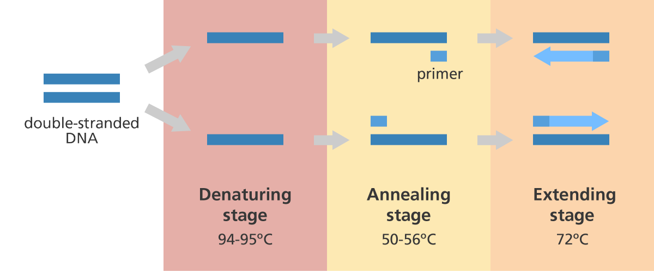
Illustration showing the main steps in the polymerase chain reaction (PCR).

PCR cycling conditions:
Initial denaturation 94°C for 5 min.
94° C for 30-60 sec.
45-65° C for 20-40 sec. 30 cycles
72° C for 30-60 sec.
Final Extension 72° C for 5 min.

Reagents and the optimal PCR reaction mixture
PCR components | Volume (μl)
Nuclease free water | 10.70
10X reaction buffer | 2.00
dNTP mix (2.5mM) | 2.00
Primer I (10picomoles/ μl) | 2.00
Primer II (10picomoles/ μl) | 2.00
Taq DNA polymerase (5U) | 0.3
Template DNA (50ng/ μl) | 1.00
Total volume | 20.0 μl

