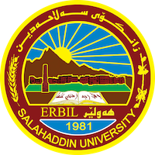

Academic Curriculum Vitae
Personal Information 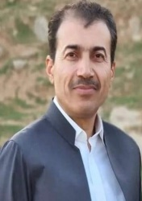
Academic Title: Lecturer
Email: dilovan.ghafoory@su.edu.krd
Mobile: 0750 467 2661
Education: Dr. Dilovan Sayfuddin Saady Ghafoory

Certificates | Name of University | College |  | Department | Year of graduation
Bachelor | Salahaddin | Languages |  | English | 1997
Master | Salahaddin | Languages |  | English | 2000
PH D Salahaddin Languages |  |  | English 2010

Employment:
- State employment starting from first employment

Qualifications
- Teaching qualifications: Scientific title
- IT qualifications: computer proficiency exam certificate
- Language qualifications such as TOEFL, IELTS or any equivalent
- Any professional qualification
- You could put any professional courses you have attended: Teaching English teacher training

Teaching experience:
- State all teaching courses you delivered, stating undergraduate or post graduate
- Courses, trainings, lab supervision, etc.,: Syntax ,morphology and Semantics for undergraduate students but Sociolinguistics ,Phonetics and Phonology ,Research Methods for post graduate students

Research and publications
- State all researches, publication you made. : 1.Animal Metaphor in English and Kurdish languages
- 2.Reduced Clauses in English and Kurdish languages
- 3.Realisation of Constituents in English and Kurdish languages
- 4.Presupposition Triggers in the types of presupposition used by Non-Native writers of English
- 5.Complex Symbols in English and Kurdish languages

Conferences and courses attended
- Give details of any conferences you have attended, and those at which you have presented delivered poster presentations.
Teaching Grammar , delivering a seminar about Language and Sex

Funding and academic awards
- List any bursaries, scholarships, travel grants or other sources of funding that you were awarded for research projects or to attend meetings or conferences.
- Cincinnatti University in Ohio in USA
IATEFL conference in Liverpool in Britain in 2013

Professional memberships
- List any membership you hold of any professional body or learned society relevant to your research or other life activities.

Professional Social Network Accounts:

- List your profile links of ReserchGate, LinkedIn, etc. : ResearchGate , LinkedIn ,Google +(Orcid)

It is also recommended to create an academic cover letter for your CV, for further information about the cover letter, please visit below link:
https://career-advice.jobs.ac.uk/cv-and-cover-letter-advice/academic-cover-letter/

