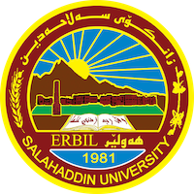
Academic Curriculum Vitae

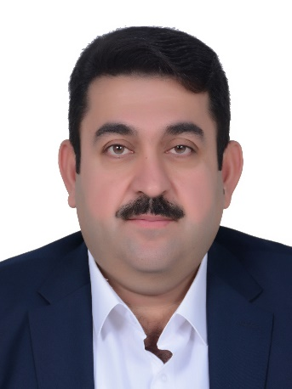
Personal Information:
Full Name: Dr.Dilshad Salih Ismael Abdulla
Academic Title: Assistant Professor
Email: dilshad.ismael@su.edu.krd
Mobile: 07504981976

Biography

Dilshad S. Ismael is Lecturer of Medical physics in the Department of Physics. He gained a B.Sc. degree in Physics from Salahaddin University-Erbil in 2001, and M.Sc. degree in Plasma Physics from Mosul University in 2005. He started an academic carrier in 2001 when he joined the work at Department of Physics/college of Science at Salahaddin University-Erbil as a lab demonstrator. He stayed with the job for 3 years. In 2005, after he obtained MSc degree, he got a position as an assistant lecturer, in 2015 he got a position as a lecturer and in 2023 he got a position as an Assistant Professor. - Since 2001 he started his contribution in teaching undergraduate. He completed his PhD (Medical physics ) at Mosul University in 2015. He is currently teaching in Salahaddin University in Iraq.

Employment:
Date of first assignment in University | 24-11-2002 | Place of recent work | Salahadden university -Erbil  College of sciences –Physics department | Job title | Academic staff/ Lecturer

Education:
Type of diploma | University | College | Department | Graduation year | Country\ Governorate
B.Sc | Salahadden- Erbil | sciences | Physics | 1996 - 2001 | Erbil - Iraq
M.Sc | Mosul | sciences | Physics | 2003 - 2005 | Mosul - Iraq
Ph.D | Mosul | sciences | Physics | 2011 - 2015 | Mosul - Iraq

Teaching experience:

Lessons taught, included:
Electromagnetic Theory | postgraduate
Medical Physics | postgraduate
Medical Physics | 3rd &2nd class
Classical Mechanics | 1st class
Mathematic | 1st class
Electronics | 2nd class
Plasma Physics | 4th class
Electromagnetic Theory | 4th class
Medical Physics Lab. | 3rd class
Physiology Lab. | 3rd class
Solid state Lab. | 4th class
Electronics Lab. | 3rd class
Properties of Matter Lab. | 1st class
General Physics Lab. | 1st class

Language Skills
Kurdish – Native language.
Arabic – Excellent in speaking, writing and reading.
English – Good in understanding, writing, reading and fair in speaking

Research and publications
- Dilshad Salih Ismael. The Effect of Deposition Plasma Current For Gold Nano Thin Film on Bacteria Using Cold Plasma Sputter. 2014. International Journal of Advanced Research, Volume 2, Issue 1, pp. 966-977
- Dilshad Salih Ismael. The Effect of Nano thin film gold on bacteria using cold plasma sputter.2014. International Journal for Sciences and Technology / ICV: 4.32, Vol. 9, No.1, pp.75-80

- Dilshad S. Ismael. Smartphone overuse and vision problems among university students.
ZANCO Journal of Pure and Applied Sciences. (2022) , 34(3);32-39

- Razaw Dindar Hussein and Dilshad Salih Ismael. Review on Surface Texturing Method for Solar Cell Efficiency Enhancement. Journal of Physical Chemistry and Functional Materials.Volume 5, Issue 1 (2022) 1-8

- Bazhdar N. Mohammed and Dilshad S. Ismael. A Computational Model for Temperature Monitoring During Human Liver Treatment by Nd: YaG Laser Interstitial Thermal Therapy (LITT). ARO-The Scientific Journal of Koya University Vol. X, No. 2 (2022), pp 38:44.

- Firas Husham Al-Mukhtar, Dilshad Salih Ismael, Raghad Zuhair Yousif, Salih Omer Haji, Bazhdar Nooraddin Mohammed. Thyroid Nodule Image Joint Segmentation and Classification Based on Deep Learning. ZANCO Journal of Pure and Applied Sciences. (2023).

- Rozhan Dilshad Haider, Dilshad Salih Ismael. Assessment of Annual Effective dose and radiological hazards associated with radioactivity on workers in Physics Laboratory. ZANCO Journal of Pure and Applied Sciences. (2023).

Professional Social Network Accounts:

ResearchGate https://www.researchgate.net/profile/Dilshad-Salih-Ismael
Linkedin https://www.linkedin.com/in/dilshad-salih-ismael-443685156/
Twitter https://twitter.com/dilshad_ismael?cn=bG9naW5fbm90aWZpY2F0aW9u&refsrc=email
Google Scholar https://scholar.google.com/citations?hl=en&user=ST8544UAAAAJ
Facebook https://www.facebook.com/dsi.dsi.777158

