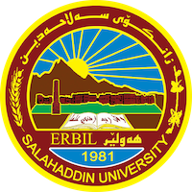
Academic Curriculum Vitae
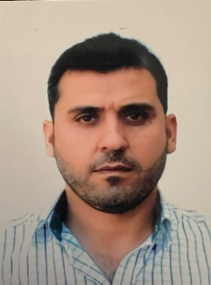
Personal Information:
Full Name: Dilzar Hamad Mawlud
Academic Title: Assistant lecturer
Email: dilzar.mawlud@su.edu.krd
Mobile:07504752898

Education:
- State all educations accomplished
- BSc: 2008 college of agricultural engineering science
- MSc: 2015 college of agricultural engineering science
Employment:
- State employment starting from first employment
- 18/3/2009 Salahadin university /Erbil

Qualifications
- Teaching qualifications:
- IT qualifications: word, excel, power point
- Language qualifications : research center of Salahaddin University (level Pre-Intermediate equal 5.5)
- Training of language Course in Salahaddin University, in 2022.
- General English course,
- power point Prezi course

Teaching experience:
- State all teaching courses you delivered, stating undergraduate:
- Principle of Entomology
- Apiculture
- Experimental design and analysis
Research and publications

- Description of Pine Ladybirds Beetle, Exochomus quadripustulatus (Linnaeus, 1758) (Coleoptera: Coccinelidae) From Kurdistan Region-Iraq.
- Molecular Identification and Morphological Study of Ground Beetle, Cyminidis andrea, Menetries, 1832(Coleoptera: Carabidae) from Erbil Governorate Kurdistan Region- Iraq.

Conferences and courses attended
- Give details of any conferences you have attended, and those at which you have presented delivered poster presentations.

Funding and academic awards
None
Professional memberships
None
Professional Social Network Accounts:
profile links: https://academics.su.edu.krd/profile-admin/index.php?p=dashboard
Research Gate: https://www.researchgate.net/profile/Dilzar-Mawlud
LinkedIn: https://www.linkedin.com/in/dilzar-hamad-mawlud-960004202/
Facebook: https://www.facebook.com/dilzar.galaly.1

