Experimental design and analysis, grade 3, Plant Protection and Forestry Department/ Instructed by Assist prof. Dr. Sirwa A. Qadir and Dilzar Hamad Mawlud

Question bank

Q1/ Conduct a laboratory experiment to study the effect of three incubation temperature on the fungal growth diameter. Each replicated three times.
Answer the following:
- Lay out the experiment with a suitable design.
Write the linear model of the design.

Q2/ A Lab experiment conducted to determine the effect of different levels of Auxins (A, B, C and D) on root length of differentiated callus. You are given the following information:
You are given the following information:
- MSE= 0.051
- Sum of A, B and C were; 10, 9 and 20.
- Grand total = 51
- Tabulated-t (, dfE) = 2.65
- Compare the treatment means using LSD test (Least Significant Difference test).
- Write the final conclusion to explain which level of Auxin is significantly differing from the others.

Q3/ Red clover plants were inoculated with 5 strains of Rhizobium replicated each in four blocks. The nitrogen content of the plants (mg/g) were later determined. The researcher assumes the significant effect of the strain and select the alternative hypothesis; HA: M1 ≠ M2 ≠ M3 ≠ M4 ≠ M5.
Answer the following:
- Complete the following ANOVA-table.
Source of Variation | Degree of freedom | Sum squares | Mean squares | Calculated-F | Tabulated- F
Treatment |  | 102.3 |  |  | 3.26
Block |  | 18.95 |  |  | 3.49
Error
Total |  | 206.55
- Did the researcher’s assumption is true or not?

Q4/ What are the three basic principles of design which were developed by Sir Ronald A. Fisher?

Q3/ An agronomic study was conducted to compare among three levels of an organic fertilizer on the final yield of wheat crop. The study involved 12 blocks, that each contain the treatments in random order in a Randomized Complete Block Design (RCBD.
1. Complete the Analysis of Variance table.
2. Test the significance of the result and make appropriate conclusion, if you know that critical F treatment value = 3.49 and critical F block = 2.45.

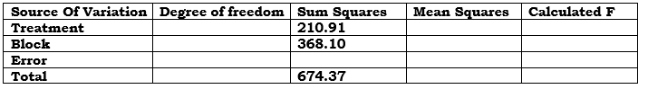

Q6/A new herbicide was tested in the field for weed control. Five levels of the herbicide were applied in the study, with each level applied to four plots by a completely randomized design. The following table shows the percent weeds in each plot and the average and the total of each treatment:
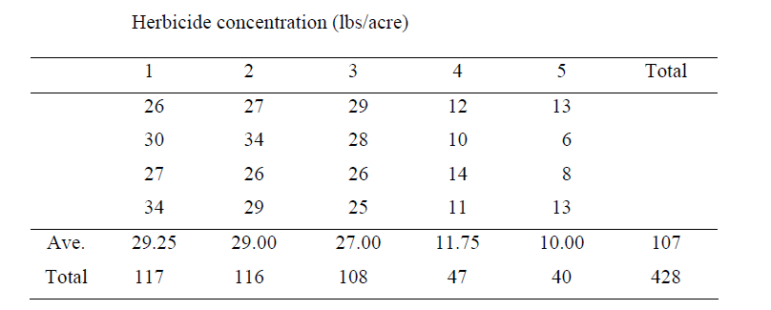
Perform an analysis of variance on the data and test the hypothesis that there is no difference among the five treatments of weed control. (F=42.00)
Is there a significant difference among treatment means? Show your procedures and calculations (F=19.55)

Q7/ An experiment was arranged in a CRD to test a hormonal growth promoter for feed efficiency (body weight gain/food consumption) of beef cattle. Four levels of the growth promoter were mixed in the feed to treat the animals. The following data were obtained:
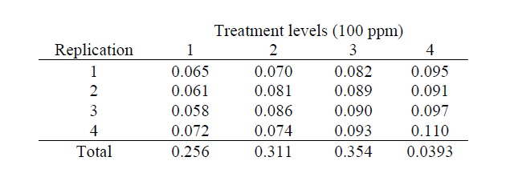

Q8/ A study was performed to test three different feed additives on growth promotion. Weight gain of heifers by treatment (pounds per animal per day) was shown in the following table.

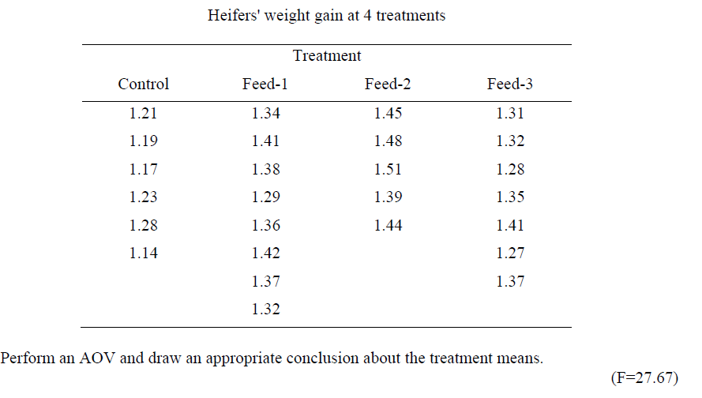

Q9/ An agricultural experiment station wishes to determine the yields of five varieties of corn. Each type of corn is planted to four plots of land with equal fertility, and the yields, in units of 100 bushels, are shown below. In view of these results, can we conclude that the mean yields of the five varieties of corn are the same using the 5% level of significance? (F=4.14)

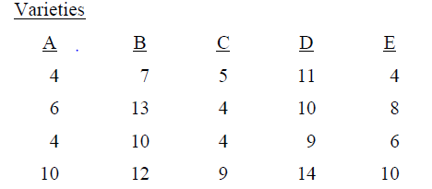

Q10/ Fifteen judges have assigned ratings on a 10-point scale to three bakery products as shown. Are there significant differences among the mean scores of products at the 5% level?
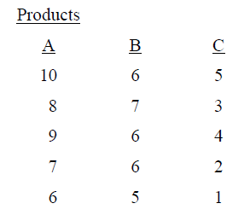

Q11/ The following are the amounts of corn in bushels obtained from equal-size plots planted to 4 different varieties. Using the 1% level analyzes the results for significant differences among variety mean yields. (F=8.75)

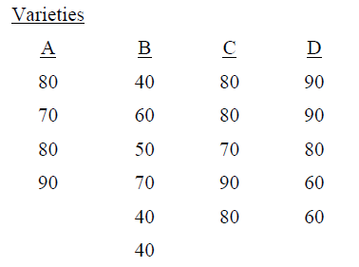
Q12/ Yield component, kernel weight (mg), of four wheat varieties is measured for comparison in a field study by a completely randomized design. Based on the data, what is your conclusion about kernel weight means of these varieties? (F=8.99)
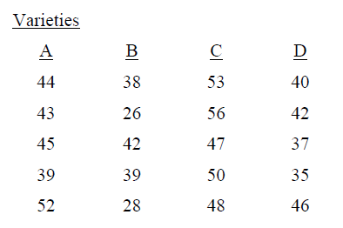
Q13/A plant scientist performed an experiment on the effect of acetic, propionic, and butyric acids on young rice seedlings' growth. After seedlings were grown in the solutions for 7 days, shoot dry weights (mg) from 5 replications of each treatment were measured and presented in the following table. (F=33.87).
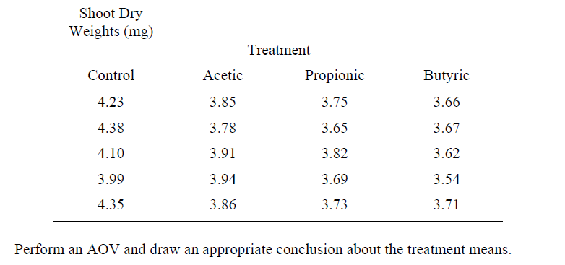
Q14/ A laboratory experiment was conducted to determine the available potassium in Soil for this purpose 4 type of Soil was tested (A, B, C, D) with (6, 8, 7, 8replicates) respectively. The following data was obtained, complete ANOVA table and select the best treatment.
 | R1 | R2 | R3 | R4 | R5 | R6 | R7 | R8
A | 3.6 | 3 | 3.4 | 2.9 | 3.5 | 3.3
B | 2.5 | 2.4 | 2.6 | 2.6 | 2.8 | 2.5 | 2.7 | 2.6
C | 5.8 | 6.2 | 6.5 | 6.1 | 5.6 | 6.3 | 5.5
D | 3 | 3.3 | 3.7 | 3.6 | 3.5 | 3.6 | 3.2 | 3.4

Q15/ Write the advantages of Randomized Complete Block Design (RCBD).

Q16/ Why you may need to be able to work with unbalanced designs?

Q17/ A researcher wants to conduct an experiment on a variety of tomato to test four integrated nutrient management T1, T2, T3 and T4 each with four replications in a pot experiment. Give your advice to the researcher to lay out and conduct the experiment with an appropriate design.
Q18/ What is the signature of a Latin square design? And why it has not been widely used in agricultural experiments despite its great potential for controlling experimental error.
Q19/ The following results are of a glass house experiments for studying the effect of five pesticides (A, B, C, D and E) each with three replications to control a certain pest in bean plant. You are given the following information:
1. Grand total = 225
2. Treatment means of number of leaves per plant were; A-= 9, B-= 15, C-= 18, D-= 22.
3. Sx- = 2.69
Compare among the treatment means using Duncan’s multiple range test (DMRT), if you are given the r table values; 3.081, 3.225, 3.312, 3.370.

Q20/ Compare all possible pairs of treatment means using Duncan's Multiple Range Test (DMRT). You are given the following information; Summation of treatments (T1, T2, T3, T4, T5 and T6) = 105, 94, 101, 91, 74 and 86 respectively, MSE= 6.97 and r values with error df of 30 and at the 5% level of significance are: 2.89, 3.04, 3.12, 3.20, 3.25.

Q21/ write the common causes of missing a datum.

Q22/ Complete the following ANOVA table obtained from an experiment on the effect of acetic, propionic, barbituric acid and butyric acids on young rice seedlings' growth. Is the scientist assumption being true; that the four amino acids will have the same effect (H0: M1= M2=M3=M4)?
Source of variation | Degree of freedom | Sum of Squares | Mean squares | Calculated F | Tabulated F
Treatment |  |  | 28 |  | 4.43
Error | 20 | 82
Total

Q23/ Define level of significance, mention its values in agricultural experiments with reasons and how it correlates with accuracy?

Q24/ A teacher practices the different teaching methods on different groups in her class to see which yields the best results. In this example, a treatment is
a) Teacher
b) Class
c) Different teaching methods
d) Different groups

Q25/ A term referring to the amount of balancing, blocking and grouping of the experimental units is:
a) Local control
b) Spurious effect
c) Systematic error
d) Extraneous factor

Q26/ Describe the experimental error and its various origins.

Q27/ The null hypothesis in a completely randomized design is
a) All treatment means are equal.
b) Not all treatment means are equal.
c) Addition of all treatment means is equal to 1.
d) Subtraction of all treatment means is equal to 1.

Q28/ Complete the given ANOVA table of Completely Randomized design:
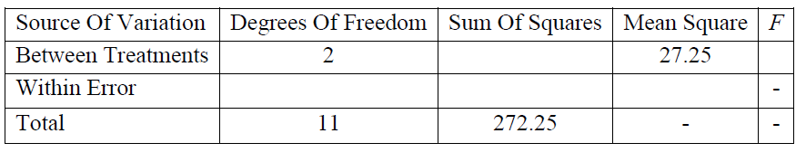

Q29/ In a Randomized Complete Block design, the randomization is restricted in
a) One direction
b) Two directions
c) Three directions
d) No restriction

30/ In a Randomized Complete Block Design (RCBD), there are 4 treatments and 5 blocks. By using the given values, Complete the ANOVA table.
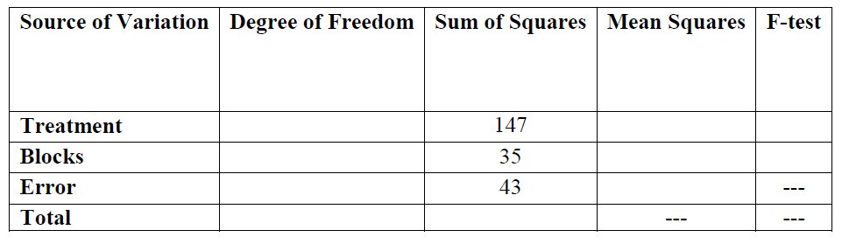

s.o.v. | df | SS | MS | F
t | 1
B | 4 | 7.67
E |  |  | 0.15
T |  | 18.26

