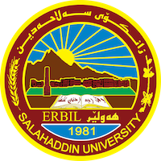
Academic Curriculum Vitae
Personal Information:
Full Name: Diman Ali Qadir
Academic Title: assistant lecturer
Email: (diman.qadir@su.edu.krd)
Mobile:07504674756

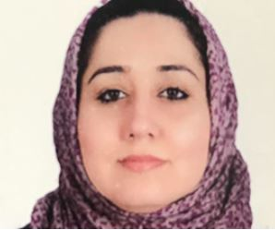
Education:
- Bachelor in Education and Psychology (Sallahaddin University 2009-2010).
- Master's degree in Psychology (Sallahaddin University 2016-207).
- Diploma in mathematic department (a central institute 1997-1998).

Employment:
-1998 Teacher in a primary school.
- 2010. Teacher in a secondary school.
-2010 Assistant Researcher, College of Education.
-2022 Assistant Lecturer, College of Education.
Qualifications
- Teaching qualifications.
-IT qualifications; very good knowledge of computer systems and software: MS Windows, Network- Internet - Social Media. Statistical analysis software package - SPSS .
- English language efficiency qualifications
Teaching experience:
- psychological measurement and evaluation, educational psychology, problem solving, Educational Assessment, Developmental psychology, Childhood and adolescence psychology. Learning theories.
- Educational Researches for Undergraduate Students.

Research and publications

Conferences and courses attended
- 2018; Participants in the course of teaching methods. Sallahaddin University - Erbil – Iraq.
-2023 Joint Symposium between Department of Media and Department of Sociology, College of Arts, Salahaddin University.
-2023 Awarding credits for the best graduation research and ideas for students of Salahaddin University.
-2022 5th Conference of the College of Islamic Sciences (Dignity of the Family in the Perspectives of Religion, Law and Economics).
-2022 cyber harassment and sexual exploitation(chase)
- Participants of module Conference of Colleges of Education department of computer.

Professional Social Network Accounts:

https://orcid.org/0009-0003-7829-3472

