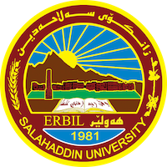
Academic Curriculum Vitae
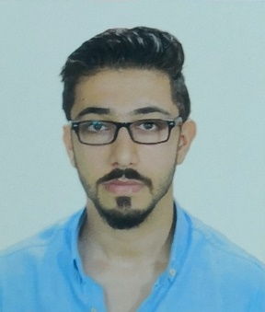
Personal Information:
Full Name: Diyar Abdulbaqi Khaleel
Academic Title: Assistant lecturer
Email: diyar.khalil@su.edu.krd
Mobile: 009647504241494

Education:
Education level
^{Nov.}2008 to ^{Jan.}2012 | Bachelor of Arts, Philosophy Department,  Salahaddin University, Erbil, Iraq
2014- 2017 | Master’s Degree in Islamic Philosophy
2017 | Diploma of Teaching Methods and Research Methodology

Employment:
- Employee in EMC (Emergency management center) from 2010 to 2012
- Teacher in Salahaddin university- collage of art- philosophy department since 2012 tell now.

Qualifications
- Certificate of English course/ intermediate level at Cambridge collage.
- Certificate of completion English course / intermediate level at Salahaddin university-Erbil.
- Certificate of methodology and teaching technics in Salahaddin University- Erbil.

Teaching experience:
- Teaching music (guitar) at (Benaslawa institute).
- Teaching at philosophy course in (Standard institute).
- Teaching online philosophy course in (Naway bir institute)

Research and publications
I have done many researches about different subjects and items as the followings:
- Books: -
Published three books in Islamic Philosophy
- The great Islamic Philosopher
- Some concepts and point of views in Islamic Philosophy
- The beginning of logical thinking in Islam (science of Kalam)
- Research
- The importance of humanity value for now a days and Rumi’s point of view about it (published in conference – philosophy department and house of Alhekma – University of Raparin)
- The meditation about Rousseau ’s philosophy of education (published in conference – college of education – Dohok university)
- The Results of the absence of philosophical education in Kurdish society. (Published in Forth international conference – DOHOK UNIVERSITY - AL IRAQIA UNIVERSITY and Noon center for specialized and studies.

- An article about violence and revolution
- Ontology in Ibn Sina’s philosophy
- Suhrawardi is a founder of Ishraki’s school.
- Pluralism and Kurdish intellectual
- A beginning of Science of Kalam
- Assume that if there's no commonwealth
- study in Kalam of Shi’a
- the five predicable
- an article about philosophy of Muhamad Zakaria al Raze
- the political philosophy of Plato
- accumulate in religion and philosophy in Averroes’s opinion
- an analyzing of (the Machiavelli’s prince book)
- Montesquieu’s Philosophical reflection behind the roman (Iranian letter)
- An analyzing of sociological science in Montesquieu’s point of view
- How Jean-Jacques Rousseau talk about the social contract
- The brief introduction of two Kalamic group Murji’ah and Mu’tazilah
- The quantity and structures of tolerance

Conferences and courses attended
- The importance of humanity value for now a days and Rumi’s point of view about it (published in conference – philosophy department and house of Alhekma – University of Raparin)
- The meditation about Rousseau ’s philosophy of education (published in conference – college of education – Dohok university)
- The Results of the absence of philosophical education in Kurdish society. (Published in Forth international conference – DOHOK UNIVERSITY - AL IRAQIA UNIVERSITY and Noon center for specialized and studies.

Professional Social Network Accounts:

https://www.facebook.com/fabd.aghasury/

https://scholar.google.com/citations?hl=en&user=nXNnmi4AAAAJ

