

**The environmental impacts of Polymer Degradation**

Research Project

Submitted to the department of Chemistry in partial fulfillment of the requirements for the degree of BSc. in Chemistry

***By:***

***Hero Esmail Sabr***

***Supervised by:***

***Dr. Dler Dlshad Kurda***

**April– 2023**

**Supervisor recommendation**

I am the student's supervisor, Hero Esmail Sabr. I support that the student has completed all the requirements for submitting the research drawn entitled **(The environmental impacts of Polymer Degradation)** according to the numbered administrative order 3/1/5/1972 on 9th oct. 2022 in accordance with the instructions of Salahaddin university quality assurance and it is ready for discussion.

**Supervisor**

**Dr. Dler Dlshad Kurda**

**31/3/2023**

**Research project lecturer**

**Dr. Dler D. Kurda**

**31/3/2023**

**Abstract**

Polymer degradation is one of a big problem in both environmental impact and production as well as in Recycling process. The rate at which waste plastic is produced is growing dangerously close to 400 million tons per year. The number of plastics that have been found in the natural world is rapidly increasing, but the length of time that these plastics remain in the environment is mostly unknown. This Perspective is a summary of what is known about the process by which the most common types of thermoplastic polymers degrade in the environment, as well as the rate at which this process occurs. The specific surface degradation rate, also known as the SSDR, is a method that can be utilized to estimate half-lives. This method is a way to bring together various types of measurements. The SSDR values are all over the place, and some of the variation can be attributed to the fact that degradation studies were carried out in a variety of natural settings. The seawater sediment deposition rates (SSDRs) for high density polyethylene (HDPE) can range anywhere from nearly 0 to about 11 meters per year. This approach results in a significant number of intriguing concepts. Linear extrapolation, using a mean SSDR for HDPE in the marine environment, leads to estimated half-lives that range anywhere from 58 years (for bottles) to 1200 years (pipes). For instance, the SSDRs for polylactic acid (PLA) and high-density polyethylene (HDPE) are surprisingly comparable in the marine environment, despite the fact that PLA degrades approximately 20 times faster than HDPE on land. Our research demonstrates how vital it is to conduct additional experiments under clearly specified reaction conditions, to report rates in a consistent manner, and to identify methods by which polymer degradation can be simulated.

***Keywords : Degradation, environnemental impact, plastics, SSDR, HDPE, PLA, Recycling, waste***

**Acknowledgements**

I would like to acknowledge and give my warmest thanks to my supervisor Dr. Dler who made this work possible. His guidance and advice carried me through all the stages of writing my project.

**Hero**



**Table of contents**

|  |  |
| --- | --- |
| **Title** | **Page Number** |
| 1.Introdaction | 1 |
| * 1. Polymer | 1 |
| 1.1.1. Monomer | 1 |
| 1.2. Polymer degradation | 1-3 |
| 1.3. Depolymerization | 3-4 |
| 1. Types of polymer degradation | 4 |
| 2.1. Thermal degradation | 4-8 |
| 2.2. Oxidative degradation | 8-10 |
| 2.3. Photo degradation | 10-12 |
| 2.4. Biodegradation of polymer | 12-14 |
| 2.5. Mechanical degradation | 14 |
| 2.6. Chemical polymer degradation | 14-15 |
| 3. Assessing plastics degradation methods | 15 |
| 3.1. Bond cleavage | 15 |
| 3.2. Assessing changes in chemical functionality | 15 |
| 3.3. Material property changes (dynamic mechanical analysis dma) | 15 |
| 4. Environmental impact of polymer degradation | 15-16 |
| 4.1. Biodegradation | 16-17 |
| 5.Discussion | 18 |
| 6. Conclusion | 19 |
| 7. References | 20-22 |

**List of figures**

|  |  |  |
| --- | --- | --- |
| **Figure**  **Number** | **Title** | **Page**  **Number** |
| 1 | Diagram indication of the combustion process | 5 |
| 2 | Diagram indication of the free-radical reactions | 6 |
| 3 | Thermal degradation reactions of PET | 8 |
| 4 | General illustration of autoxidation. R stands for the polymer backbone | 10 |
| 5 | Norrish II photodegradation mechanism of poly (lactic acid) | 11 |
| 6 | Possible photodegradation mechanisms of poly(l-lactide) (PLLA) under UV | 12 |
| 7 | Diagram illustration of aerobic and anaerobic biodegradation reactions | 14 |

**List of tables**

|  |  |  |
| --- | --- | --- |
| **Table**  **Number** | **Title** | **Page**  **Number** |
| 1 | Thermal degradation reactions of polystyrene during pyrolysis | 7 |

**List of Scheme**

|  |  |  |
| --- | --- | --- |
| **Scheme**  **Number** | **Title** | **Page**  **Number** |
| 1 | Relation among polymerization, depolymerization and degradation | 2 |

**1.INTRODACTION**

* 1. **POLYMER**

T

he term polymer stems from the Greek roots poly (many) and metro’s (part). The word thus means "many parts" and designates a molecule made up by the repetition of some simpler unit called a *mer*. Polymers contain thousands to millions of atoms in a molecule that is large; they are also called macromolecules. Polymers are prepared by joining a large number of small molecules called monomers The structure of polystyrene, for example, can be written as the following scheme:



**1.1.1. MONOMER**

A polymer's repeating unit has a structure that is substantially identical to or closely comparable to that of a monomer molecule (s). Thus, it can be shown that the formula for the polystyrene repealing unit is essentially the same as the formula for the monomer styrene CH2 =CHCGH5. A linear polymer's repeating unit is a little fraction of the macromolecule, and by joining these repeating units together one after another, the formula for the entire molecule is created. A repeating unit can either consist of the residues of multiple components, as in poly (I), or it can be a single component, like (I) for the polymer (ethylene terephthalate), which has the structure (Chanda, 2006)



**1.2. POLYMER DEGRADATION**

Polymer degradation is defined as a combination of chemical and physical changes occurring during the processing, storage and use of polymeric materials and resulting in the loss of some useful properties of the material. The conflicting chemical processes of macromolecular breakdown and cross-linking are mostly to blame for these alterations. Numerous conjugated chain-radical, ionic, and molecular processes are involved in the breakdown and cross-linking of polymers. The goal of polymer stabilization is to slow down or completely stop the breakdown process by a mix of chemical and physical alterations.

The types and causes of polymer degradation and the strategies for polymer stabilization are extremely varied due to the complexity of polymeric material composition and the various manufacturing, storage, and usage environments.

Degradation may be mechanical, biochemical, and microbiological, as well as thermal, thermoxidative, light- and radiation-induced, chemodegradation in aggressive media (acids, alkalis, ozone, etc.), laser and space radiation-induced, flame-induced, etc. This distinction is frequently regarded as conventional because polymeric materials are typically experience many simultaneous influences, leading to the coexistence of various forms of deterioration. (Emanuel and Buchachenko, 1987)

The act of bringing something or someone down to a lower status or level of respect is known as degrading. In the field of polymer science, the term "degradation" refers to a more generic concept that describes the process by which a polymeric material that has been subjected to stress and the elements loses its initial qualities (Alemán et al., 2007). The process of degradation is almost always undesirable. On the other hand, regulated polymer degradation may be helpful in some circumstances. For instance, it may make the polymer more amenable to processing, or it might be put to use in the recycling or natural breakdown of waste polymer. Both of these things are possible (Jellinek, 1977). Cleavage of macromolecules occurs during the breakdown of polymers in the overwhelming majority of instances. This is an essential aspect of the process. Hence, in a more restricted sense, the process of cleaving macromolecules into fragments of diverse shapes and sizes is commonly referred to as polymer degradation. (Jellinek, 1977) If, on the other hand, monomer(s) are the ultimate result, then the cleavage is called depolymerization since it is the reverse of (Penczek and Moad, 2008). (Scheme 1).

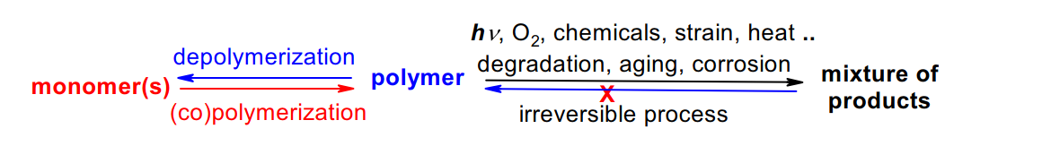

***Scheme 1: Relation among polymerization, depolymerization and degradation***

The term "polymer degradation" refers to a change in the polymer's tensile strength, color, form, and molecular weight caused by one or more environmental elements including heat, light, chemicals, or any other applied force. The molecular weight of the polymer decreases as a result of degradation, which is frequently brought on by changes in the chemical and/or physical structure of the polymer chain. These modifications could be undesired, like those that occur during use, or advantageous, like biodegradation or purposefully decreasing a polymer's molecular weight. These elements' impact on the chemical makeup of the polymer is the main cause of these modifications

One of the most difficult challenges to the long-term use of polymeric materials is polymer breakdown and aging. The inclusion of additives can significantly increase the stability of polymers and act as a stabilizer against aging,. By suppressing chemical changes and preventing changes to a polymer's physical qualities, such as cracking and a loss of surface gloss, the right additives can lengthen a polymer's useful life. Most crucially, during the service life of the stabilized polymer products, additives can control or prevent embrittlement and early failure.

Utilizing polymers in the environment presents another challenge: stabilization against light-induced deterioration. Depending on the mode of degradation, chemicals including radical traps, UV absorbers, optical quenchers, and acid scavengers are utilized to prevent this aging. A detailed discussion on the examination of polymers with additives and their impact on stability and characteristics polymer degradation can be obtained by different processes, for example, by thermo-oxidative, photo-oxidative treatment, or by hydrolytic, ultrasonic, radiological, and plasma chemical exposition of materials. Degradation strongly influences the stability and durability of polymer materials, which can have dramatic consequences in safety and reliability of products. The degradation predominantly results in the formation of products with lower molecular masses. These species are often characterized by end groups that indicate a specific degradation pathway. Therefore, MS is especially capable of investigating these processes. (Vimalathithan et al., 2018)

The application of these exceptional and adaptable materials is severely constrained by the degradation of polymers under typical use settings. All polymers eventually deteriorate in the environment to which they are exposed throughout their life cycle. Despite the fact that polymers differ significantly in their resistance to deterioration, all polymers eventually experience adverse effects as the chemical processes that cause degradation continue. Polymeric materials frequently degrade before achieving the requisite service life due to loss in mechanical strength, dielectric quality, and aesthetic attractiveness. Various different methods, depending on the structure and environmental factors, are used to breakdown polymers. Degradation is the result of an irreversible alteration that ultimately ends in failure. Although chemical interactions are the most frequent way that degradation occurs, there are a few significant instances of deterioration that solely happens as a result of physical changes. Instead of chemical processes, the latter form of degradation is caused by loss of polymer shape. Examples of physical degradation include the phenomena of environmental stress cracking and thermal embrittlement. Although less as thoroughly studied as chemical degradation, these alterations can they do lead to fast and total tailure when occur. determining the point of failure, the polymeric material's intended usage must be taken into consideration. Unacceptable changes in mechanical, electrical, or aesthetic qualities can cause polymers to fail. Since each of these properties is influenced by certain reactions occurring within polymer molecules, they typically change throughout aegradation at relatively different speeds. Reactions that either shrink molecules or cause polymer chains to cross-link to produce hard, three-dimensional structures change the mechanical characteristics.(Carswell-Pomerantz et al., 1999)

**1.3. DEPOLYMERIZATION**

Depolymerization occurs only if the system's Gibbs energy decreases, like any chemical process. If the polymer is created by polymerization without a side product and polymerization entropy sp < 0, it depolymerizes exclusively at temperatures above ceiling temperature Tc. Occasionally, such as in sulfur S8 polymerization, sp and hp both exceed 0, causing depolymerization below the floor temperature Tf - hp/sp (Penczek and Moad, 2008). The byproduct is engaged in the polymer-monomer(s) equilibrium and promotes depolymerization if introduced to polycondensation polymers like polyesterification and polyamidation even then, temperature matters. In a live polymerization system, each macromolecule possesses an active center end-group, allowing optimal chain depolymerization (radical, ionic). While the activation Gibbs energy of propagation and depropagation is low, such a system responds to temperature increases by gradually releasing monomer molecules from active ends of live chains until the polymer-monomer equilibrium is established. Unzipping is chain-end cleavage mode. Monomer molecules become macromolecules after temperature recovery. In a dilute aqueous solution, water-soluble polyester hydrolyzes to depolymerize virtually perfectly. In the random cleavage mode, each ester bond may be cleaved at the same moment (Vohlídal, 1994)

Since the creation of active centers requires a large activation Gibbs energy, polymers that do not include these centers are now stable at temperatures that are substantially higher than Tc. In terms of thermodynamics, it is unstable, but in terms of kinetics, it is stable. Yet, once active centers are generated inside the polymer—that is, following initiation—the polymer will begin to disintegrate. Radicals are the mostly active centers of degradation, and they may be formed in a polymer by thermal, photochemical, mechanochemical, or oxidation processes. Radicals can also be created mechanochemically. When describing the kind of polymer breakdown, it is common practice to use the starting type as an adjective. Polymers undergo chemical reactions at high temperatures without additional molecule. Thermal degradation of polymers is crucial for rational polymer manufacturing, employing polymers at higher temperatures, and understanding thermal breakdown processes for fire-safe polymeric products. Polymers degrade thermally in three ways. First, the primary chain breaks completely. Second-type fractures, volatile compounds, and char residues are unique. Third-type crosslinked polymers produce char and few volatiles. Degradation mechanisms have been used to prolong polymer lifetimes and increase the degradation rate of large-volume plastics like polyethylene, poly (vinyl chloride) (PVC), polyamides (PA), and polystyrene (PS) to address the growing problem of landfills filled with slowly degrading waste plastic products. Polymers may be processed at high temperatures, where thermal deterioration may change the material's characteristics more than in regular use. (Andersson et al., 2002)

1. **TYPES OF POLYMER DEGRADATION**
   1. **THERMAL DEGRADATION**

Thermal degradation may cause substantial damage to any polymeric material, but recycled polymers, which undergo repeated high and low temperatures, are more vulnerable. Shear-related thermal degradation occurs during polymer manufacturing. Hence, shear effects on thermal deterioration must be studied.

Controlling degradation requires understanding many phenomena, including the diverse chemical mechanisms underlying structural changes in macromolecules, the influence of polymer morphology, the complexities of oxidation chemistry, stabilizer additive reaction pathways, the interaction of fillers and other ingredients and impurities, and reaction–diffusion processes. Pure and industrial polymers vary greatly, which may affect macromolecular material heat breakdown. The lack of mass transport constraint owing to small particle diameter affects degradation in chemically pure powder poly (methyl methacrylate) (PMMA) compared to industrial-grade PMMA. With pure powdered PMMA, the differential thermal analysis (DTA) technique showed all chemical steps to be endothermic in both pure nitrogen and oxidative atmospheres, whereas industrial-grade PMMA, owing to its comparatively large particle diameter, is endothermic in pure nitrogen but exothermic in oxygen. Due to the tiny particle size of powdered PMMA, mass transport restriction did not control deterioration.(GOUIN, 2000)

Polymer material change is affected by numerous chemical reaction processes. Heat, chemicals, and temperature promote polymer degradation, which changes qualities including tensile strength and molecular weight. Polyethylene degrades into hydrocarbon derivatives at 450 °C. Polymer-based products may unintentionally lose their chemical structure and physical qualities. Hence, polymer processing, such as injection and molding, must be done under circumstances that enable the material to liquefy (by raising its temperature for thermoplastics) and minimizing deterioration.(Gałko and Sajdak, 2022)

Plastic may partly degrade if the injection temperature or duration is too high or lengthy. This decreases product quality and mechanical and aesthetic qualities. The results of burning of organic matter in plastic materials like PE (which only includes carbon and hydrogen atoms) are CO2, H2O, N2 (from the air), and perhaps gaseous contaminants from material contamination. Complex chemical interactions between fuel components (e.g., hydrocarbons) and the oxidant (e.g., oxygen in the air) create heat and (occasionally) light in the form of a flame. Figure 1 summarizes the combustion process, which produces energetic radicals in many chemical processes.(Farris et al., 2010)

Under nitrogen, organic compounds decompose around 400–800 °C. Waste plastics pyrolyze at polymer breakdown temperatures. Free radicals dominate waste polymer pyrolysis. It burns. Waste polymers like PET and catalytic polymerization utilize ionic processes. Figure 2 depicts free-radical initial stages. Polymer degradation begins, propagates, and ends .(McNeill et al., 1990)

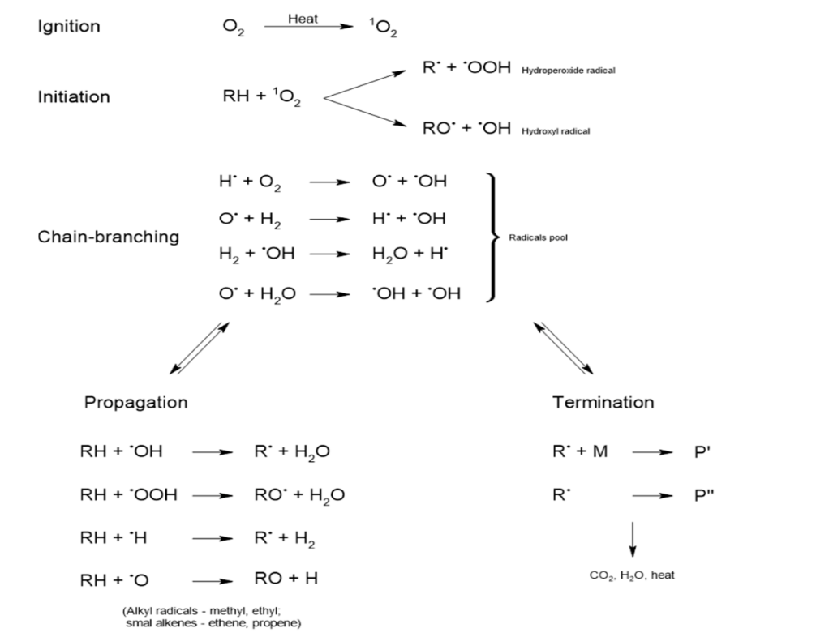

***Fig.1: Diagram indication of the combustion process***

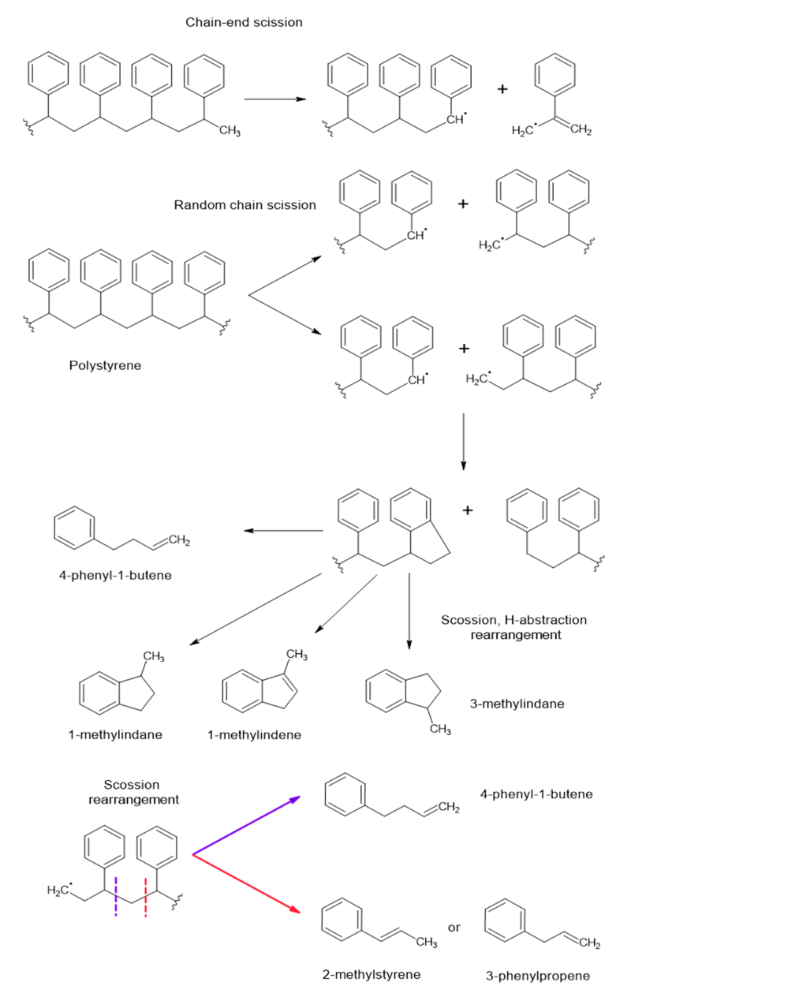

***Fig.2: Diagram indication of the free-radical reactions***

Polystyrene demonstrates. Start two methods. Terminal group scission follows random chain scission. Both situations create main and secondary transition state radicals. Hydrogen transfer and unzipping processes spread free radicals next. Table 1 demonstrates that Polystyrene pyrolysis temperature produces a diversity of products with different quantitative and qualitative components.(Salamah and Aktawan, 2018)

Following studies and computational research [64], Poly (ethylene terephthalate) PET thermal breakdown proceeds by cyclization, particularly an intramolecular (ionic) alcoholizing process between 250 and 300 °C.

Intramolecular exchange, an ionic process that forms cyclic oligomers, is PET's main thermal mechanism below 300 °C. Figure 3 (Buxbaum, 1968)

***Table 1. Thermal degradation reactions of polystyrene during pyrolysis***

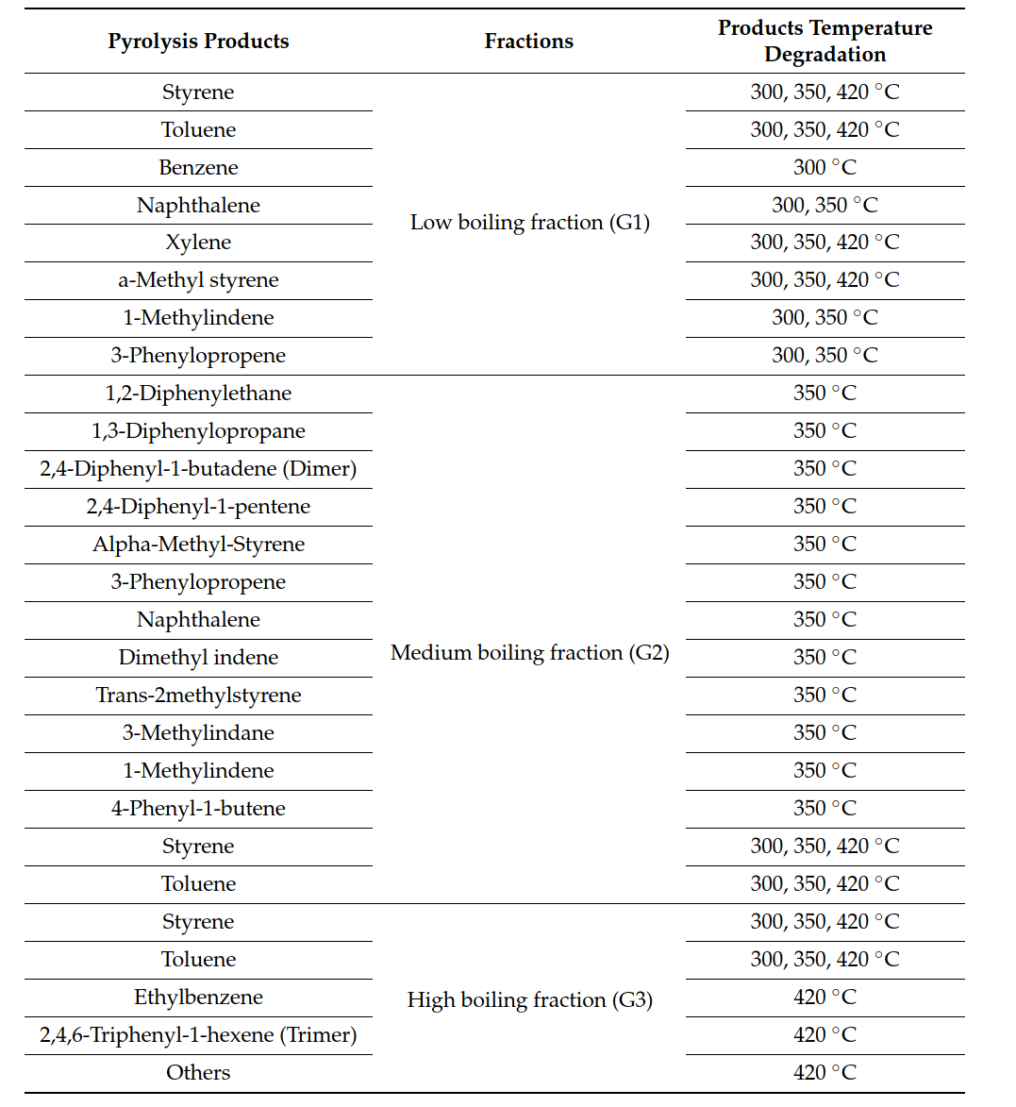

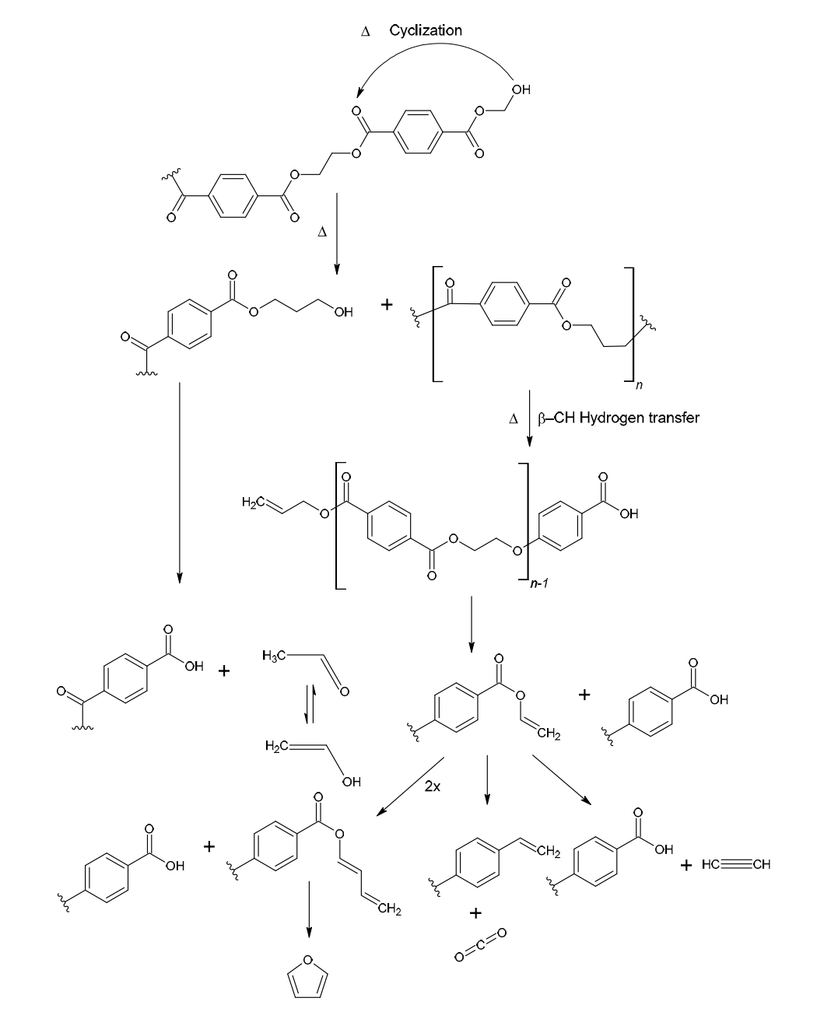

***Fig.3: Thermal degradation reactions of PET***

**2.2. OXIDATIVE DEGRADATION**

Several academics have studied polymer oxidative degradation for decades. Commercially important polymer breakdown mode. After reviewing the complex sequence of reactions producing oxidative degradation, recent advances in the oxidation of a few polymers will be examined. Oxygen irreversibly breaks polymers most often. Oxygen changes the molecular structure of all commercially relevant polymers. These techniques may modify critical mechanical, dielectric, or aesthetic characteristics beyond tolerance.

Singlet oxygen, ozone, and molecular oxygen may break polymers. Early oxidative degradation effects are often subtle. A small percentage of bulk molecules undergo random chemical changes. Since initial reactions are infrequent, even the most sensitive analytical methods cannot detect them. Throughout normal service life, these early reactive sites oxidize more, causing considerable changes. So, understanding all oxidation points in a polymer's life cycle is essential. Producing sensitive polymers may cause oxidative degradation.

If unprotected, sensitive polymers oxidize slowly at ambient temperature. Thermoformed polymers oxidize. Extruders and injection molding machines have enough oxygen to start deteriorating. Fabrication usually occurs above the polymer's Tm, thus oxidation starting sites may form. Certain processes exclude oxygen, yet (Hawkins, 1984)

Oxidative degradation happens when oxygen is present. Hydrogen peroxide may oxidatively degrade polymers (the body's physiological milieu or the environment may initiate this process). Oxidation causes stress cracking. Degradation of the polymer's surface causes chemical changes under oxidizing conditions in vivo or in vitro. Polyether urethane elastomers with oxidative aliphatic stress fracture.

Polymers age due to unwanted surface change induced by oxidative breakdown. Oxygen affects polymers largely on their surfaces as they are usually exposed to air. Temperature, humidity, and light affect this oxidation. Oxidation yellows and brittles most polymers. Air oxidizes unsaturated polyolefins. Oxidation produces peroxide, which promotes chain scission and perhaps free radicals. Hydroperoxides are produced by autocatalytic oxidative destruction of hydrogen atoms. Hence, polymer stability is inversely linked to the number of hydrogen atoms in the polymer chain together with the carbon atoms. Copper accelerates disintegration. Hydrogen-donating compounds like hindered phenols or peroxide decomposers may prevent degradation. Combining stabilizer kinds seems synergistic. Microcrystalline wax can protect elastomers against ozone. Phenol p-phenylenediamene derivatives improve stability. Polymers age due to unwanted surface change induced by oxidative breakdown. Oxygen affects polymers largely on their surfaces as they are usually exposed to air. Temperature, humidity, and light affect this oxidation. Oxidation yellows and brittles most polymers. Air oxidizes unsaturated polyolefins. Oxidation produces peroxide, which promotes chain scission and free radicals. Chain length decrease degrades mechanical properties. Air exposure shortens chain length, and surface oxidation creates additional polar groups. The solid polymer's gas permeability controls this modest bulk change.(Sainsbury, 1964)

Autoxidation of polymer was first studied in natural rubber aging. Hoffmann discovered the oxygen-aging relationship. Autoxidation was modeled as a free radical-initiated chain reaction because hydrocarbon molecules interacted with molecular oxygen to create oxidation products. After a brief induction time, the reaction accelerates as the hydroperoxides concentrate. The free radical-initiated chain reaction of autoxidation, like other radical reactions, has three steps: chain initiation, propagation, and termination. Thermodynamic and kinetic factors discourage bimolecular reactivity of hydrocarbons with molecular oxygen. In polymerization, adventitious catalysts including transition metals, radical initiators, monomer impurities, and minute quantities of oxygen react to create peroxy radicals ROO· that extract hydrogen from the polymer and form an alkyl radical. Polymer cannot be "purest" technically. Impurities and structural flaws are possible. Extrusion, blow molding, and injection molding produce extra peroxide radicals by reacting molecular oxygen with heat and mechanical shear. Figure 4 (Arnaud et al., 1994)

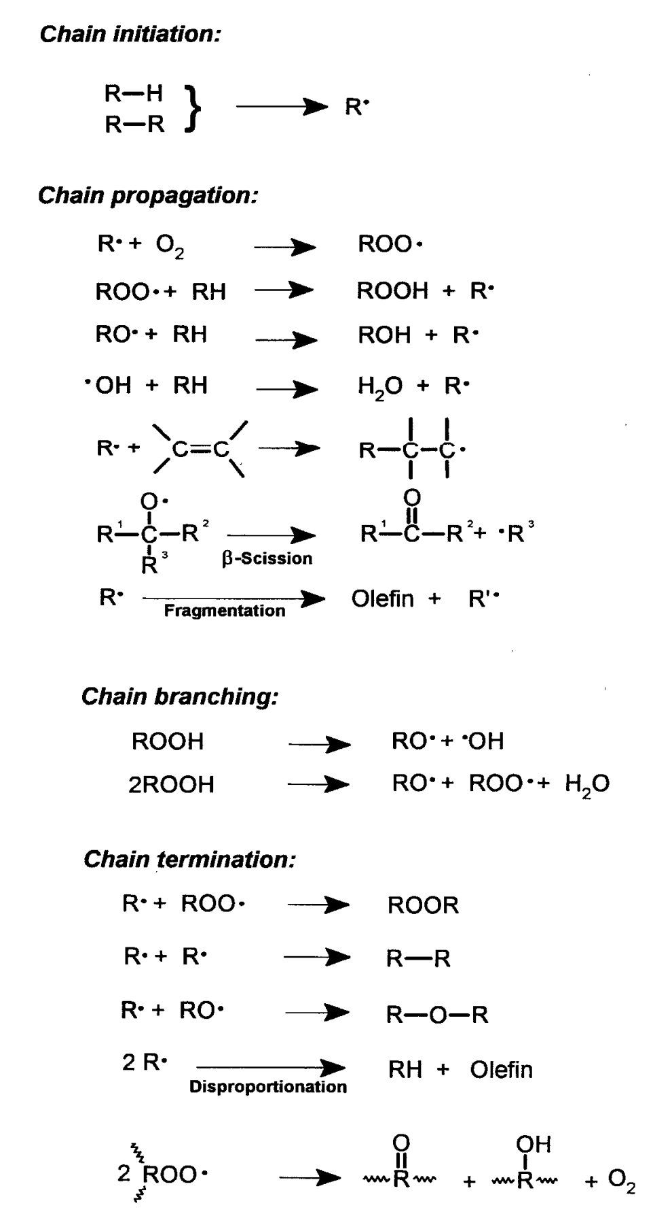

***Fig.4: General illustration of autoxidation. R stands for the polymer backbone***

**2.3. PHOTO DEGRADATION**

Photodegradation (chain scission and/or crosslinking) is caused by polymer macromolecule activation by light absorption. In photoinitiated degradation, photo initiators absorb light and photocleave into free radicals, which further degrade polymer macromolecules in non-photochemical processes. Photo-thermal degradation involves simultaneous photodegradation and thermal deterioration. One might accelerate the other. Solar UV light, air, and contaminants start photoaging, whereas water, organic solvents, temperature, and mechanical stress accelerate it. Many review papers have covered photo degradation's general characteristics, including light absorption, photophysical and photochemical reactions, kinetics, oxidized group production, etc.

Photophysical processes in photodegradation and photoinitiated deterioration include:

1. Electronically stimulated singlet (S) state absorption.

2. Radiationless transition (intersystem crossover, ISC), forming the electrically excited triplet (T) state.

3. Excited singlet (S) and triplet (T) states create free radicals.

4. Energy transfer between excited D and A molecules.(Rabek, 2012)

Photochemical reactions caused by polymer backbone carbonyl groups absorbing UV radiation cause photodegradation. Norrish reactions that photoionize and chain scission polymers are the principal photodegradation processes (Norrish II). Photodegradation may cause Norrish, crosslinking, or oxidative reactions .(Lucas et al., 2008)

As demonstrated in Figure 5 , Poly(lactic acid) and Poly(ε-caprolactone) photodegrade by Norrish type photo-cleavage, especially the Norrish II type reaction, which causes chain scission (reduction in molecular weight), C=C double bonds, and hydroperoxide O–H at newly generated chain terminals .(Tsuji et al., 2006)

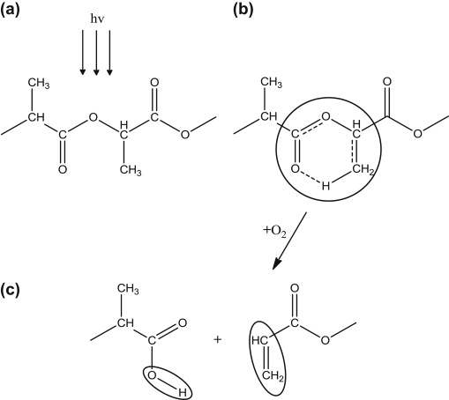

***Fig.5: Norrish II photodegradation mechanism of poly (lactic acid)***

Sakai et al. postulated further photodegradation methods that included dissociation at the RCOO–R′ bond and dehydrogenation of α-hydrogen on an asymmetric carbon . Yasuda et al. presented Scheme 2.4 as a photodegradation process (Yasuda et al., 2010). Since acrylic acid was undetected, this method overlooked the Norrish II type reaction. Alternatively, it was hypothesized that an RCOO–R′ bond is broken to create carbonyl and alkyl radicals, which abstract a tertiary proton on chiral carbon, resulting in a racemization equilibrium at the carbonyl chain end unit. Irradiation-accelerated hydrolysis must favor the hydroxyl group at another chain end.

Like l-lactic acid, the hydroxyl chain end unit is reactive and mobile, causing a racemization equilibrium under irradiation. Racemization equilibrium turns l-lactate units at both chain ends into d,l-lactate units, making the d-unit formation ratio statistically near to the chain scission ratio.

When exposed to sun light, poly (butylene adipate-co-terephthalate) (PBAT) or Ecoflex® (BASF AG) biodegradable mulch films degrade by crosslinking and chain scission processes (Kijchavengkul et al., 2008). Figure 6

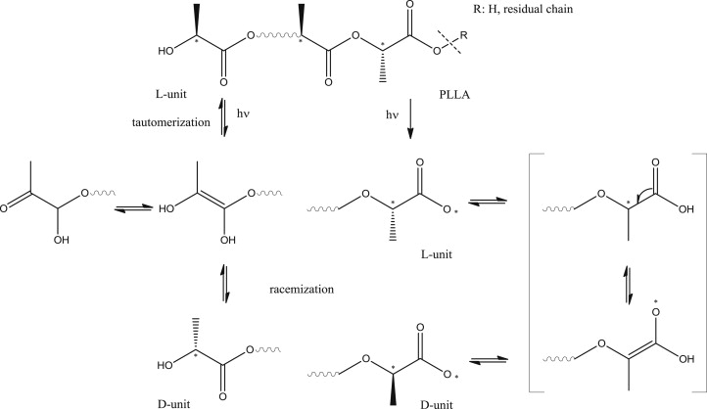

***Fig.6: Possible photodegradation mechanisms of poly(l-lactide) (PLLA) under UV***

**2.4. BIODEGRADATION OF POLYMER**

Biodegradable synthetic polymers are superior for tissue engineering scaffolds. Benefits include the ability to change mechanical properties and degradation kinetics for varied applications. Synthetic polymers may be formed into various shapes with pore morphologic features that encourage tissue in-growth, making them desirable. Polymers may also comprise chemical functional groups that encourage tissue in-growth. Clinical applications have used biodegradable synthetic polymers including trim ethylene carbonate and glycoside copolymers, poly (glycolic acid), poly (lactic acid), and their copolymers. Applications include medication delivery systems, resorbable sutures, and orthopedic fixation devices including pins, rods, and screws. Due to the simplicity with which ester linkage may be hydrolyzed, the ability of modifying degradation rates via structure, and the possibility of resorption of breakdown products through metabolic pathways, polyesters are especially promising for these applications. Tissue engineering uses polyesters too. Tissue-engineered orthopedic therapies need innovative polymers that meet tight standards. Requirements. From mechanical support during tissue development and decay to biocompatible goods, scaffolds must be able to absorb cells, growth hormones, and provide osteoconductive and osteoinductive environments. In tissue engineering, in-situ polymerizable compositions that may deliver cells as injectable liquids or pastes are becoming popular. Several degradable polymers on the market do not match all of these characteristics, and therefore must be chemically altered to be used in particular applications.(Gunatillake et al., 2003)

Synthetic polymers are important in packaging. Yet, waste deposition and use difficulties harm the ecosystem. Hence, biodegradable polymers are preferred. Starch-based polymers are gaining popularity. Global research is focused on biodegradable polymers as an environmental waste management option. Biodegradation occurs when microorganisms including bacteria, fungus, and algae interact with polymers. "A degradable polymer whereby the predominant breakdown mechanism is via the action of metabolism by microorganisms" is the most common definition of biodegradable polymers. Biodegradation is biological decay. Most environmental chemicals will biodegrade.

Live microbes degrade polymers by eating them. Biodegradation relies on fungi, bacteria, and algae. Oxidation and hydrolysis break down proteins, polysaccharides, and nucleic acids. Biodegradable materials produce biomass, carbon dioxide, and methane. Microbes must employ their carbon backbone for synthetic polymers. Bacillus is essential to biodegradation (capable of producing thick-walled endospores that are extremely resistant to heat, radiation, and chemical disinfection), Pseudomonas, Klebsiella, Actinomycetes, Nocardia, Streptomyces, Thermoactinomycetes, Micromonospora, Mycobacterium, Rhodococcus, Flavobacterium, Com One degrees are present .(Leja and Lewandowicz, 2010)

Microorganisms living on the biopolymer surface release enzymes that break it down into oligo- or monomeric components like hydroxy acids. Aliphatic polyester microorganisms employ hydroxy acids as carbon sources. Biopolymers breakdown to carbon dioxide and water in aerobic environments and methane (biogas) in anaerobic environments.

Figure 7 shows that a little amount of biopolymer organic component is transformed to biomass. Biopolymers produce 10–40 wt% biomass. Intermediates/residues are nondegraded carbon compounds or intermediate degradation products.

Depending on the polymer, biodegradation takes days, months, or years cell biomass and other intermediates will mineralize to CO2 over time. The polymer degrades via many methods. Biodegradation include disintegration, dispersion, dissolution, erosion, hydrolysis, and enzymatic degradation. Most microbial processes are sequential, so one organism's metabolic product becomes another's substrate. Polymers are impacted by biodegradation. Mechanical damage from growing cells, direct enzymatic effects that break down the polymer structure, and secondary biochemical effects from excretion of substances other than enzymes that may directly affect the polymer or change environmental conditions like pH or redox conditions can all affect polymers (Vasile, 2009).

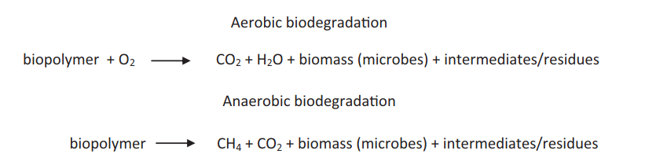

***Fig.7: Diagram illustration of aerobic and anaerobic biodegradation reactions***

**2.5. MECHANICAL DEGRADATION**

Processing, storage, and usage may mechanically degrade biopolymer products. Shear, stress, and compression may degrade materials. Processing mechanical deterioration is caused by agitation, grinding, and extrusion. The molecule breaks when the polymer is sheared extremely hard. Polymer molecular weight decreases mechanically. organisms (aerobic, anaerobic biodegradation). Mechanical variables might promote biodegradation. Mechanical stresses work with temperature, UV, and humidity in the field (Briassoulis, 2007).

**2.6. CHEMICAL POLYMER DEGRADATION**

Most polymer activities break double bonds. Degradation caused by chemical reactions between the polymer and its environment. Several chemical processes degrade polymers by breaking double bonds. Polymer chemical degradation includes thermal and oxidative breakdown.

Solvolysis: under solvent action

Oxidation: oxygen-induced

Ozone-induced ozonolysis

Chemical deterioration starts with solvolysis. It breaks C-X bonds with non-carbon atoms, usually O, N, P, S, Si, or halogens. Water, alcohols, ammonia, lubricants, acids, alkalis, halogens, and other solvents disrupt the polymer's primary chain. The breakdown product of solvolysis is water. Water-soluble polymers hydrolyze quickly, but water-insoluble polymers degrade only on the specimen.

Solvolysis and hydrolysis breakdown step-growth polymers like polyesters, polyamides, and polycarbonates into lower molecular weight molecules. Water with an acid or base catalyst hydrolyzes. Strong acids break polyamide moldings.

• A gasoline connector's fracture surface demonstrated the crack's progression from acid assault (Ch) to the ultimate polymer cusp (C). The polymer hydrolysis generated stress corrosion cracking. It reversed polymer synthesis (Mahdi, 2021):

  
**3. ASSESSING PLASTICS DEGRADATION METHODS**

Methods for analyzing plastics degradation include those that measure small molecule removal, chemical changes (hydrophobicity, functional groups) in the polymer structure, and physical changes in materials qualities (tensile strength, surface morphology, crystallinity, etc.).

**3.1. BOND CLEAVAGE**

Mass loss. Mass changes are the easiest approach to measure polymer breakdown. Degradation in soil, compost, and microbially enriched labs is measured by mass loss. Degradation occurs at the surface; hence mass loss is proportional to the plastic piece's surface area. Gel-Permeation Chromatography (GPC). Size exclusion shows molecular weight variations in polymer breakdown (Yabannavar and Bartha, 1994).

**3.2. ASSESSING CHANGES IN CHEMICAL FUNCTIONALITY**

Chemical Analysis. Nuclear magnetic resonance (NMR) and infrared (IR) spectroscopies can readily detect the presence and concentration of certain functional groups in polymers (Rouillon et al., 2016)

**3.3. MATERIAL PROPERTY CHANGES (DYNAMIC MECHANICAL ANALYSIS DMA)**

This method commonly characterizes polymer strength. Tensile strength and elongation at break also indicate physical degradation during polymer breakdown. These mechanical qualities cause surface fractures and holes and lower molecular weight (Li et al., 2017).

Thermal analysis, this approach includes slowly heating or cooling a sample and measuring its physical properties. DSC measures Cp, Tm, and Gt (Tg). Since shorter chains are more mobile, polymer breakdown decreases Tg. TGA measures heat-induced mass changes. This approach and product analysis may reveal heat degrading breakdown, such as oxidation or volatile loss (Rouillon et al., 2016).

**4. ENVIRONMENTAL IMPACT OF POLYMER DEGRADATION**

Polymer or plastic contamination in the ocean has many harmful repercussions. Plastic waste harms numerous animals. Most species' principal plastic hazards are entanglement and ingestion (Derraik, 2002) ]. Plastic waste may entangle juvenile animals, preventing them from eating and breathing. Plastic litter harms marine birds , sea turtles, cetaceans , fur seals, sharks , and filter feeders (Moore et al., 2001). Sea birds are more likely to eat plastic [5,6]. Changes in these animals' digestive systems may diminish eating stimulation, gastrointestinal obstruction, stomach enzyme release, and steroid hormone levels, causing reproductive issues (Azzarello and Van Vleet, 1987).

Oceanic plastic trash has continuously included toxic substances such polychlorinated biphenyls (PCBs), nonylphenol (NP), organic pesticides like dichlorodiphenyltrichloroethane (DDT), polycyclic aromatic hydrocarbons (PAHs), polybrominated diphenyl ethers (PBDEs), and bisphenol A (BPA) . These substances enhance the dangers of animals eating plastic litter, and many may bio magnify and constitute a direct health risk(Hirai et al., 2011).

These hazardous chemicals may cause developmental damage (neurological impairment, growth abnormalities, and hormonal imbalances), cancer, endocrine disruption, neurobehavioral alterations, arthritis, breast cancer, diabetes, and DNA hypomethylation (Zhou et al., 2011).

Plastic waste also helps invasive and dangerous animals move. Several marine species colonize and disperse on plastic waste, including barnacles, bryozoans, polychaetes, dinoflagellates, algae, and molluscs. Marine debris may also transport terrestrial creatures. Ants have been seen riding debris from the Brazilian mainland to San Sebastian Island, many km distant, while iguanas have ridden flotsam to new Caribbean islands (Censky et al., 1998).

Most studies of marine plastic contamination measure beach debris. Plastics float, therefore they collect on beaches. Plastic makes about three quarters of the beach litter investigated. Because of plastic's availability and persistence, the environment has significant quantities of plastic debris (do Sul and Costa, 2007).

Plastic particles recovered in purpose-built trawl nets exceeded zooplankton levels in the North Pacific's neustonic layer. Zooplankton outnumbered plastic five to one, while plastic overpowered it six-fold. Several studies found comparable plastic pollution: From the Southern Ocean to the high Arctic, an Atlantic Ocean expedition characterized all floating marine debris, including kelp. Plastic was found in every 10° latitudinal strip and accounted for 92% of trash in one sample. A 22-year study of Atlantic plastic litter indicated that 62% of net tows had plastic particles big enough to be identified, with some places having more than 20,000 pieces km−2 . The North Pacific subtropical gyre comprises 335,000 plastic pieces km−2 (5.1 kg km−2) (Ryan et al., 2009).

Widely used polymers seldom breakdown spontaneously. Because of their stability and longevity, several polymers are popular and widely used. Photodegradation, thermooxidative degradation, hydrolytic degradation, and microorganism-mediated biodegradation destroy plastics. Photodegradation leads to thermooxidative deterioration of plastic. UV sunlight activates the polymer's oxygen atom incorporation. This makes the plastic brittle and split into smaller pieces until the polymer chains are short enough for microorganisms to metabolize. These microorganisms transform polymer chain carbon into carbon dioxide or biomolecules (Andrady, 2011).

Plastic degrades slowly, taking 50 years or more. The lower temperature and oxygen availability in saltwater reduce the photodegradative impact, and most polymers hydrolyze slowly in the ocean (Müller et al., 2001).

**4.1. BIODEGRADATION**

Bacteria can clean up pollutants due to their metabolic diversity. Bacteria clean up oil spills, PCBs, and heavy metals as arsenic, mercury, cadmium, and lead. Examples demonstrate that microorganisms can use most chemicals for metabolic activity. Biodegradation may be cheaper, more efficient, and less polluting than incineration and landfill(Pieper and Reineke, 2000). Bacterial metabolism of contaminants may produce valuable compounds like ethanol for biofuels. Hydrocarbon bioremediation, like crude oil, is challenging. Bacteria prefer water-soluble nutrients. Hydrocarbons lack nitrogen, potassium, and phosphorus. Fertilizer or ammonium sulphate may help bacteria degrade hydrocarbons. Hydrocarbons accumulate in cell membranes and damage the phospholipid bilayer; however certain bacteria may withstand organic solvents. Zheng et al (Zheng et al., 2005) found that polymers with pure carbon backbones withstand most degradation techniques, whereas heteroatom-containing polymers (e.g., polyesters, polyamines) are more susceptible. Although having hydrolysable linkages, aromatic polymers are resistant to degradation. PET is a famous example of such a polymer; its ester bonds may ordinarily be broken by a variety of processes, but its aromatic groups make it basically non-degradable under normal circumstances.

Microbial communities may use diethylene glycol terephthalate (DTP), a PET component, as a single carbon and energy source. PET polymer is stable and durable. Being polymeric may explain the extraordinary stability. Many investigations have linked plastic degradability to polymer crystallization (Asakuma et al., 2009).

Crystallization reduces chain mobility and polymer chain availability for degradative agents like microbial lipases or ester lysing molecules (Figure 3). Lipase-catalyzed breakdown of poly(hydroxybutyrate-co-valerate) (PHBV) preferentially exposes polymer crystals in amorphous areas. Modifications of PET to diminish intermolecular cohesion have increased its biodegradability (Rwei et al., 2012), but this technique requires a tradeoff between optimal biodegradability and the mechanical and chemical stability that makes PET so popular.

Biodegradable polymers may be made by adding degradability to ordinary plastics without affecting their qualities. Post-polymerization procedures and copolymerization with comparable functionalized monomers have created polymers containing functional groups on the polymer chains. This allows more microbial enzymes to attack polymer chains. Biodegradation of these polymers is still restricted, and energy input is needed, particularly for post-polymerization treated materials. Block copolymers of ordinary plastics with hydrolysable polymeric components degrade faster. Starch, lactic acid, ethylene glycol, and caprolactone are typical. However, these polymers are less durable than many traditional plastics, and it is sometimes unclear whether they biodegrade or merely disintegrate into little bits.(Asakuma et al., 2009)

Polymers made from starch, lactic acid, caprolactone, proteins, cellulose acetate, and other polysaccharides have increased mechanical durability by adding plasticizers or nanoparticles or by carefully managing manufacturing conditions. Poly(hydroxyalkanoates) are important biopolymers (PHAs). Several bacteria and archaea create polymeric PHAs, which may be processed into packaging, coatings, and medicinal uses. Figure 4 shows PHA structure. Due to high manufacturing costs and a lack of high-value applications, PHAs are manufactured commercially by bacterial fermentation. By using cheaper food stocks for bacteria to metabolize, PHAs may be made from waste products including whey, wheat and rice bran, molasses, vegetable oil, and even carbon dioxide. Nevertheless, the extraction process for polymer recovery is still the most expensive. Solvent extraction, chemical digestion, enzymatic treatment, mechanical disruption, supercritical fluid disruption, flotation, gamma irradiation, and two-phase systems are all extraction procedures, but none are cheap enough to enable PHAs to compete with traditional plastics (Chen, 2009, Akaraonye et al., 2010, Kunasundari and Sudesh, 2011).

**5.DISCUSSION**

Chemical composition changes reduce polymer strength and other physical qualities.Polymers, especially plastics, degrade over their product life cycle. Biodegradation takes decades, but commercial techniques may degrade a polymer in hours (Singh and Sharma, 2008)

Polymer degradation occurs when environmental elements including heat, light, chemicals, or applied force affect the polymer's characteristics, such as tensile strength, color, form, and molecular weight. The chemical and/or physical structure of the polymer chain changes during degradation, lowering its molecular weight. Changes during usage, biodegradation, or polymer molecular weight reduction might be good or bad.

These influences modify polymer chemical composition, which causes these modifications. Structure determines polymer breakdown. Epoxies and aromatic chains are particularly vulnerable to UV breakdown, whereas hydrocarbon-based polymers are thermally degradable and not appropriate for high temperature applications . Heat, light, air, and water degrade plastic polymers most. Chain scission and oxidation reduce the polymer's molecular weight and polymerization. These modifications influence strength, malleability, melt flow index, appearance, and color. "Aging" describes property changes (Hamid, 2000).

Polymers degrade under various conditions: 1) Thermal oxidation, thermal deterioration, and thermo-mechanical degradation during processing 2) Chlorine-induced cracking, 3) Environmental degradation, such as photooxidation, hydrolysis, ozonolysis of rubbers, and biological degradation, and 4) Degradation through recycling, remelting, thermal depolymerization & pyrolysis, and chemical depolymerization.

Nowadays, polymer breakdown is most important. It endangers human and environmental health. PP, PVC, PVA, and low- and high-density PE are popular polymers that are hard to breakdown. Research uses gravimetric and respirometry methods. They respond well to biodegradable polymers. They're perfect for biodegradable polymer mix components.

Recent polymers are biodegradation-resistant and cannot be utilized in this purpose. The information on different methodologies suggested the greatest match for persons interested in analyzing polymer degradation under various environmental circumstances and choosing an appropriate methodology for a particular mix of polymer and catalysts that helps polymeric breakdown. Polymer degradation measurement methods include (Obasi et al., 2013, Al-Mutairi and Mousa, 2021):

1. Weight change

2. Thermodynamics (TGA, DSC)

3. Mechanical Thermal Analysis (DMTA)

4. Molecular mass change (GPC)

5. FTIR and NMR

6. SEM/AFM structural changes

7. Viscosity-based rheological properties

**6. CONCLUSION**

Degradation is the big problem of polymer and plastic technology during preparation, production, end using as well as in recycling process. Today Plastic trash is produced at a rate of 400 metric tons per year, of which 175 metric tons are sent to landfills and the natural environment. The quantity of plastic waste that is dumped in landfills and released into the environment is adequate. In order to reconstruct the portion of the Great Wall of China that is still intact and has a length of 6000 km187 per year. In spite of the enormous scale involved, there is a disproportionately little amount of published research on the breakdown of plastics under environmental settings. For the items listed below, the literature has published only a limited amount of information:

How soon do plastics break down when exposed to the elements? Which paths lead to deterioration are there? What aspects of the environment cause the processes of deterioration to occur? What are the byproducts of the deterioration process?

When compared, the various values found in the available literature on the breakdown rates of plastics reveal a broad variation.

Additive materials also cause many problems for the environment, because these materials are added for the purpose of resisting degradation and increasing physical, chemical, and mechanical property, and most of these materials cause air and water pollution, in addition to major health damages.

Plastic accumulation, especially in seas, is a growing environmental issue. PET, used in textiles and food packaging, is a substantial component of plastic trash. PET accumulates and absorbs organic contaminants, harms marine creatures, and spreads potentially invasive species to new settings due to its resistance to environmental biodegradation. Landfill, incineration, and recycling are the only large-scale plastic disposal techniques. Each method has downsides. Both landfill and incineration generate harmful secondary pollutants, and landfill requires a lot of land. Recycling reduces landfill and incineration's environmental impact, but it's inefficient and produces low-quality polymers. The procedure is less cost-effective, which reduces recycling facility investment. Biodegradation of plastic trash is a green and effective solution. With microorganisms' immense metabolic capability, it is believed that effective PET biodegradation techniques will be developed soon.

**7. REFERENCES**

AKARAONYE, E., KESHAVARZ, T. & ROY, I. 2010. Production of polyhydroxyalkanoates: the future green materials of choice. *Journal of Chemical Technology & Biotechnology,* 85**,** 732-743.

AL-MUTAIRI, N. H. & MOUSA, Z. O. 2021. Some methodes for measurements of polymer degradation: A review. *Journal of University of Babylon for Engineering Sciences,* 29**,** 99-114.

ALEMÁN, J., CHADWICK, A. V., HE, J., HESS, M., HORIE, K., JONES, R. G., KRATOCHVÍL, P., MEISEL, I., MITA, I. & MOAD, G. 2007. Definitions of terms relating to the structure and processing of sols, gels, networks, and inorganic-organic hybrid materials (IUPAC Recommendations 2007). *Pure and Applied Chemistry,* 79**,** 1801-1829.

ANDERSSON, T., WESSLÉN, B. & SANDSTRÖM, J. 2002. Degradation of low density polyethylene during extrusion. I. Volatile compounds in smoke from extruded films. *Journal of applied polymer science,* 86**,** 1580-1586.

ANDRADY, A. 2011. Microplastics in the marine environment. Mar Pollute Bull 62 (8): 1596–1605.

ARNAUD, R., DABIN, P., LEMAIRE, J., AL-MALAIKA, S., CHOHAN, S., COKER, M., SCOTT, G., FAUVE, A. & MAAROUFI, A. 1994. Photooxidation and biodegradation of commercial photodegradable polyethylenes. *Polymer degradation and Stability,* 46**,** 211-224.

ASAKUMA, Y., NAKAGAWA, K., MAEDA, K. & FUKUI, K. 2009. Theoretical study of the transesterification reaction of polyethylene terephthalate under basic conditions. *Polymer degradation and stability,* 94**,** 240-245.

AZZARELLO, M. Y. & VAN VLEET, E. S. 1987. Marine birds and plastic pollution. *Marine Ecology Progress Series,* 37**,** 295-303.

BRIASSOULIS, D. 2007. Analysis of the mechanical and degradation performances of optimised agricultural biodegradable films. *Polymer Degradation and Stability,* 92**,** 1115-1132.

BUXBAUM, L. 1968. The degradation of poly (ethylene terephthalate). *Angewandte Chemie International Edition in English,* 7**,** 182-190.

CARSWELL-POMERANTZ, T., BABANALBANDI, A., DONG, L., HILL, D., PERERA, M., POMERY, P., SAADAT, G. & WHITTAKER, A. 1999. Stability and Stabilization of Polymers under Irradiation. *IAEA: Vienna, Austria***,** 111.

CENSKY, E. J., HODGE, K. & DUDLEY, J. 1998. Over-water dispersal of lizards due to hurricanes. *Nature,* 395**,** 556-556.

CHANDA, M. 2006. *Introduction to polymer science and chemistry: a problem-solving approach*, CRC Press.

CHEN, G.-Q. 2009. A microbial polyhydroxyalkanoates (PHA) based bio-and materials industry. *Chemical society reviews,* 38**,** 2434-2446.

DERRAIK, J. G. 2002. The pollution of the marine environment by plastic debris: a review. *Marine pollution bulletin,* 44**,** 842-852.

DO SUL, J. A. I. & COSTA, M. F. 2007. Marine debris review for Latin America and the wider Caribbean region: from the 1970s until now, and where do we go from here? *Marine Pollution Bulletin,* 54**,** 1087-1104.

EMANUEL, N. N. M. & BUCHACHENKO, A. L. 1987. *Chemical physics of polymer degradation and stabilization*, VSP.

FARRIS, S., POZZOLI, S., BIAGIONI, P., DUÓ, L., MANCINELLI, S. & PIERGIOVANNI, L. 2010. The fundamentals of flame treatment for the surface activation of polyolefin polymers–A review. *Polymer,* 51**,** 3591-3605.

GAŁKO, G. & SAJDAK, M. 2022. Trends for the Thermal Degradation of Polymeric Materials: Analysis of Available Techniques, Issues, and Opportunities. *Applied Sciences,* 12**,** 9138.

GOUIN, F. 2000. Quand la température est le challenge. *Plastiques & élastomères magazine,* 52**,** 33-38.

GUNATILLAKE, P. A., ADHIKARI, R. & GADEGAARD, N. 2003. Biodegradable synthetic polymers for tissue engineering. *Eur Cell Mater,* 5**,** 1-16.

HAMID, S. H. 2000. *Handbook of polymer degradation*, CRC Press.

HAWKINS, W. L. 1984. Stabilization against degradation by radiation. *Polymer degradation and stabilization.* Springer.

HIRAI, H., TAKADA, H., OGATA, Y., YAMASHITA, R., MIZUKAWA, K., SAHA, M., KWAN, C., MOORE, C., GRAY, H. & LAURSEN, D. 2011. Organic micropollutants in marine plastics debris from the open ocean and remote and urban beaches. *Marine pollution bulletin,* 62**,** 1683-1692.

JELLINEK, H. H. G. 1977. *Aspects of degradation and stabilization of polymers*, Elsevier Scientific Pub. Co.

KIJCHAVENGKUL, T., AURAS, R., RUBINO, M., NGOUAJIO, M. & FERNANDEZ, R. T. 2008. Assessment of aliphatic–aromatic copolyester biodegradable mulch films. Part I: Field study. *Chemosphere,* 71**,** 942-953.

KUNASUNDARI, B. & SUDESH, K. 2011. Isolation and recovery of microbial polyhydroxyalkanoates. *Express Polymer Letters,* 5.

LEJA, K. & LEWANDOWICZ, G. 2010. Polymer biodegradation and biodegradable polymers-a review. *Polish Journal of Environmental Studies,* 19.

LI, Y., CHU, Z., LI, X., DING, X., GUO, M., ZHAO, H., YAO, J., WANG, L., CAI, Q. & FAN, Y. 2017. The effect of mechanical loads on the degradation of aliphatic biodegradable polyesters. *Regenerative Biomaterials,* 4**,** 179-190.

LUCAS, N., BIENAIME, C., BELLOY, C., QUENEUDEC, M., SILVESTRE, F. & NAVA-SAUCEDO, J.-E. 2008. Polymer biodegradation: Mechanisms and estimation techniques–A review. *Chemosphere,* 73**,** 429-442.

MAHDI, F. A. A. 2021. *Chemical Degradation of Polymer.* Babylon University.

MCNEILL, I., ZULFIQAR, M. & KOUSAR, T. 1990. A detailed investigation of the products of the thermal degradation of polystyrene. *Polymer degradation and stability,* 28**,** 131-151.

MOORE, C. J., MOORE, S. L., LEECASTER, M. K. & WEISBERG, S. B. 2001. A comparison of plastic and plankton in the North Pacific central gyre. *Marine pollution bulletin,* 42**,** 1297-1300.

MÜLLER, R.-J., KLEEBERG, I. & DECKWER, W.-D. 2001. Biodegradation of polyesters containing aromatic constituents. *Journal of biotechnology,* 86**,** 87-95.

OBASI, H., ONUOHA, F., EZE, I., NWANONENYI, S., ARUKALAM, I. & UZOMA, P. 2013. Effect of soil burial on properties of polypropylene (pp)/plasticized potato starch (pps) blends. *The International Journal Of Engineering And Science (IJES),* 2**,** 14-18.

PENCZEK, S. & MOAD, G. 2008. Glossary of terms related to kinetics, thermodynamics, and mechanisms of polymerization (IUPAC Recommendations 2008). *Pure and Applied Chemistry,* 80**,** 2163-2193.

PIEPER, D. H. & REINEKE, W. 2000. Engineering bacteria for bioremediation. *Current opinion in biotechnology,* 11**,** 262-270.

RABEK, J. F. 2012. *Polymer photodegradation: mechanisms and experimental methods*, Springer Science & Business Media.

ROUILLON, C., BUSSIERE, P.-O., DESNOUX, E., COLLIN, S., VIAL, C., THERIAS, S. & GARDETTE, J.-L. 2016. Is carbonyl index a quantitative probe to monitor polypropylene photodegradation? *Polymer degradation and stability,* 128**,** 200-208.

RWEI, S.-P., LIN, W.-P. & WANG, J.-F. 2012. Synthesis and characterization of biodegradable and weather-durable PET/PEG/NDC copolymers. *Colloid and Polymer Science,* 290**,** 1381-1392.

RYAN, P. G., MOORE, C. J., VAN FRANEKER, J. A. & MOLONEY, C. L. 2009. Monitoring the abundance of plastic debris in the marine environment. *Philosophical Transactions of the Royal Society B: Biological Sciences,* 364**,** 1999-2012.

SAINSBURY, M. 1964. Five-Membered Heterocyclic Compounds with Two Different Hetero-Atoms in the Ring. *Rodd's Chemistry of Carbon Compounds.* Elsevier.

SALAMAH, S. & AKTAWAN, A. Product distribution of pyrolysis of polystyrene foam waste using catalyst of natural zeolite and nickel/silica. IOP Conference Series: Earth and Environmental Science, 2018. IOP Publishing, 012012.

SINGH, B. & SHARMA, N. 2008. Mechanistic implications of plastic degradation. *Polymer degradation and stability,* 93**,** 561-584.

TSUJI, H., ECHIZEN, Y. & NISHIMURA, Y. 2006. Photodegradation of biodegradable polyesters: A comprehensive study on poly (l-lactide) and poly (ɛ-caprolactone). *Polymer degradation and stability,* 91**,** 1128-1137.

VASILE, C. 2009. *Environmentally degradable polymeric materials: definition and background*, CRC Press: New York.

VIMALATHITHAN, P. K., BARILE, C., CASAVOLA, C., VIJAYAKUMAR, C. T., ARUNACHALAM, S., BATTISTI, M. G. & FRIESENBICHLER, W. 2018. Investigation on the thermal degradation kinetics of polypropylene/organically modified montmorillonite nanocomposites with different levels of compatibilizer. *Macromolecular Materials and Engineering,* 303**,** 1800260.

VOHLÍDAL, J. 1994. Determination of the rate constant of random degradation from the time dependence of weight‐average and z‐average degrees of polymerization. *Macromolecular rapid communications,* 15**,** 765-769.

YABANNAVAR, A. V. & BARTHA, R. 1994. Methods for assessment of biodegradability of plastic films in soil. *Applied and environmental microbiology,* 60**,** 3608-3614.

YASUDA, N., WANG, Y., TSUKEGI, T., SHIRAI, Y. & NISHIDA, H. 2010. Quantitative evaluation of photodegradation and racemization of poly (l-lactic acid) under UV-C irradiation. *Polymer Degradation and Stability,* 95**,** 1238-1243.

ZHENG, Y., YANFUL, E. K. & BASSI, A. S. 2005. A review of plastic waste biodegradation. *Critical reviews in biotechnology,* 25**,** 243-250.

ZHOU, Q., GAO, Y. & XIE, G. 2011. Determination of bisphenol A, 4-n-nonylphenol, and 4-tert-octylphenol by temperature-controlled ionic liquid dispersive liquid-phase microextraction combined with high performance liquid chromatography-fluorescence detector. *Talanta,* 85**,** 1598-1602.