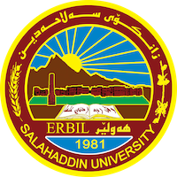
Academic Curriculum Vitae

Personal Information:
Full Name: Dler Farhan Ismael
Academic Title: Lecturer
Email: dlir.ismael@su.edu.krd
Mobile: 07504472259
Date of birth: 1967
Languages: Kurdish – English - Arabic

Education:
- Master Of Arts
- Doctor Of Philosophy

Employment:
- From 23rd / 11 / 1993 as employee from Salaheddin University as a lecturer

Qualifications
- Master Of Arts / Erbil – Salahaddin Uni
- Doctor Of Philosophy / Mousl Uni
- Bechelors Degree / Mousl Uni

Teaching experience:
- Ancient history of Mesopotamia
- History of old Kurdistan

Research and publications
- Writing and publishing book by the name Kurd in Yemen. 2019

Professional memberships
- Member Of the Kurdistan Historical Culture Association
- Member Of Kurdistan Union Teachers
- Member of History Magazine writer

Professional Social Network Accounts:

- Facebook: https://www.facebook.com/dler.farhan
- Google Scholar: https://scholar.google.com/citations?view_op=list_works&hl=en&authuser=2&user=Oj37rSAAAAAJ
- LinkedIn: https://www.linkedin.com/in/dlir-farhan-5a2685163/
- Twitter: https://twitter.com/dlir67
- Google+: https://myaccount.google.com/u/2/profile
- ResearchGate: https://www.researchgate.net/profile/Dlir-Ismail

