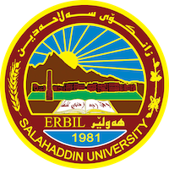
Academic Curriculum Vitae

Personal Information: 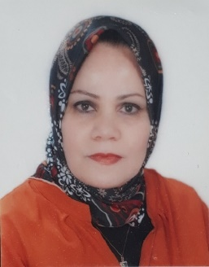
Full Name: Dlpak Birkhader Yaba
Academic Title: Lecturer
Email: (university email) dlpak.yaba@su.edu.krd
Mobile: 07504622779

Education:
- State all education accomplished
-BSc: 1989 College of Science / Salaheddin University
-MSc: 2006 College of Education / Salaheddin University
Employment:
- State employment starting from first employment
- 18/11/1989 as a biology teacher in the Ministry of Education
- 2006 as Assistant lecturer in the Ministry of Education
- 2007 transport to Ministry of Higher Education

Qualifications
- Teaching qualifications
- IT qualifications: word, excel, PowerPoint
- Language qualifications such as TOEFL, IELTS, or any equivalent IELTS: 4.5
- Any professional qualification Non
- You could put any professional courses you have attended

Teaching experience:
- State all teaching courses you delivered, stating undergraduate or postgraduate
- Courses, training, lab supervision, etc.,
- Undergraduate student
- Genetics
- General zoology
- General botany
- Forest insect
- Non-insect animal pest
- Lab of Entomology plant protection department
- ILTS courses
- Computer courses
- English courses, pre-intermediate, intermediate, and advanced courses in a language center.

Research and publications
- State all research, and publications you made.
- Role of sex chromatin on performance in local black goats.
- Role of sex chromatin on performance in crossbred cows.
- Role of sex chromatin on performance in crossbred cows.
- Identification and effect of essential oil compounds of Cyperus rotunds in the biological and quantity of DNA in Triboliuum castaneum.

Conferences and courses attended
- Give details of any conferences you have attended and those at which you have presented delivered poster presentations.

Funding and academic awards
- List any bursaries, scholarships, travel grants or other sources of funding that you were awarded for research projects or to attend meetings or conferences.

Professional memberships
- List any membership you hold of any professional body or learned society relevant to your research or other life activities.
- Kurdistan biological syndicate
- Kurdistan teacher union

Professional Social Network Accounts:

- List your profile links of ReserchGate, LinkedIn, etc.
- Academic link: Dlpak Yaba | Education (su.edu.krd)
- Profile link: Dlpak BIRKHADER YABA | College of Agriculture | Research profile (researchgate.net)
- Google Scholar link: dlpak birkhader yaba‬ - Google Scholar‬‬‬‬‬‬‬
- Orcid link: dlpak yaba (0009-0000-9460-6481) (orcid.org)
- LinkedIn link: Dlpak birkhader | LinkedIn

It is also recommended to create an academic cover letter for your CV, for further information about the cover letter, please visit the below link:
https://career-advice.jobs.ac.uk/cv-and-cover-letter-advice/academic-cover-letter/

