Lecture 01
Forest Insects:
Insects are a group of animals of the phylum Arthropoda, known as class Insecta. Arthropods are invertebrates with distinct body regions, an exoskeleton or hard exterior shell made of chitin and segmented appendages. Insects have three body regions (Head, Thorax and Abdomen). The adult stages have three pairs of legs, a pair of antennae and, if winged, two pairs of wings.
Tens of thousands of species of insects are found in forests, and many play an important role in pollinating plants, recycling nutrients, decomposing vegetation, and providing food for wildlife. They also occasionally can kill trees and impact forest health. Forest insects associated with forest trees as economic crop.

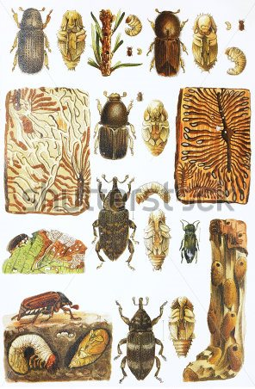

Metamorphosis of Insects:
1- Ametabola Egg == Young stages == Adult
2- Incomplete Metamorphosis Egg == Naiad == Adult
3- Gradual Metamorphosis Egg == Nymph == Adult
4- Complete Metamorphosis Egg == Larvae == Pupa == Adult

Immature stages of Insects:

The Eggs of Insects:
All insects develop from eggs and normally each female insect lays many eggs. Eggs may be laid singly or arranged in groups, e.g. in a case called an Ootheca (Cockroaches), or in a so-called egg-pod (grasshoppers).
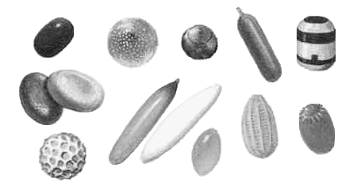
The form of insect eggs varies considerably. Some are almost spherical but others are flattened (e. g. leaf rollers), or elongate (most Diptera). There is sometimes a definite shell to the egg as in butterflies and moths but in other cases like some soil-inhabiting beetles, the eggs are quite soft and must absorb moisture before hatching. Collect insect eggs from leaves and stems of plants or from the soil, and make their drawings to show the range of variation in structure, form and colouration. Also record the place in which it is found; the way in which it is laid or attached to substratum.
This sometimes may be of great importance in forecasting the appearance of the destructive stages of a particular insect pest.

The Larvae of Insects:
Insect’s larvae are highly variable in form and most of them have developed adaptations suitable to their characteristic mode of life. According to Berlese (1913), insect larvae are classified into three types based on resemblances they show to the three phases of embryonic development – protopod, oligopod and polypod. Hinton (1955) strongly refutes this basis, but suggests that Berles’s terms can be used descriptively to help in classifying the larvae. Thus we can study mainly 4 types of insect larvae, namely, protopod, polypod, oligopod and apod larvae.

Types of Larvae:
- Protopod L.: limbs rudimentary or absent; internal organs incompletely differentiated.
Examples: Some parasitic Hymenoptera.
- Eruciform L. (caterpillar): cylindrical, well-formed head, thoracic legs, and abdominal legs, and abdominal.
Example: Lepidoptera.
- Scarabaeiform L. (White grub): C-shaped, well-formed head and thoracic legs (no prolegs).
Example: Coleoptera (Scarabidae)
- Campodeiform L. (Crawler): flattened body with long legs usually filaments on the end of the abdomen.
Examples: Coleoptera (Coccienellidae)
- Vermiform L. (Maggot): Cylindrical and elongate lacks legs. Examples: Diptera and Hymenoptera

The Pupae of Insects:
Based on the adherence of their appendages to the body, insect pupae are classified into three types:
- Obtect P. (Chrysalis): Developing appendages held tightly against the body by a shell like casing. Often found enclosed within a silken cocoon.
Examples: Lepidoptera
- Exarate P.: All developing appendages free and visible externally.
Examples: Hymenoptera
- Coarctate P. (Puparium): Body encased within the hard exoskeleton of the next-to-last larval instars.
Examples: Diptera

Detection and evaluation of infestation
Insects Data Collection:
The following point must be considered:
- Team work
- Training and preparing the staff
- Data recording

The impact of forest insects:
- Direct impact on trees and trees products and its economy.
- Indirect impact such as the impact of parasitic insects and predatory insects.
- Secondary impact: the impact of insects on the organic waste presence under the tree stems on the forest land.

Insect counts in the limited forest areas:
- By traps.
- By feces.
- By cocoons (saw flies).
- By infestation symptoms.
- By the mean of other insect stages.

Insect counts in the large forest areas:
Land count:
- In the mountain regions the surveying of the large areas of the forests can be done by the use of magnifying tools or binoculars.
- By the use of well-trained persons, moving through the forest and they write their observation.
- The use of passing's through the forests.

Aerial count by airplanes:
The airplanes regarded as the main tool or object which characterized by the speed, accuracy and efficiency in doing this work or task.

Forest tree insects
There is a big diversity in the insects which attack forest trees and are divided in to the following main groups:

1) Leaf eating insects, this includes:
A- Leaf chewing insects e.g. Gypsy moth.
B- Leaf folding insects e.g. Spruce budworm
C- Tent making e.g. Ocnogyna loewii
D- Leaf miners e.g. Phyllonorycter sp.
E- Leaf eating insects in the order Coleoptera, Orthoptera and
Hymenoptera.

2) Insects with piercing and sucking mouth parts:
A- Order: Hemiptera, Bugs (true bugs)
B- Order: Homoptera, Aphids, Scale insects.

3) Meristems tissue insects:
A- Order: Coleoptera e.g. Chaetoptelius vestitus
B- Order: Lepidoptera e.g. Cydia fagiglandana
C- Order: Hymenoptera e.g. Cynips quercusfolii
Andricus kollari

4) Phloem and Bark insects:
A- Family: Scolytidae e.g. Scolytus sp.
B- Family: Buprestidae, Borers, Flat head borers
e.g. Capnodis miliaris

5) Wood tissue insects:
I- Insects attacking living trees (Type 1).
e.g.: Stem borer, Cerambyx dux
Peach stem borer, Chlorophorus varius.
Leopard Moth (Willow stem worm), Cossus cossus

II- Dying tree insects or newly cutting insects (Type 2):
e.g.: Red-bay ambrosia beetle, Xyleborus glabratus
Oak pinhole bore, Platypus cylindrus
Sirex wood wasp, Sirex noctilio

III- Wet wood insects (Type 3):
e.g.: White ants (Termites), Microcerotermes diversus

IV- Dry wood insects (Type 4):
e.g.: Brown lyctus beetle, Lyctus brunneus
Red shot-hole borer, Xylobiops basilaris

