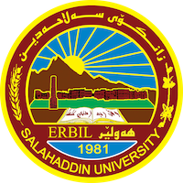
Academic Curriculum Vitae
Full Name:Dlshad Abdulraman Omar
Academic Title: Assistant lecture
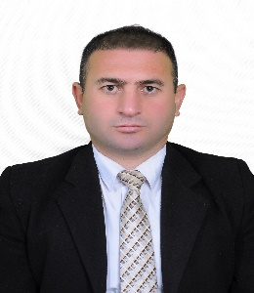
Email: dlshad.omar@su.edu.krd
Mobile:07504549006
Education:
2008-2012 Bachelors degree in (thelogy) got high marks (Excellent) college of Islamic science, Salahadden University- Erbil;
2014-2017 Master degree in (Islamic Philosophy) got (Very good) Salahaddin University-Erbil
Employment:
Worked two years as researchers at university of salahaddin (2012-2014)
Worked three years as Lecturer at shaqlawa educational college - university of salahaddin (2014-2017)
Lecturing five years at salahaddin university- College of Arts- Department Philosophy from 2017 until now.
I am officially as instructor working at College of Arts- Department of Philosophy.
Qualifications
Partispation of scientific, Technical, and Leguistal courses:
Achieved certification in (methods of teaching)- at salahadden university- Erbil date 14/7/2018 .
Achieved certification in (ICDL) in Computer science, in program (windows, Microsoft word, Microsoft Excel, Microsoft power point and internet date 8/7/2013.
Achieved certification in (English Language) Language Center - Salahaddin University-Erbil date 13 /2/ 2014 .
(English Language) Level intermediate at (CLAD Center-Soran University 2022-2023 equally band 6 EILTS .

