**Question Bank: FTIR, HNMR, CNMR, and MS Spectrometry**

**Infrared (IR) Spectroscopy**

1. What is the principle behind IR spectroscopy?
2. What is the region of the electromagnetic spectrum used in IR spectroscopy?
3. What are the functional groups that can be identified using IR spectroscopy?
4. Explain the concept of fingerprint region in IR spectra.
5. How can you distinguish between primary, secondary, and tertiary alcohols using IR spectroscopy?
6. How can you identify the presence of a carbonyl group in a molecule using IR spectroscopy?

**Nuclear Magnetic Resonance (NMR) Spectroscopy**

1. **¹H NMR Spectroscopy**
   * What is the principle behind ¹H NMR spectroscopy?
   * Explain the concept of chemical shift.
   * What factors influence the chemical shift of a proton?
   * What is spin-spin splitting?
   * How can you predict the splitting pattern of a proton signal using the n+1 rule?
   * What is the significance of the integration of NMR peaks?
2. **¹³C NMR Spectroscopy**
   * How does ¹³C NMR differ from ¹H NMR?
   * What is the purpose of using a DEPT experiment?
   * How can you distinguish between primary, secondary, tertiary, and quaternary carbons using ¹³C NMR?

**Mass Spectrometry (MS)**

1. What is the principle behind mass spectrometry?
2. Explain the concept of the mass-to-charge ratio (m/z).
3. What is the base peak in a mass spectrum?
4. How can you determine the molecular weight of a compound from its mass spectrum?
5. What is the fragmentation pattern in mass spectrometry?
6. How can you use mass spectrometry to identify functional groups in a molecule?

**Additional combined questions**

1. How can you use a combination of IR, NMR, and MS to determine the structure of an unknown compound?
2. A compound shows a strong IR absorption band at 1700 cm⁻¹. What functional group is likely present?
3. A compound shows a singlet peak at 2.1 ppm in its ¹H NMR spectrum. What functional group is likely present?
4. A compound shows a molecular ion peak at m/z 100 in its mass spectrum. What is the possible molecular formula of the compound?

**Questions based on the use of spectra to identify a compound or distinguish between different compounds:**

1. The UV spectrum of this compound shows only end absorption. Determine the structure of the

compound.

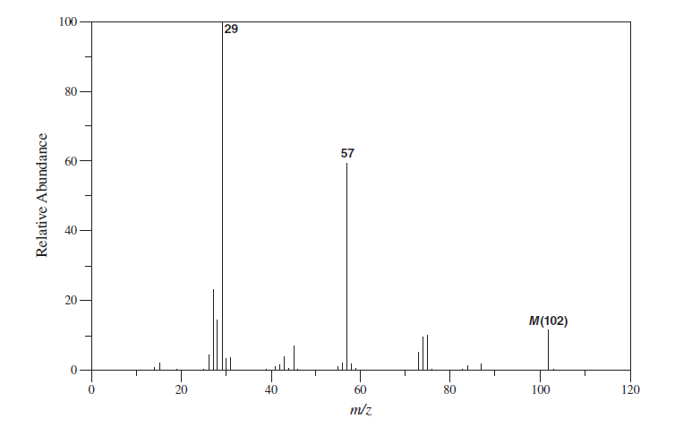

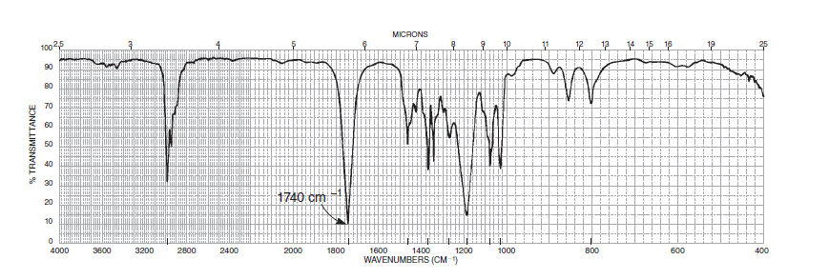

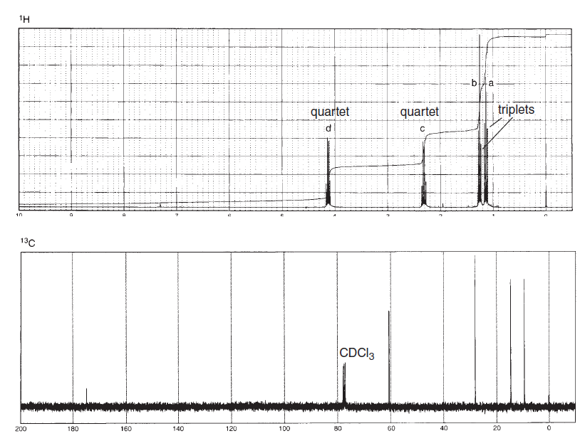

1. Determine the structure of a compound with the formula C10H12O2. In addition to the infrared spectrum

and 1H NMR, the problem includes tabulated data for the normal 13C NMR, DEPT-135, and

DEPT-90 spectral data.

