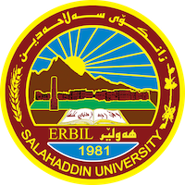
Academic Curriculum Vitae
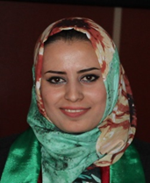
Personal Information:
Full Name: Drakhshan Rasul Abdulrahman
Academic Title: Assistant lecturer
Email: drakhshan.abdulrahman@su.edu.krd
Mobile: 009647504129422

Education:
- BSc. Soil and Water/Salahaddin University-Erbil/2009
- MSc. Soil Survey and Management /Salahaddin University-Erbil/2015

Employment:
- Academic staff at soil and water dept./College of Agricultural Engineering Science/Salahaddin University-Erbil

Qualifications
- Languages
  - Kurdish
  - Arabic
  - English
- Software
  - Microsoft Office
  - ArcMap

Teaching experience:
- 2009- Administrated Dept. of soil and water science, College of Agricultural engineering science, Salahaddin University-Erbil, Kurdistan region-Iraq.
- 2015- Assistant Lecturer Dept of Soil and Water, College of Agricultural engineering science, Salahaddin University-Erbil, Kurdistan region-Iraq.

Research and publications
- M.Sc. thesis entitled (Land Suitability for Wheat Production under Dry Farming System in Erbil Plain Using Remote Sensing and GIS).
- Land Suitability for Wheat Production under Dry Farming System in Erbil Plain Using Remote Sensing and GIS. International Journal of Research in Agriculture and Forestry, Volume 3, Issue 8, August 2016.

Conferences and courses attended
- A 160 hrs of English training course in Language center/Salahaddin University-Erbil.
- Computer training course in Salahaddin University-Erbil.
- Teaching methods in Continuous Education Directory/ Salahaddin University-Erbil.
- A 7 weeks 8-10 hours per week, online training course Sustainable Soil Management: Soil for Life in Wageningen University & Research.
- Participated in online training course Environment and its pollution causes in Environment course in the training hall of green school in Telegram.
- Participated in online workshops in the training hall of Dwobz Organization for Environment Protection in Telegram channel.
- Others.

Professional memberships
- Kurdistan Teachers Syndicate
- Kurdistan Agricultural Engineers Syndicate

Professional Social Network Accounts:
LinkedIn: Drakhshan Jaf
RG: Drakhshan Jaf
ORCID:0009-0000-1056-8642
Google Scholar: Drakhshan Jaf

