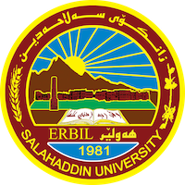
Academic Curriculum Vitae
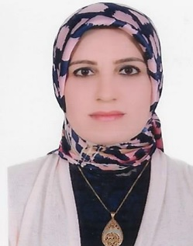
Personal Information:
Full Name: Drakhshan Jalal Hassan
Academic Title: Assistant Professor
Email: drakshan.Hassan@su.edu.krd.com
Mobile: 009647504902074

Education:
- 2000-2003: (BSc. in Statistics). Department of Statistic, College of Administration and Economic, University of Salahaddin – Erbil.
- 2009-2011: (MSc. in Statistics). Department of Statistic, College of Administration and Economic, University of Salahaddin – Erbil.
- 2019-2022: (Ph.D in Theoretical Statistics). The title of the thesis is (Application of Multi-Type Branching Process and Hidden Markov Chain on Patients Affected by Chemical Attack in Kurdistan Region). Department of Statistic, College of Administration and Economic, University of Salahaddin – Erbil.
Employment:
2004-2007: Teaching assistant in statistic department, College of Administration and Economic, University of Salahaddin – Erbil.
2012-2017: Assistant Lecturer in statistic department, College of Administration and Economic, University of Salahaddin – Erbil.
2018-2022: Lecturer in statistic department, College of Administration and Economic, University of Salahaddin – Erbil.
2023: Assistant Professor in statistic department, College of Administration and Economic, University of Salahaddin – Erbil.

Qualifications
- IT qualifications: Microsoft Word, Excel, PowerPoint, and SPSS.

- Languages qualifications: Kurdish- Reading, writing and speaking
Arabic- Reading, writing and speaking
English- Reading and Speaking
Teaching experience:
- Teaching the subject Principle of Statistic 2012-2015 in Administration department, College of Administration and Economic, University of Salahaddin – Erbil.

- Teaching the subject Principle of Statistic 2015-2016 in Economic department, College of Administration and Economic, University of Salahaddin – Erbil.

- Teaching the subject Principle of Statistic 2016-2017 in Accounting department, College of Administration and Economic, University of Salahaddin – Erbil.

- Teaching the subject Operation Research 2017 until now in Statistic department, College of Administration and Economic, University of Salahaddin – Erbil.

- Teaching the subject Principle of Statistic and Operation Research 2019-2022 in Accounting department, College of Administration and Economic, at Bayan University.

Research and publications
- Bestun M. Abdul-Kareem, Drakhshan J. Hassan, Using the two type diseases branching process resulted by Chemical Weapon, Zanco Journal of Humanity Science, (2022), Vol. (26), NO. (2).
- Bestun M. Abdul-Kareem, Drakhshan J. Hassan, Apply the Hardy- Weinberg law and Markov Chain on Chemical attack in Kurdistan, Technology Reports of Kansai University, ISSN (04532198), 2021.
- درخشان جلال حسن ، كوثر سعيد طه، (التنبؤ بدرجات الحرارة العظمى و الصغرى بإستخدام نماذج السلاسل الزمنية لمحافظة أربيل) ، كوفارى ئةكاديمياى كوردى، عدد (43) ، 2019.
- كوثر سعيد طه ، درخشان جلال حسن، (استخدام أنموذج اللوجستي لدراسة أهم العوامل المؤثرة على مرض السكري حسب نوع المرض)، مجلة قةلاى زانست العلمية، المجلد (5) ، 2020.
- Drakhshan J. Hassan and Delshad S. Botani, Selection optimal queuing model to serve patients at C.T scan unit in Erbil teaching Hospital, Zanco Journal of Humanity Science. (2017).
- درخشان جلال حسن ، خديجة قادر سمايل ،( استخدام طرق تحليل متعدد المتغيرات لتحديد أهم العوامل المؤثرة على ظاهرة الغش لدى الطلاب) ، كوفارى ئةكاديمياى كوردى، عدد (39) ، 2017.

Professional Social Network Accounts:

https://scholar.google.co.uk/citations?view_op=new_articles&hl=ar&imq=drakhshan+jalal+hassan#

