Mr.edres abdulla
Department of Animal Resources
Reproductive Physiology and Artificial Insemination (Practical)
Physiology in Reproduction in Male
Structure of male reproductive organs in mammals:
1. The male gonads (testes)
2. Epididymis
3. Spermatic cords
4. Accessory sex glands
- The vesicular glands
- The prostate gland
- The Cowper’s glands (bulbourethral glands)
5. Penis
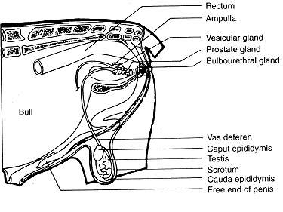
The male gonads (testes):
The testes consist of two parts:
1. Seminiferous tubules
2. The interstitial (Leydig) cells.
Functions of male gonads (testes):
1. Spermatogenesis (production of spermatozoa) in the seminiferous tubules
2. Secretion of testosterone by interstitial (Leydig) cells.

Epididymis:
- The epididymis consists of one highly coiled tubule, which receive sepermatozoa from the testes.
- Storage and maturation of spermatozoa occur in the epididymis.
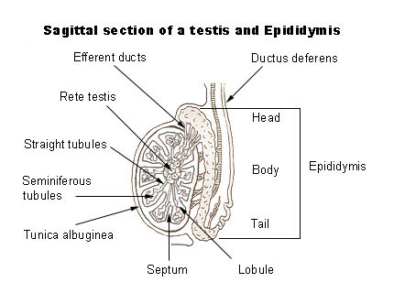
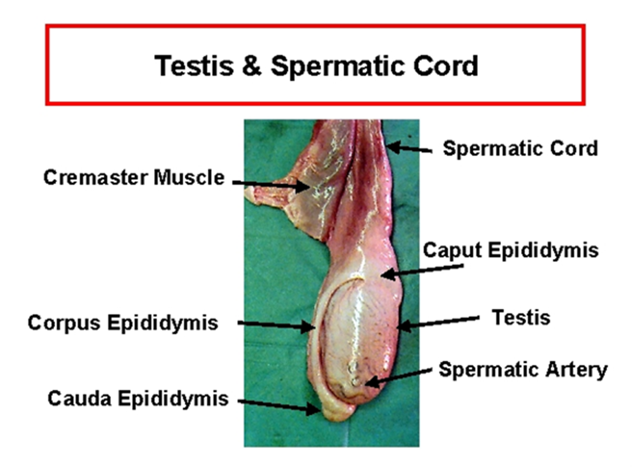
Accessory Glands
Seminal vesicles are important in rats, bulls, boars and stallions but are absent in cats and dogs. When present they produce secretions that make up much of the volume of the semen, and transport and provide nutrients for the sperm.
The prostate gland is important in dogs and humans. It produces an alkaline secretion that neutralizes the acidity of the male urethra and female vagina.
Cowper’s glands (bulbourethral glands) have various functions in different species. The secretions may lubricate, flush out urine or form a gelatinous plug that traps the semen in the female reproductive system after copulation and prevents other males of the same species fertilizing an already mated female. Cowper’s glands are absent in bears and aquatic mammals.
Penis: Is composed in most animals of erectile tissues
Penis composed of three parts:
A_ root, B_ body of penis, C_ glans of penis
The erectile tissues are sponge like structure its full with blood when the male is sexually stimulated.
