Infertility in Ruminant Animals
Infertility is the inability of a person, animal or plant to reproduce by natural means, it is usually not the natural state of a healthy adult organism. The causes of infertility are many and can be complex in both male and female animals.
Causes of infertility in Female
- Congenital morphological causes:
Congenital causes of infertility are often inherited. They include developmental abnormalities of the ovaries, oviducts, uterus, cervix, vagina and vulva. Some are lethal, a few have a morphological significance and others a functional significance.
- Infectious causes of infertility
a-Bacterial and protozoan infection. b-Viral infections
- Common causes of infertility of females include:
- ovulation problems (e.g. polycystic ovarian syndrome)
- tubal blockage
- pelvic inflammatory disease caused by infections like tuberculosis
- age-related factors. 5- uterine problem. 6- endometriosis
7-advanced maternal age.

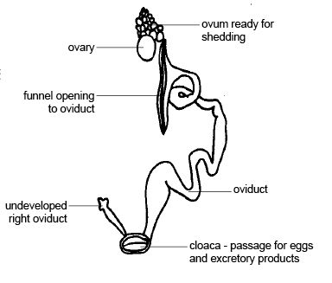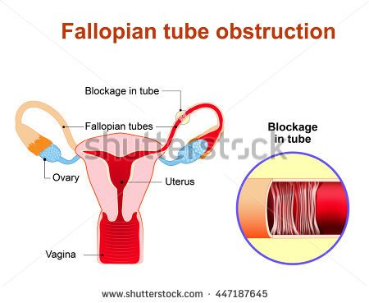
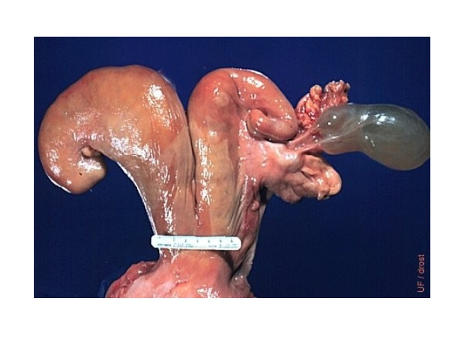
Male infertility
Males can be affected by several sexual disorders which might disturb their capabilities to have proper mating, or cause total or partial sterility, depending on how much these disorders affected on sexual functions.
1_ Congenital anomalies:
Related either to abnormalities in testes development and subsequent abnormal growth, or by unilateral and bilateral cryptorchidism, so in bilateral cryptorchidism both testes in this case are incapable of producing sperms then seminal fluid will be sperm free, due to high abdominal temperature compared with that in scrotum. While unilateral cryptorchidism leads to decrease spermatogenesis, but theses males can show sexual reflexes and still give an acceptable semen quality.
2_Animal age:
When animals reach a certain age, they face a decreasing in fertility efficiency, low activity, and stoppage of sexual reflexes; as a result they will have poor semen quality. Aged animals have a low hormonal activity in testes that leads to disturb spermatogenesis and causes poor sexual reflexes.
3_ Nutritional factors:- in general dietary deficiency or unbalanced forage intake will lead to decrease in showing sexual reflexes and producing bad semen quality.
Specific dietary deficiencies e.g. of zinc and vitamin A, will impair reproductive functions.
Vitamin E has been highly overrated in reproductive function in domestic animals.
4_ Mating circumstances:_
The following factors have significant effect on decreasing males fertility capabilities.
A_ not following the suitable conditions when using the males in mating.
B_ difference in body sizes between male and female.
C_ incorrectly prepared males for mating.
D_ incorrectly prepared artificial vagina (in artificial insemination).
5_ Climatic factors(Weather)
producing bad semen quality depending on the following climatic conditions:
A_ highly increasing in surrounding temperature
B_ increase in solar radiation. C_ sever coldness. D_ unhealthy barns.
E_ variable and sever surrounding climatic changes.
6_ Diseases :_ generally when animals are exposed to genital or normal body diseases (contagious and non-contagious),will weaken male fertility efficiency.
7_ Misusage:_ male overwork in mating ,or by agricultural works, or by carriage; they will lead to decrease in showing sexual reflexes and producing bad semen quality (small ejaculate amount and low sperm activity).
To avoid these disturbances we must establish a specific system for using males in mating according to breeds, age, and body conditions, And to keep them away from overworking in hard agricultural works.

