Department of Animal Resources

Reproductive Physiology and Artificial Insemination (Theory) Third Class

Birth

Signs of Imminent Birth
As the pregnancy continues, the mammary glands enlarge and may secrete a milky substance a few days before birth occurs. The vulva may swell and produce thick mucus and there is sometimes a visible change in the position of the fetus. Just before birth the mother often becomes restless, lying down and getting up frequently. Many animals seek a secluded place where they may build a nest in which to give birth.

Labor (Parturition)
Labor involves waves of uterine contractions that press the fetus against the cervix causing it to dilate. The fetus is then pushed through the cervix and along the vagina before being delivered. In the final stage of labor the placenta or “afterbirth” is expelled.
There are three stages of parturition.
1- Initiation of myometrial contraction (removed of progesterone block) 2- Expulsion of fetus
3-Expulsion of fetal membranes
Milk Production
Cows, sheeps and primates have two mammary glands but animals like pigs that give birth to large litters may have as many as 12 pairs. Ducts from the gland lead to a nipple or teat and there may be a sinus where the milk collects before being suckled.
Lactation: Lactation begins after parturition because of the hormonal changes that occur.
Mammogenesis refers to the growth and development of the mammary gland. Lactogenesis is the process by which mammary alveolar cells acquire the ability to secrete milk.
The hormones oestrogen and progesterone stimulate the mammary glands to develop and prolactin promotes the secretion of the milk. Oxytocin from the pituitary gland releases the milk when the baby suckles. The first milk is called colostrum. It is a rich in nutrients and contains protective antibodies from the mother. Milk contains fat, protein and milk sugar as well as vitamins and most minerals although it contains little iron. Its actual composition varies widely from species to species. For example whale’s and seal’s milk has twelve times more fat and four times more protein than cow’s milk. Cow’s milk has far less protein in it than cat’s or dog’s milk. This is why orphan kittens and puppies cannot be fed cow’s milk.
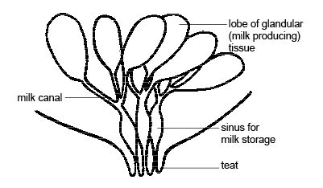
Diagram - A mammary gland
Reproductive efficiency
Breeding efficiency is an important aspect of both natural and man-controlled animal systems.
Measures of the reproductive efficiency
No. ewes lambed
- Fertility = --------------------------------------------------------------- ×100
No. ewes exposed to ram for inseminated

No. ewes lambed+ aborted
- Conception rate = --------------------------------------------- ×100
No. ewes exposed to ram

No .lambs born
- Lambing % = ------------------------------------------------- ×100
No. ewes exposed
No .lambs born or weaned
- Litter size = ---------------------------------------
No. ewes lambing

Synchronization of estrus
Is a modern scientific method by which a group of animals can get estrus a one-time (synchronization occurrence of oestrus between animals). This is done by using hormones that act on the thyroid in the secret hormones of the gland (GNRH) responsible for the secretion of FSH (the growth promoter of the follicles)and LH responsible of ovulation.
property of estrus cycle of ewe and goat:

Trait Ewe Goat
Estrus cycle (days) 17 21
Meta estrus (days) 2 – 3 2 – 3
Diestrus (days) 10 -12 13 – 15
Proestrus (days) 3 -4 2 – 3
Estrus (hr) 24 – 36 30 – 40
Ovulation late estrus few hours after estrus

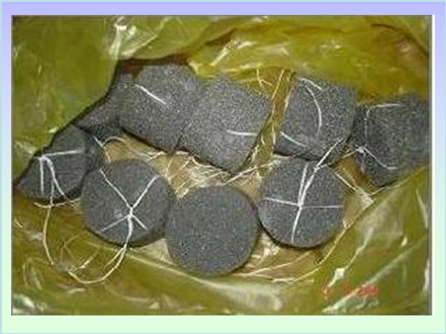
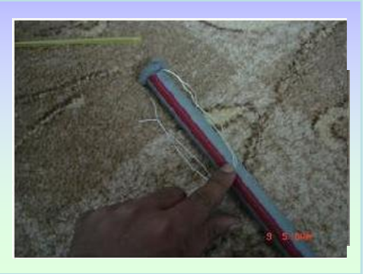
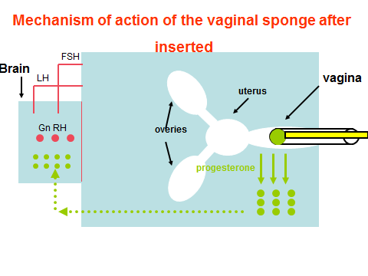
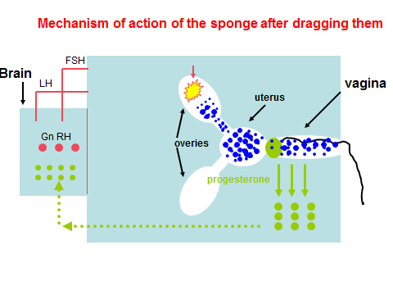
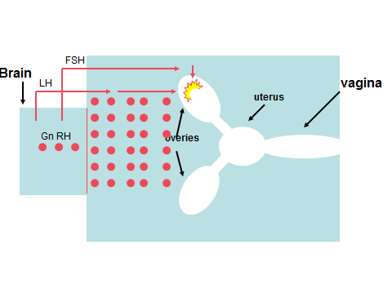
Advantages and disadvantages of synchronized breeding &lambing
Advantages:
- Increased supervision of ewes in labour and then of new born should reduce prenatal mortality.
- Accurate feeding appropriate to the stage of production at all times.
- Lambs can be weaned in even batches.
- The use of resource such as building ,and especially labour can be planned creating optimum use.
- Flock health programs can be planned.
- Early mating of ewe lambs can be induced.
- Frequent lambing system can be developed.
Disadvantages:
- The need for more rams.
- Accurate mating records are required and higher degree of management skill.
- Indoor lambing, more lambing pens and more facilities.
- Additional cost of the druges needed.

