Ministry of Higher Education 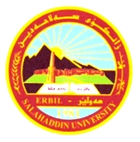 Animal Resource Department
University of Salahaddin 3^{d} Stage
College of Agriculture Time: 2 H.

Final Examination (Second Trail) Animal Reproductive Physiology 2018-2019

Q¹/ Answer the following questions: (40) Marks
- Define Uterus? Explain the main functions of it?
- What are the differences between puberty and sexual maturity in animals (male and females)?
- What are the functions of uterine tube (oviduct)? Explain its parts?
- What are the function of:
- Sertoli cells
- somniferous tubules
- acrosome
Q²: Define the Followings Terms (30) Marks
Reproductive efficiency , Parturition , follicular phase, Copulation, seasonal breeders , Lactogenesis
Q³: A/ Answer the followings (20) Marks
1: parts of pregnancy period , 2: Signs of Estrous or Heat , 3: stages of estrus cycle
B: Named the Pointed Parts of the following Figure (10) Marks

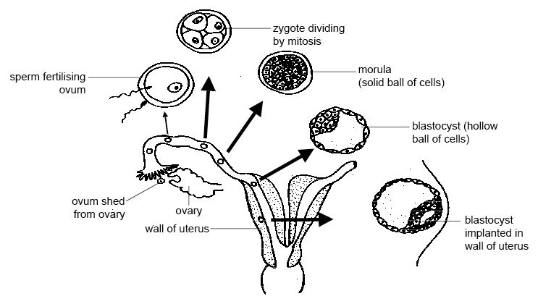
10
8
1
9
7
6
5
4
2
3

Mr. Edres Abdulla Hamdamen Mrs. Sirod Sami Yahya
lecturer lecturer

