Mr.edres abdulla
Department of Animal Resources
Reproductive Physiology and Artificial Insemination (Theory 1)
Male Reproductive Tract
The basic component of the male reproductive system are the
1-Testis 2-Scrotum 3- Spermatic cord 4-Excurrent ducts system
5-Accessory sex glands 6-Penis and muscles or protrusion, erection and ejaculation
The testes
The testis produces spermatozoa and testosterone as well as other substances such as inhibin, estrogen and several proteins.
Sperm need temperatures between 2 to 10 degrees Centigrade lower and then the body temperature to develop. This is the reason why the testes are located in a bag of skin called the scrotal sacs (or scrotum) that hangs below the body and where the evaporation of secretions from special glands can further reduce the temperature. In many animals (including humans) the testes descend into the scrotal sacs at birth but in some animals they do not descend until sexual maturity and in others they only descend temporarily during the breeding season.
Each testis consists of mass of coiled somniferous tubules surround by a heavy fibrous capsule called the tunica albuginea .The interstitial tissue, Leydig cells (between the tubules) that produce testosterone. The somniferous tubules are the site of spermatogenesis, the formation of spermatozoa.
The epithelium lining the somniferous tubules contains two cell types Sertoli cells and germ cells. The germ cells are the precursor of developing spermatozoa. Sertoli cells secrete a fluid that bathes the developing germ cells and assists with the transport of spermatozoa from tubules .One component of this fluid, androgen- binding protein, and transports androgen form their site of synthesis in the testis to epididmyis.
Spermatogenesis is the term for all processes involved in the formation of mature male gametes form the most undifferentiated germ cells.

Spermatocytogenesis is some of the cells resulting from the mitotic cell divisions of the most undifferentiated germ cells. Other begin the sequence of cell divisions (mitotic followed by meiotic division) and developmental changes to become spermatozoa.
Spermiogenesis is the process which changes the spermatids to spermatozoa.
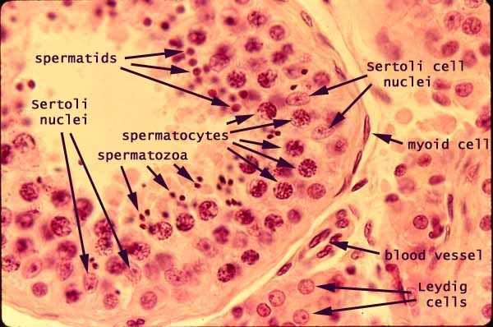
Slide view of somniferous tubules with different cells
Epididymis
Epididymis is composed of a long convoluted tube that connects the efferent ductules of the testis with the ductless deferent. The epididymal duct houses the spermatozoa as they mature before they are expelled by ejaculation. The is divided into a head (caput), body (corpus) and tail (caudal). The epididymides are the major sites of storage of spermatozoa, and most spermatozoa are contained in the tail of each epididymis.
Ductus Defferent
Ductus Defferent is the muscular tube that undergoes peristaltic contractions during ejaculation. Propelling the spermatozoa from the epididymis to the urethra.
Scrotum
Scrotum a sac consisting of skin, sweat glands, a layer of smooth muscle (tunica dartos) which during exposure to cold the muscle fibers of tunica dartos contract and help hold the testes against the abdominal and connective tissue that houses the testes. The creaser muscle which also assists with drawing the testicle closer to the body wall when ambient temperatures are low or as a protective reflex.

Slide view of scrotum
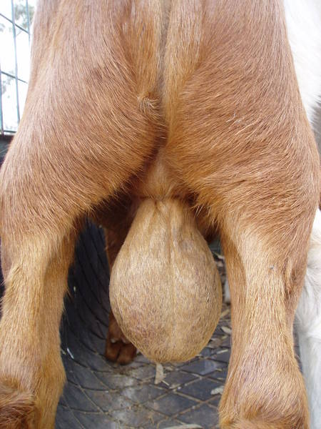

Semen
Semen consists of sperm and 90% fluid and as sperm pass down the ducts from testis to penis, (accessory) glands add various secretions.

Process of spermatogenesis
The process of spermatogenesis begins with the spermatogonia that have diplod number of chromosomes. These spermatogonia are type of stem cells that undergo cell division via Process of mitosis. In this process some spermatogonia remain attach to the basement membrane as the reservoir of cells for the later stages whereas other passes through the blood- testis barrier, develops and differentiate to form primary spermatocytes. Primary spermatocytes thus formed are also diploid and after a short interval time period, it replicates and undergoes meiosis 1 to form secondary spermatocyte.
Now, this secondary spermatocyte is haploid. As we know that chromosomes consist of two chromatids hence the separation of these chormatids takes place in meiosis 2, thus forming 4 haploid spermatids. After the division process, spermiogenesis occurs by which sperms are formed from the spermatids. The function of sertoli cell comes in play, thus clearing excess cytoplasm and now the individual cell develops acrosome and flagellum. Then spermiation takes place where the sperm cells are released to sertoli cell that directs the movement of sperm to the lumen of seminiferous tubule.

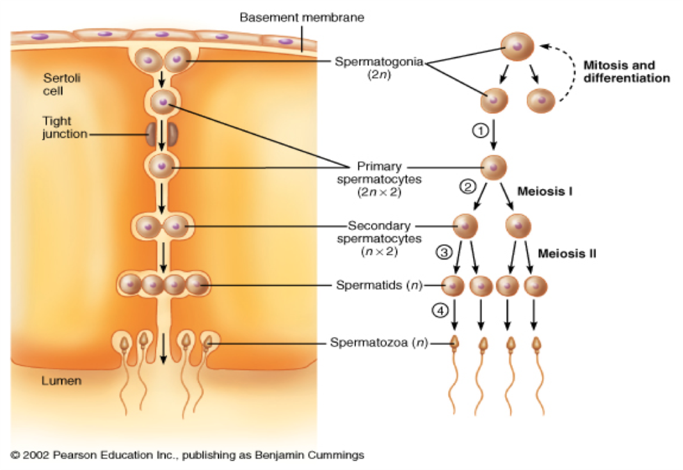

The Penis
The penis consists of connective tissue with numerous small blood spaces in it. These fill with blood during sexual excitement causing erection.
Penis Form and Shape
Dogs, bears, seals, bats and rodents have a special bone in the penis which helps maintain the erection. In some animals (e.g. the bull, ram and boar) the penis has an “S” shaped bend that allows it to fold up when not in use.

Sperm
Structure of sperm: millions of sperms are made and these many sperms complete the process of spermatogenesis. Sperm is well designed consisting of several structures that help in reaching and penetrating the secondary acolyte from female. The head part of the sperm consists of 23 chromosomes inside a nucleus that are highly condensed. Thus, the upper part of the nucleus is covered with the acrosome, a cap like structure that is filled with enzymes and helps in the penetration process. The body is divided into different parts: neck, middle piece, principle piece and end piece. Neck consist of centrioles, middle piece consist of mitochondria for locomotion of sperm. A single ejaculation may contain 2-3 hundred million sperm but even in normal semen as many as 10% of these sperm may be abnormal and infertile. Some may be dead while others are inactive or deformed with double, giant or small heads or tails that are coiled or absent altogether.
Sperm do not live forever. They have a definite life span that varies from species to species. They survive for between 20 days (guinea pig) to 60 days (bull) in the epididymis but once ejaculated into the female tract they only live from 12 to 48 hours. When semen is used for artificial insemination, storage under the right conditions can extend the life span of some species.
