**Department of Animal Resources**

**Reproductive Physiology and Artificial Insemination (Theory) Third Class**

**Female Reproductive Tract**

Structures of the female reproductive tract include the **Ovaries** (the female gonads), **Uterine tubes (oviducts), Uterus, cervix, vagina, external genitalia.**

**The ovaries** are both endocrine and cryogenic (cell producing), since they produce hormones, which are released directly into the blood stream, and ova, which released from surface of the ovary in ovula.In most species the ovaries are some what ovoid.

In the mare, however, the ovaries have a bean shape because of a definite ovulation fosses .The ovary has a surface or superficial layer of epithelium tissue. The medulla is centrally located and contains loose connective tissue, blood vessels, lymphatic, and nerves.

The follicles within the cortex are classified as:-

1. Primary follicles

The Primary follicles contain a single oocyte that surrounded by single layer of granulose cells.

2-secondary follicle

3-Growing follicles (Tertiary)

Growing follicles has two or more layers of granulose cells surrounding the oocyte.

4- Graafian follicles (antral follicle)

Graafian follicle is those in which an antrum is clearly visible. Two layers of theca cells, theca interna and theca externa.

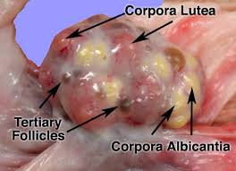 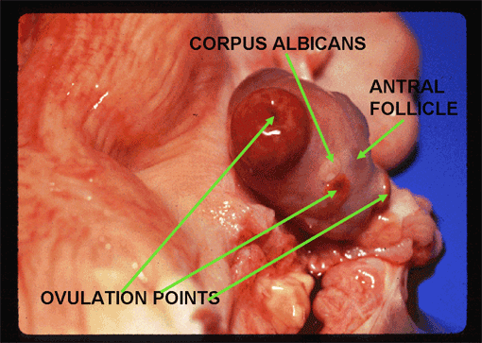

**Uterine tubes (oviduct)**

The uterine tubes are also called the oviduct or fallopian tubes. They are paired convoluted tubes that conduct oocytes from ovaries to the respective horn uterus. The uterine tubes serve as the site for fertilization of released oocytes by the spermatozoa in domestic species.

**The oviducts consist**

**1-Infundibulum**

The infundibulum is the terminal end of oviduct and consists of a funnel-shaped opening; the surface of the funnel is covered with many velvety, finger-like projections called **Fimbria.**



Side view of the cow’s infundibulum

**2-Ampulla**

The infundibulumleads directlyinto a thick portion of oviduct called the ampulla.

**3-Isthmus**

The isthmus is the smaller in diameter than the ampulla. It is connected directly to the uterus and the point of junction is called the **uterotubal junction**

**Uterus** In most mammals, the uterus consists of two uterine horns or corneas among mammals there are three distinct anatomical types of uteri.

**The first** **duplex** (having cervical canals) which separate each uterine horn into distinct compartments. This find in the rabbit.

**The second type is the** **bicornuate** which is having two uterine horns and small uterine body (cow, sheep, goat and sow).

**The simplex uterus** is characterized as having a single uterine body. The simplex uterus is fund in primates, including human.

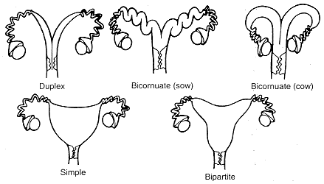

In ruminants, the surface of the endometrium is characterized as having small, nonglandular areas that protrude from the surface of the endometrium are referred **Caruncles.**

**Cervix**

It is a thick –walled, and its projects caudally into the vagina. The cervix is heavy, muscle sphincter that is tightly closed except during estrus and parturition .The cervix provides lubrication, a flushing system and a barrier during pregnancy. During estrus the cervix relaxes slightly permitting spermatozoa enter the uterus. In ruminants and to some extent in sows, the inner surface of the cervix is arranged in series of circular rings sometimes called annular **folds** .The cervix of the mare is relatively smooth and projects prominently into vagina which surrounds the cervix as a deep **vagina fornix.** **Vagina**

It is the portion of the reproductive tract that lies within the pelvis between the uterus cranially and the vulva caudally. The vagina is the birth canal for delivery of the fetus at parturition and a sheath for the penis of the male during copulation. In the posterior vagina there is **vestibule,** it belongs to both urinary and the genital system. The vestibule is the portion of the vagina that is common to the urinary system and the reproductive system.

**Vulva**

Is the external part of female reproductive tract. It consists of two labia (major and minor) which meet in the medial portion of the tract to form a **commeasure** (site of union).The ventral commissure of vestibule houses the **clitoris**, the female homologue of the glans penis .In the posterior portion of the vestibule there is the **Bartholin gland** which secrete mucous-like material during estrus.