Department of Animal Resources
Reproductive Physiology and Artificial Insemination (Theory) Third Class
The Ovarian Cycle
The ovarian cycle refers to the series of changes in the ovary during which the follicle matures, the ovum is shed and the corpus luteum develops.
A mature follicle can be quite large, ranging from a few millimeters in small mammals to the size of a golf ball in large animals. It bulges out from the surface of the ovary before eventually rupturing to release the ovum into the abdominal cavity. Once the ovum has been shed, a blood clot forms in the empty follicle. This develops into a tissue called the corpus luteum that produces the hormone progesterone. If the animal becomes pregnant the corpus luteum persists, but if there is no pregnancy it degenerates and a new ovarian cycle usually.
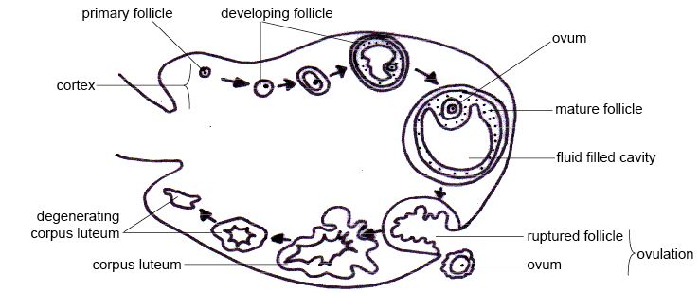

Diagram - The ovarian cycle showing from the top left clockwise

The Ovum
When the ovum is shed the nucleus is in the final stages of meiosis (cell division). It is surrounded by few layers of follicle cells and a tough membrane called the zona pellucida.
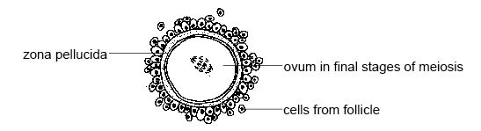Diagram - An ovum

The process of oogenesis

Following sex determination, oogenesis begins with the formation of primary oocytes in a process known as oocytogenesis. This occurs before birth. The primordial oocytes, known as oogonia, migrate through the embryo from the germinal epithelium, to the genital ridges and undergo mitosis to produce the primary oocyte. The first meiotic division of these cells also occurs before birth, while the fetus is still developing. However, the first meiotic block will be met here and this process will arrest in the prophase of meiosis I, until puberty begins. These oocytes reside within structures made up of granulosa and theca cells derived from the germinal epithelium, known as follicles in the ovaries.

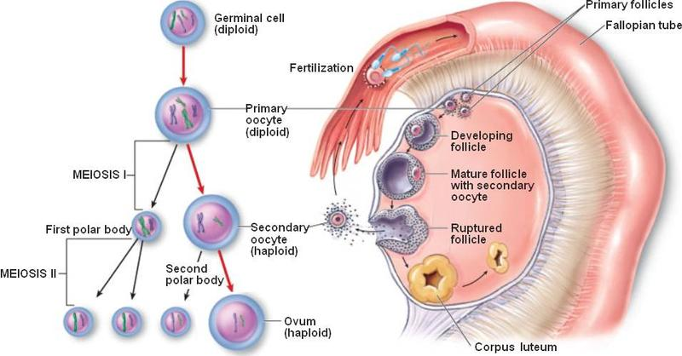
Diagram- Oogenesis

At puberty, each oocyte enters meiosis again, just before it is ready to be ovulated. This means some oocytes can remain dormant for up to 50 years.

The Estrous Cycle
The estrous cycle is the sequence of hormonal changes that occurs through the ovarian cycle. These changes influence the behaviour and body changes of the female. Estrous cycles provide females with repeated opportunities to become pregnancy. Each estrous cycle consists of a relatively short follicular phase and a longer luteal phase.

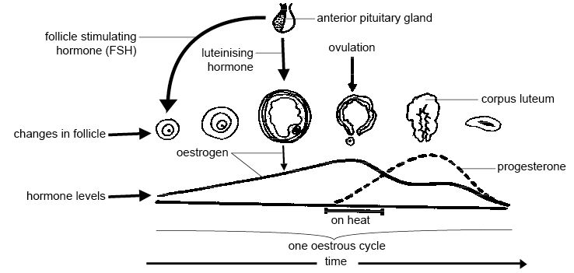
Diagram - The estrous cycle
The estrus cycle divided into four stages
- Pro-estrus= Formation of ovulatory follicles +E₂ secretion .The period beginning after CL regression .During pro-estrus rapid follicle development lead to ovulation and to the onset of sexual receptivity.
- Estrus=Sexual receptivity peak + E₂ secretion. Sometimes referred to as "heat". ovulation usually, but not always, occurs at the end of estrus
- Metestrus = CL formation and beginning of P₄ secretion. It is the early postovulatory period
- Diestus = Sustained luteal secretion of P₄. It is the period of mature luteal activity.
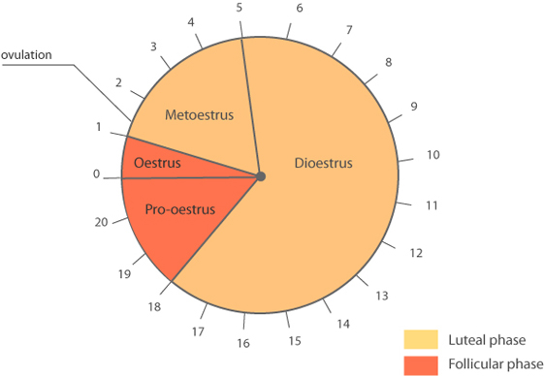

The estrus cycle consists of two major phases
A-follicular phase
Follicles are the dominant ovarian structure during follicular phase.
Estrogen (produced by the follicles) is the dominant hormone during the follicular phase. Follicular phase =Pro-estrus +Estrus
The follicular phase consists of four major events:-
1; gonadotopin release from the anterior pituitary
2; follicular preparation for ovulation
3; sexual receptivity
4; Ovulation
B-Luteal phase
Corpora lutea are the dominant ovarian structure during the luteal phase.
Progesterone (produced by corpora luteal) is the dominant hormone during the luteal phase. Luteal phase= Metestrus + Diestrus.
During the early luteal phase (metestrus), corpora lutea are formed follicular cells. In the mid-luteal phase (diestrus), they produce large quantities of progesterone. During the late luteal phase, corpora lutea are destroyed (lysed) by prostaglandin F2α which is produced by the uterine endometrium, luteolysis of corpus luteum (corpus albicans)
Estrogens (E2)
The important estrogens in mammals are steroids, produced by the ovary (granulose cells of follicle), placenta and the cortex of adrenal gland
The principal functions are:-
1- Cellular proliferation and growth of the tissues.
2-Stimulation of endometrial gland growth,
3-Stimulationof duct growth in the mammary gland
4-Increase in secretory activity of uterine duct
5-initiation of sexual receptivity
6-Regulation of secretion luteinizing hormone (LH) by the pituitary gland.
7- Possible regulation of PGFα release from non-gravid and gravid uterus
Progesterone (P4)
It like the estrogen is a steroid hormone produced by the corpus luteum (CL) of the ovary, placenta and adrenal cortex.
The functions of P4 include:-
1-Promotion of endometrial gland growth
2- Stimulation of secretory activity of oviduct and endometrial glands to provide nutrition for the developing embryo prior to implantation.
3-Promotion lobulalveolar growth in mammary gland
4-Preventionof contractility of the uterus during pregnancy and
5- Regulation of secretion of gonadotropins.
The length of the estrous cycle varies from species to species. In rats the cycle only lasts 4-5 days and they are sexually receptive for about 14 hours. Dogs have a cycle that lasts 60-70 days and heat lasts 7-9 days and horses have a 21-day cycle and heat lasts an average of 6 days.
Ovulation is spontaneous in most animals but in some, e.g. the cat, and the rabbit, ovulation is stimulated by mating. This is called induced ovulation.

Signs of Estrous or Heat
The various symptoms of heat are
- The animal will be excited condition. The animal will be in restlessness and nervousness.
- The animal will be bellow frequency.
- The animal will reduce the intake of feed.
- The animals which are in heat will lick other animals and smelling other animals.
- The animals will try to mount other animals
- The animals will standstill when other animal try to mount. This period is known as standing heat. This extends 14-16 hours.
- Frequent maturation (urination) will be observed.
- Clear mucous discharge will be seen from the vulva, sometimes it will be string like the mucous will be seen stick to the near the pasts of vulva.
- Swelling of the vulva will be seen.
- Congestion and hyperemia of membrane.
- The tail will be in raised position.
- Milk production will be slightly decreased.
- On Palpation uterus will be turgid and the cervix will be opened.
