**Department of Animal Resources**

**Reproductive Physiology and Artificial Insemination (Practical 4) Third Class**

**semen collection**

The process of collecting semen from male animals, the first step of artificial insemination, which is also the most important steps because it is needful to get the ejaculation normal in terms of size and activity and free of impurities so that it can perform the following steps of dilution and conservation and insemination.

**Methods of semen collection**

In the past you followed a primary method to get the semen. 1-semen collected by spoon or sponge Vaginal of females after normal insemination, But collected semen in this method contaminated by female secretions and quantity ofa few.  
2- By massaging the ampulla through rectal wall:- The method was used for sensory stimulation of the centers by throwing hand extended in the rectum can be obtained on the semen in this method, but it is contaminated with urine  
And large numbers of bacteria.

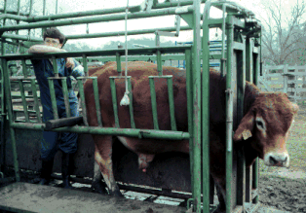

3- By Electro-stimulation:- Can also be electrical stimulation to provoke sensory centers in the male reproductive system of the bullsthat are difficult to push to ejaculation.  
It is used in Beef bulls , cattle and sheep on a large scale, and the process is done enter a electrode( Prob) in animal and generating an alert nervous in the genital tract by raising the strength of electric a gradual and at regular intervals during a period of five minutes has been designed different types of means alert electrical for the purpose of collecting semen.

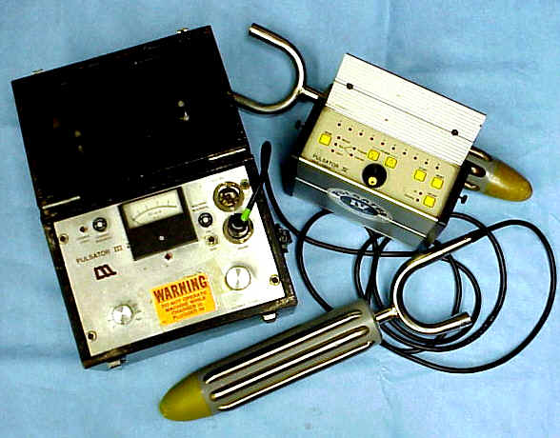

**Artificial Vaginal Method** 4-

The only method it used at the present time to obtain semen for artificial insemination in cattle of the vagina artificial because of the simplicity of composition , and the ease and speed of its use on the one hand and also because this method ensures the semen to a large degree of purity recipes good in terms of size, concentration and activity. and first used by Russian scientists to collect semen from bulls.

There are many artificial vaginas, but they all share in terms of the basis for it consists of the following parts: -

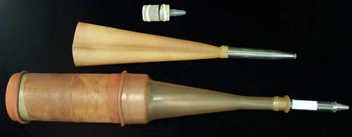

1- Outer Casing

The cylindrical is made up of hard rubber in length between 25 to 45 cm in diameter and from 1.5 to 4.6 cm depending on the age and size of the animal.

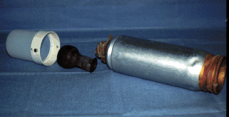

2- Inner Liner

It is a long rubber tube folds on the edges of the end cylinder State and prove by a good strong rubber rings consists cavity including the nature of the inner lining can be soft for the Bulls small or rough tern advanced age to increase their sensitivity.

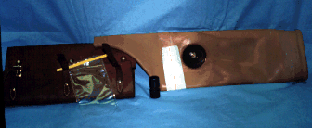

3- **Funnel** **collecting**

A piece of rubber in the form of funnel prove on one end of the vagina artificial to contain semen and directed to the test tube prove at the tip of funnel.

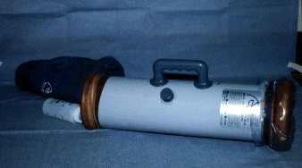

**4- Tube Collection**

A special test tube and the listed limit of 15 **cm3**, and are either Pyrex Tube or Centrifuge Tube.

**5- Insulated hot**

Note protective covering for the funnel and collection tube which prevents cold shock and tube breakage.



Advantages of Artificial Vaginal Method this method

1- Practically the whole ejaculate is collected in uncontaminated and natural stage.

2- It is free from the extraneous secretions.

3- A sterile condition of the apparatus ensures disease control.

4- The activity of the sperm is better.

5- No female is needed if dummy is a success.

Disadvantages of this method

1- Occasionally it is difficult to get the males to serve the artificial vagina.

2- The apparatus involved is slightly costly and requires technical hands. The following Precautions should be taken while collection of semen is made by using AV.

3- Protect the collection vial from sunlight by placing a black cover immediately after collection.

4- Avoid contamination of the semen from water, lubricating jelly or other harmful substances.

5- Avoid cold shock by providing adequate protection for the collection tube and funnel.

**Features person standing With collect**

1 - agility movement

2 - Self-esteem

3 - Not to be afraid of the bull foot

4 - You do not do unneedful movements