Department of Animal Resources
Reproductive Physiology and Artificial Insemination (Theory) Third Class
Puberty
Puberty is the process of acquiring reproductive competence. The onset of puberty depends upon the ability of specific hypothalamus neurons to produce GnRH in sufficient quantities to promote and support gametogenesis. In the female, hypothalamic GnRH neurons must develop the ability to respond to estradiol positive feedback before they can produce sufficient quantities of GnRH to cause ovulation. Development of hypothalamic GnRH neurons is influenced by:-
1-Development of threshold body size,
2- Exposure to a variety of environmental social cues, and
3- The genetics of the animal. Puberty in the male appears to be less dependent on body size and social factors than in the female.
(Puberty: the age at first estrus occurs and the female's life when she becomes capable of reproduction and when the reproductive processes begin to function).
In the male the spermatogenesis commences at puberty and the testes fully descend from the abdomen and both the seminiferous tubules and the interstitial cells become active.
Sexual maturity is capable the male for mounting, intercourse and ejaculation. The female is capable of pregnancy and normal parturition.
Factors affecting puberty: There are several factors influenced the puberty:-
1-Season: The season of birth, had a highly significant on the of puberty Sheep are seasonal breeders with estrus in mature ewes occurring only in summer (or late summer)
2-Temperature: The effect constant environment temperatures on appearance of puberty in some animals
3-Nutrition: An adequate level of nutrition is necessary for proper functioning of the endocrine system.
4-Genetic Factors: Genetic factors affecting the age of puberty are reflected by differences between breeds (some of the diary breeds reach puberty before beef breeds)
5-Hormones: Hormonal activity responsible for the occurrence of puberty and the
6- Photo-period (length of daylight): Sheep respond to decreasing daylight length and known as short day breeders. Other animals such as horses, poultry respond to increasing day light and are known as long day breeders.
7-Presence of the male: An important point to recognize is that the presence of male ,either in visual contact with the females or in direct physical contact with them. Such mediation is caused by olfactory recognition of pheromonal substance present in the urine. Some pheromones appear to be less volatile and need to be detected by the vomero nasal in the bull, ram, stallion and boar. Vaginal secretions and urine evoke an investigative behavior known as the Flehmen response (snuff)
Fertilization
The opening of the fallopian tube lies close to the ovary and after ovulation the ovum is swept into its funnel-like opening and is moved along it by the action of cilia and wave-like contractions of the wall.
Copulation deposits several hundred million sperm in the vagina. They swim through the cervix and uterus to the fallopian tubes moved along by whip-like movements of their tails and contractions of the uterus. During this journey the sperm undergo their final phase of maturation so they are ready to fertilize the ovum by the time they reach it in the upper fallopian tube.
High mortality means only a small proportion of those deposited actually reach the ovum. The sperm attach to the outer zona pellucida and enzymes secreted from a gland in the head of the sperm dissolve this membrane so it can enter. Once one sperm has entered, changes in the zona pellucida prevent further sperm from penetrating. The sperm loses its tail and the two nuclei fuse to form a zygote with the full set of paired chromosomes restored.
Development of the Morula and Blastocyst
As the fertilized egg travels down the fallopian tube it starts to divide by mitosis. First two cells are formed and then four, eight, sixteen, etc. until there is a solid ball of cells. This is called a morula. As division continues a hollow ball of cells develops. This is a blastocyst.
Implantation
Implantation involves the blastocyst attaching to, and in some species, completely sinking into the wall of the uterus.
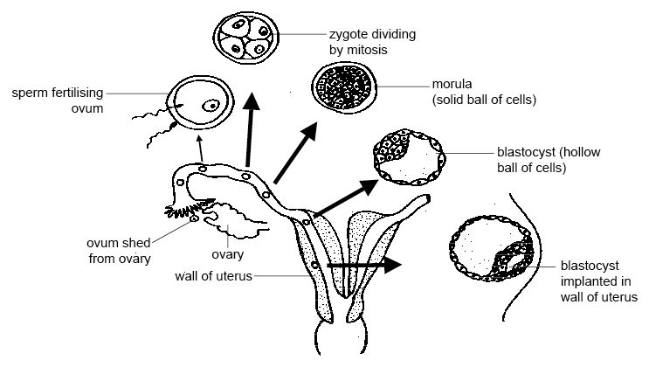
Diagram - Development and implantation of the embryo

