Department of Animal Resources
Reproductive Physiology and Artificial Insemination (Theory) Third Class
pregnancy period:
The gestation or pregnancy period is the period from fertilization to parturition.
The pregnancy period divided in to three parts, based on the size of the individual and development of its tissue and organs.
1- The period of the early embryo, ovum or blastula:
This period of a bout 10 to 12 days in cow extends from the time of fertilization to development of the zygotes primitive fetal membranes in the uterus, during this period division or olevage of the fertilized ovum progresses in the region of the ampullary isthmic junction of the uterine tube to morula stage characterized by totaling about 16 to 32 cells.
The morula enters the uterus on day 3 after fertilization. By 2 to 11 days after fertilization zona pelucida has fragmented and plastocyst has formed.
The corpus luteum is developing and producing progesterone, a hormone necessary for the growth and preparation of the endomaterium.
2- Period of the embryo and organogenesis: This period extend from 12 t0 15 days to about 45 days of pregnancy in the cow, 11 to about 34 days in the ewe and about 12 to 55to 60 days in the mare.
During this period the major tissue, organs and system of the body are formed and changes in the body shape occurs so that by the end of this period the species of the embryo is readily recognizable.
3- The period of the fetus and fetal growth: This period extends from about 34 days of pregnancy in the ewe, 45 days in the cow and 55 days in the mare to parturition , during this period minor details in the differentiation of organs ,tissue, and systems occur along with the growth and maturation.
During this period caruncles and cotyledons develop and enlarge to supply nutrition to the fetus in the cow, ewe.
Increase in size of the fetus, with the weight of the bovine and equine fetus increasing very rapidly the last two to three months of pregnancy. From 210 to 270 days the increase in weight of bovine fetus is equal to three times the increase from the time of fertilization to 210 days.
Hormonal control of pregnancy
During pregnancy the progesterone from the carpus luteum or the fetal placenta is essential for endometrial gland growth and secretion of uterine milk, for endometrial growth and attachment of the placenta for nourishment of the fetus, and for inhibiting uterine motility to aid in placenta attachment.
A certain amount of ovarian or placental estrogen necessary to enhance the effect of progesterone and in later pregnancy to produce udder development, relaxation of the pelvic ligments, initial uterine tonus, cervical relaxation and to sensitize the uterus to oxytocin and prostaglandins. Gonadotropic hormones from anterior pituitary gland necessary for the persistence of the corpus luteum and it are active secretion of progesterone.
In the mare gonadotropines (PMSG OR ECG) are produced by the endometrial cup and in women by the chorion (HCG) of the fetal placenta during the first trimester of pregnancy. The endocrine gland of the fetus, thyroid, adrenals, gonads, anterior pituitary gland and besides the fetal placenta, play important roles in maintaining and terminating pregnancy. In the seep the placenta or fetal cotyledons the major source of progesterone the last 100 days of gestation since removal of ovaries from ewe after 50 days of pregnancy did not cause abortion.

Duration of pregnancy:
The length of the pregnancy period differs between the animal species, breeds. In cows and mares male fetuses are carried one to three days longer than female fetuses.
Young cow in their first and second pregnancy periods carry fetuses one to two days less than older cows.
Short pregnancy period:
1- Associated with abortions and premature births.
2- The pregnancy period of twin fetuses in cattle is an average of 3 to 6 days shorter than pregnancy period of single fetuses.
3- Reduction in the length of pregnancy has been observed in ewes an does carrying two or more fetuses.
4- Adverse disease factors influencing the health of the endometrium and placenta or infecting the fetus may cause abortion or short pregnancy period.
5- Malnutrition debilitating disease, starvation, severe stress causing abortion or premature birth.
Premature birth
are those between 250 – 270 days in cow.
are those between 310 – 330 in mare cow.
are those between 130 – 140 in ewe and goat.
Prolonged pregnancy period:
1- Iodine deficiency in cows, to produce hypothyroidism, caused pregnancy periods 4 to 10 days longer than normal.
2- Delayed parturition in ewes, cows has been produced with large continued injection of progesterone.
3- Ewes consuming veratrum californicum about the 14 days of pregnancy, causing severe deformities of the face and head with hypoplasia or aplasia of the hypophysis.
4- Destruction of the pituitary gland of fetuses at 90 to 140 days of pregnancy produced of prolonged pregnancy.
5- Bilateral adrenalectomies an sheep and goat at 110 to 120 days of gestation, resultodin prolonged pregnancy of 157 to 168 days.
Duration of pregnancy in domestic animals
Cow: 273 – 296 days.
Horse: 327 – 357 days.
Sheep: 140 – 155 days.
Goat: 148 – 156 days.
The Placenta and Fetal Membranes
As the embryo increases in size, the placenta, umbilical cord and fetal membranes (often known collectively as the placenta) develop to provide it with nutrients and remove waste products. In later stages of development the embryo becomes known as a fetus.
The placenta is the organ that attaches the fetus to the wall of the uterus. In it the blood of the fetus and mother flow close to each other but never mix. The closeness of the maternal and fetal blood systems allows diffusion between them. Oxygen and nutrients diffuse from the mother’s blood into that of the fetus and carbon dioxide and excretory products diffuse in the other direction. Most maternal hormones (except adrenaline), antibodies, almost all drugs (including alcohol), lead and DDT also pass across the placenta. However, it protects the fetus from infection with bacteria and most viruses.

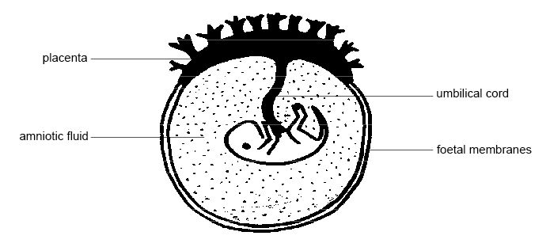
Diagram- The fetus and placenta
The fetus is attached to the placenta by the umbilical cord. It contains arteries that carry blood to the placenta and a vein that returns blood to the fetus. The developing fetus becomes surrounded by membranes. These enclose the amniotic fluid that protects the fetus from knocks and other trauma.
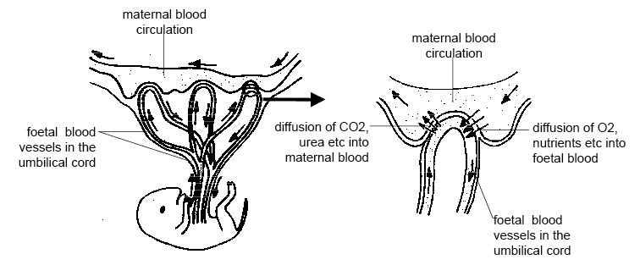
Diagram - Maternal and fetal blood flow in the placenta
The placenta conceptus consists of the embryo and the extraembryonic membranes (amnion, allantois and chorionic). The functional unit of the fetal placenta is the chorionic villus. The chorionic villi distribution is classified as:
Diffuse type (Pig, mare) - Cotyledonary (Ruminants) - Zonary (dogs and cats) and Discoid (rodent and primates).
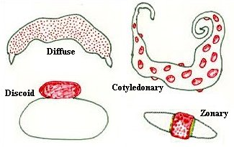
Diagram- Types of Placenta

Function of placenta:
The blood of fetus and dam nerve comes into direct contact. Oxygen and nutrient can pass from the maternal blood to the fetal blood, and waste products in the opposite direction, the placenta only allows these exchanges.

The placenta produces hormones that can:
- Stimulate ovarian function
- Equine chorionic gonadotropin (eCG) also called pregnant mare serum (PMS) which stimulus for maintenance of the primary corpus luteum.
B-Human chorionic gonadotropln (hCG), it is to provide a luteotropic stimulus for the transition of the ovulatory corpus luteum to the CL of pregnancy.
2-Maitain pregnancy: the placenta secretes Progesterone and Estrogen.
3-Influence fetal growth by hormone known Placenta Lactogen. 4-Stimulation mammary function by hormone placenta lactogen 5-Assist in parturition by hormone Relaxin.

