Lecture 3/part 3

Streak Plate

Streak literally means “a long, thin line”: and the streak plate method is a microbiological culture
technique where a sample is spread in a petri dish in the form of a long, thin line over the surface of solid media.

Streak Plate Method
The streak plate method is a microbiological laboratory technique of isolating pure cultures, and/or getting well-isolated colonies of bacteria from a mixed population. It is mostly used to get pure cultures of bacteria; however, yeasts can also be isolated by this method. It is one of the most commonly used aseptic techniques in microbiology to isolate and propagate bacteria. It is a mechanical isolation technique used in microbiology, commonly known as th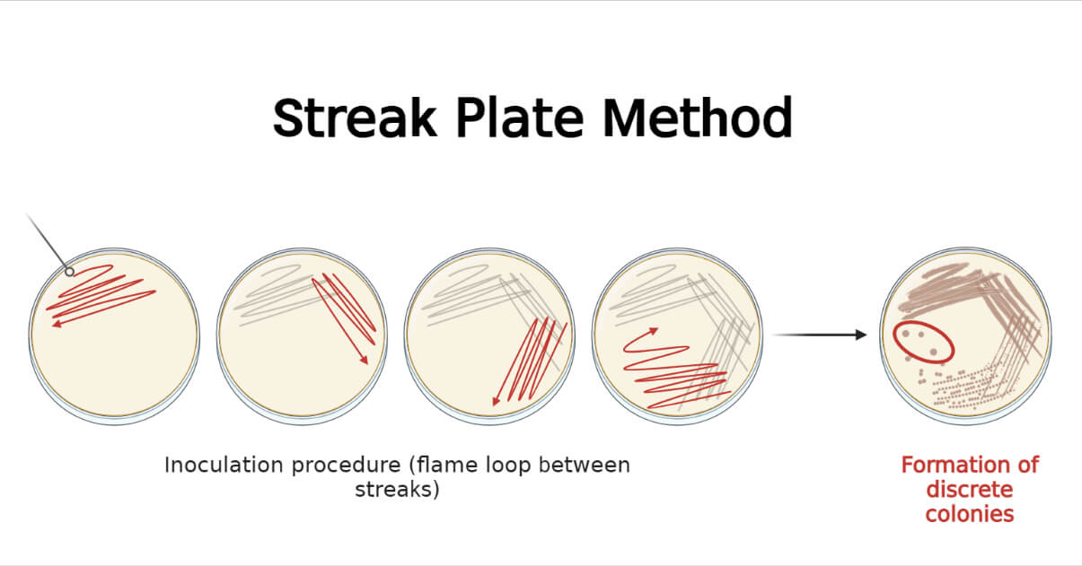e
streaking proceeds, and ultimately only a few bacterial cells will be inoculated at the end giving well-isolated colonies in the final streaks. Thus, this method mechanically isolated the bacteria from a mixed population of either the same or different species. After inoculation, the same types of colonies are seen in the terminal streaks if the specimen contained single species, whereas, different types of colonies may be seen if the specimen contained different species.
It is a very simple and reliable aseptic technique that uses tools like cotton swabs, wooden or plastic, metal sticks and toothpicks, or inoculating loop to dilute and spread the specimen over the surface of pre-sterilized specific solid culture media.
The specimen used can be either suspension or colonies from the agar surface. Well isolated colonies can be obtained from successfully performed streaking which allows describing the colony character of the organism on that specific culture media and condition.

Objectives of Streak Plate Method
- To obtain a pure culture of bacteria from a mixed culture
- To obtain well-isolated colonies
- To propagate bacteria

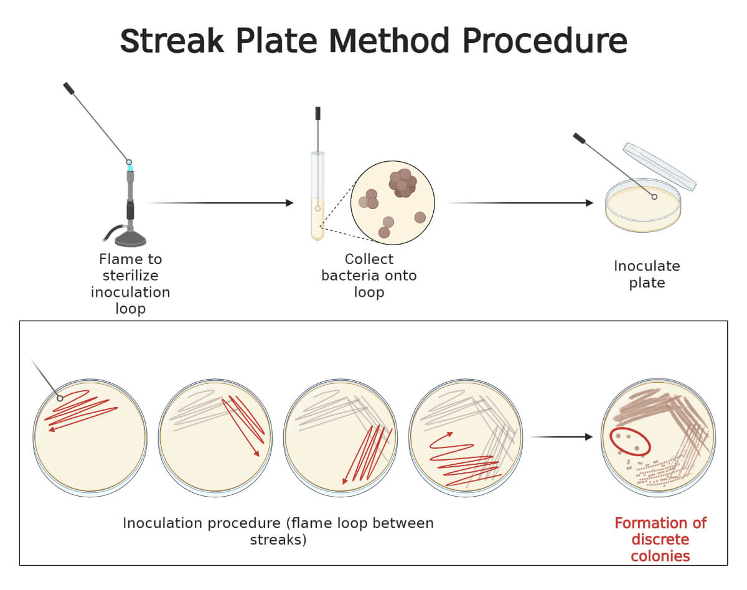
Sterilize the inoculating loop by flaming and allow it to cool. Pick a small portion of the isolated colony.

