Lecture 5
Gram staining
Gram staining is a common technique used to differentiate two large groups of bacteria based on their different cell wall constituents.
- Gram-positive bacteria (thick layer of peptidoglycan-90% of cell wall)- stains purple
- Gram-negative bacteria (thin layer of peptidoglycan-10% of cell wall and high lipid content) –stains red/pink

Application of the primary stain (crystal violet). Crystal violet stains all cells blue/purple
- Application of mordant: The iodine solution (mordant) is added to form a crystal violet-iodine, all cells continue to appear blue.
- Decolorization step: The decolorization step distinguishes gram-positive from gram-negative cells.
The organic solvent such as acetone or ethanol, extracts the blue dye complex from the lipid-rich, thin-walled gram-negative bacteria to a greater degree than from the lipid-poor, thick-walled, gram-positive bacteria. The gram-negative bacteria appear colorless and gram-positive bacteria remain blue.
- Application of counterstain (safranin): The red dye safranin stains the decolorized gram-negative cells red/pink; the gram-positive bacteria remain blue.

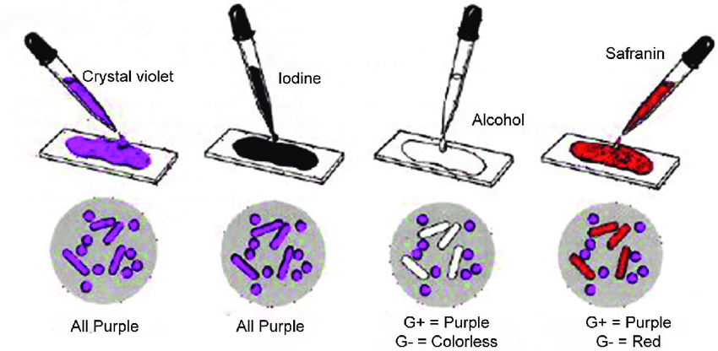
Gram Staining Procedure\:
- Flood air-dried, heat-fixed smear of cells for 1 minute with crystal violet staining reagent.
- Wash slide in a gentle and indirect stream of tap water for 2 seconds.
- Flood slide with the mordant: Gram’s iodine. Wait 1 minute.
- Wash slide in a gentle and indirect stream of tap water for 2 seconds.
- Flood slide with decolorizing agent (Acetone-alcohol decolorizer). Wait 10-15 seconds or add drop by drop to slide until decolorizing agent running from the slide runs clear.
- Flood slide with a counterstain, safranin. Wait 30 seconds to 1 minute.
- Wash slide in a gentile and indirect stream of tap water until no color appears in the effluent and then blot dry with absorbent paper.
- Observe the results of the staining procedure under oil immersion (100x) using a Bright field microscope.
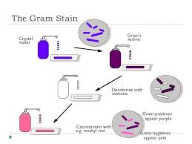

Results:
- Gram-negative bacteria will stain pink/red and
- Gram-positive bacteria will stain blue/purple.

