Lecture 1

Lab Safety Rules and Guidelines
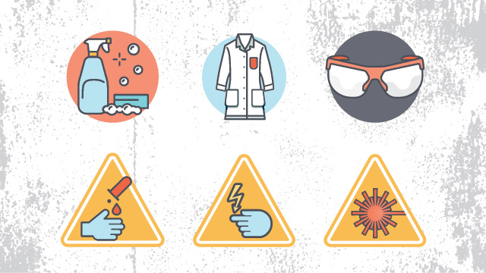
- Be sure to read all fire alarm and safety signs and follow the instructions in the event of an accident or emergency.
- Ensure you are fully aware of your facility's/building's evacuation procedures.
- Know emergency phone numbers to use to call for help in case of an emergency.
- Lab areas containing carcinogens, radioisotopes, biohazards, and lasers should be properly marked with the appropriate warning signs.
- Open flames should never be used in the laboratory unless you have permission from a qualified supervisor.
- Always work in properly-ventilated areas.
- Do not chew gum, drink, or eat while working in the lab.
- Laboratory glassware should never be utilized as food or beverage containers.
- \If you are the last person to leave the lab, make sure to lock all the doors and turn off all ignition sources.
- Do not work alone in the lab.
- \\ Never smell or taste chemicals.
- Do not pipette by mouth.
- Make sure you always follow the proper procedures for disposing lab waste.
- If you have been injured, yell out immediately and as loud as you can to ensure you get help.
- In the event of a chemical splashing into your eye(s) or on your skin, immediately flush the affected area(s) with running water for at least 20 minutes.
- If you notice any unsafe conditions in the lab, let your supervisor know as soon as possible.

