Lecture 2 a

Instruments used in Microbiology Lab

The instruments used in the microbiology labs includea a bunch of different kinds of instruments required for a lot of different processes conducted within those laboratories.

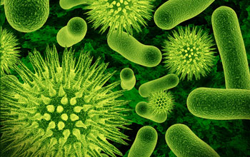

List of Instruments used in Microbiology Lab
- Autoclave
- Bunsen burner
- Centrifuge
- Incubator
- Microscope
- Water Distiller

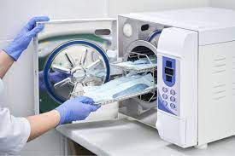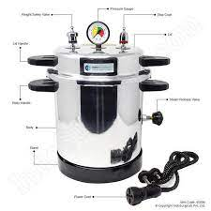

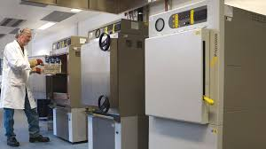

a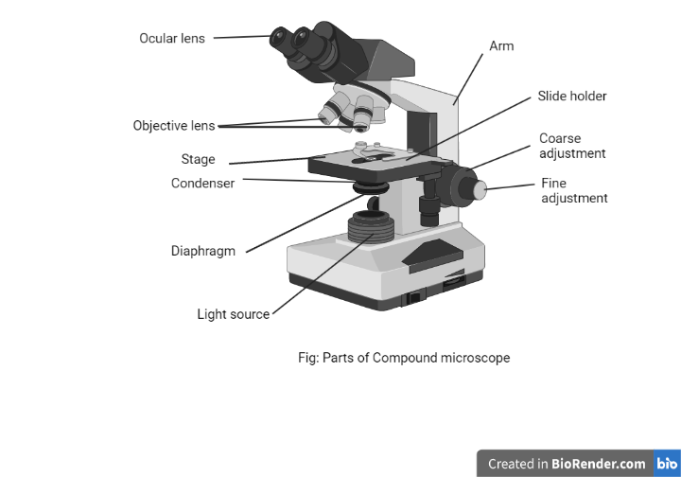
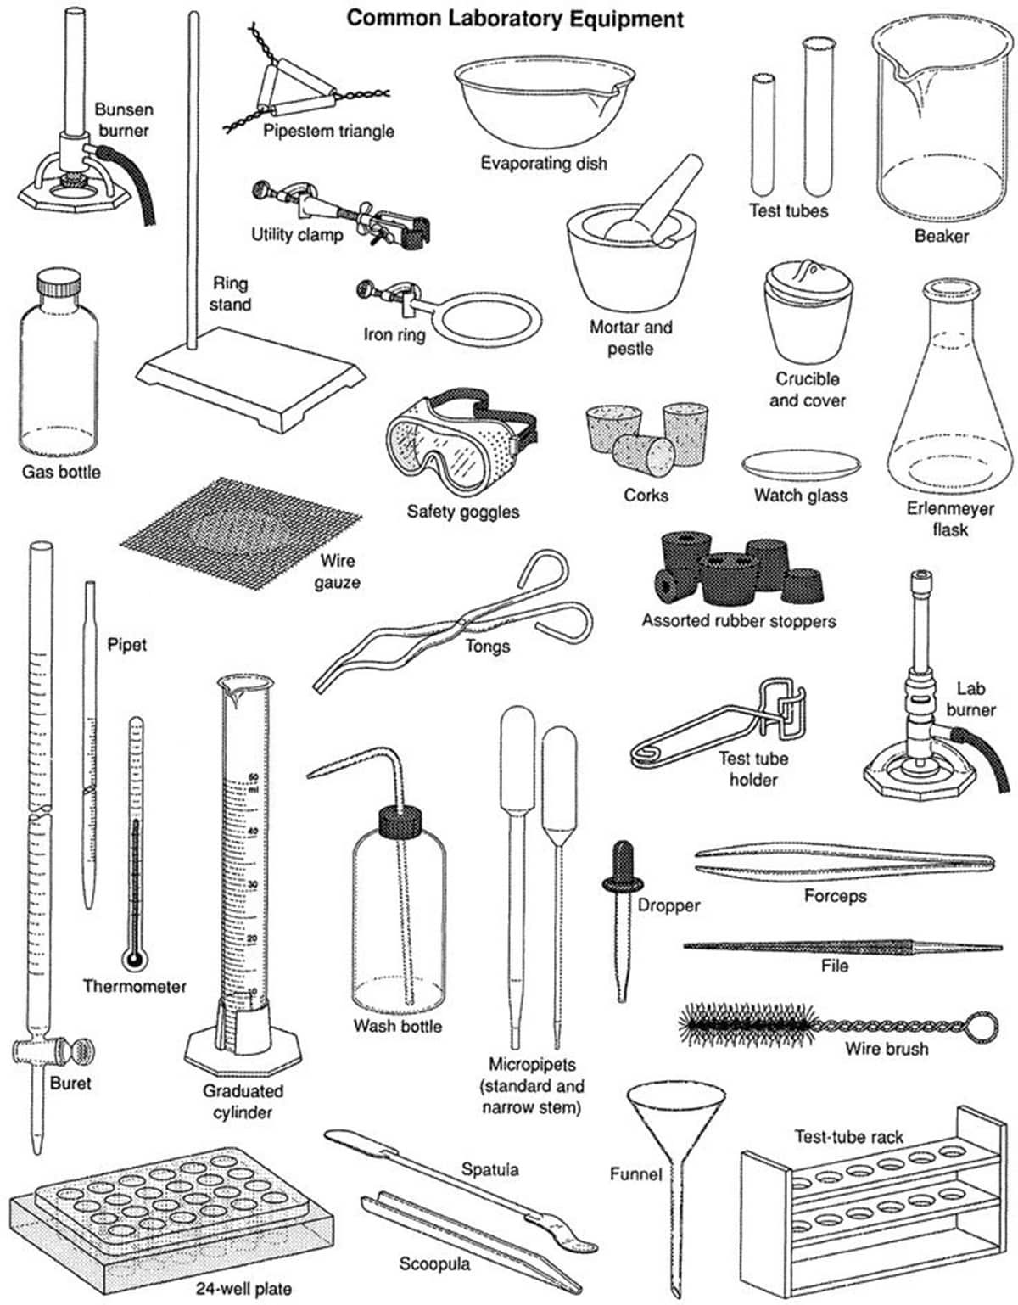

a
721.8K

Autoclave
An autoclave is a pressurized chamber used for the process of sterilization and disinfection by combining three factors: time, pressure, and steam

Uses
- Autoclaves are mostly used for the sterilization of medical or laboratory equipment with the capacity of sterilizing a large number of materials at once.
- They are commonly used for the preparation of culture media during laboratory applications.

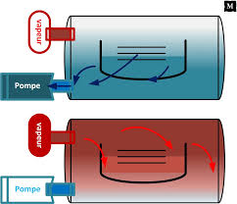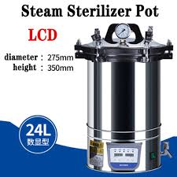

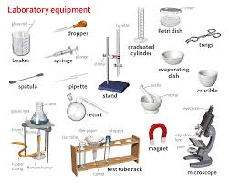

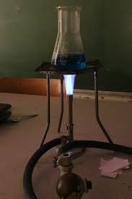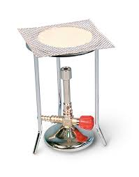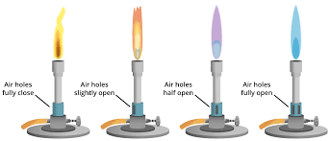

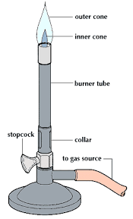

Bunsen burner
Bunsen burner is a standard tool uased in laboratories, named after Robert Bunsen. It is a gas-fueled single open flame.

Uses
- It is commonly used for processes like sterilization, combustion, and heating. In medical or microbiology laboratories, it is commonly used for micro-loop sterilization.

Incubator
An incubator is a device that is used in laboratories for the growth and maintenance of microorganisms and cultures. Incubator provides an optimal temperature, pressure, moisture, among other things required for the growth of microorganisms.

Microscope
Microscopes are devices that allow the observer to have an aaexceedingly close view of minute particles.

Uses
- Based on the type of microscopes, different microscopes are used for different purposes.
- They are primarily used for the observation of minute particles which cannot be observed with naked eyes.

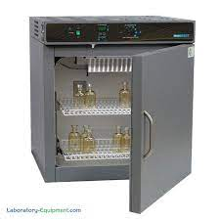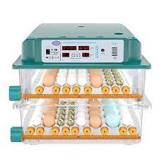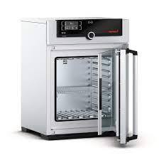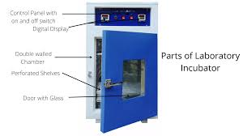

Water Distiller
A water distiller is a device that purifies water by the process of distillation. This instrument is commonly used in medical laboratories, microbiology laboratories, organic chemistry laboratories, and medical industries.

Uses
- It is used to obtain distilled water required for many lab tests as well as for the preparation of culture media.

