Lecture 6
l

Negative Staining
The main purpose of Negative staining is to study the that is difficult to stain.

Principle :
Negative staining requires an acidic dye such as India Ink or Nigrosin.
This means that the stain readily gives up a hydrogen ion (proton) and the chromophore of the dye becomes negatively charged. Since the surface of most bacterial cells is negatively charged, the cell surface repels the stain. The glass of the slide will stain, but the bacterial cells will not. The bacteria will show up as clear spots against a dark background.

Negative Staining procedure

1. Place a very small drop of nigrosinnear one end of a well-cleaned and flamed slide.
2. Remove a small amount of the culture from the slant with an inoculating loop and disperse it in the drop of stain without spreading the drop.
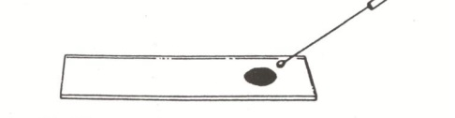
3. Use another clean slide to spread the drop of stain containing the organism using the following technique.
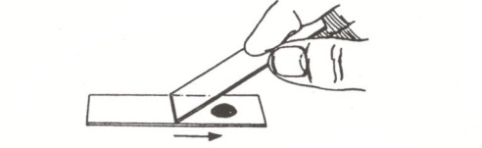
4. Rest one end of the clean slide on the center of the slide with the stain. Tilt the clean slide toward the drop forming an acute angle and draw that slide toward the drop until it touches the drop and causes it to spread along the edge of the spreader slide. Maintaining a small acute angle between the slides, push the spreader slide toward the clean end of the slide being stained dragging the drop behind the spreader slide and producing a broad, even, thin smear.
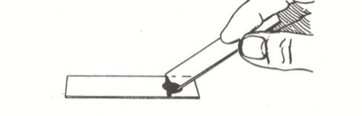 | 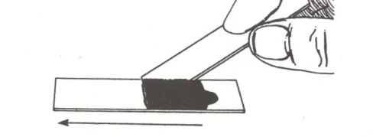
5. Allow the smear to dry without heating.
6. Focus a thin area under oil immersion and observe the unstained cells surrounded by the gray stain.
