aa »

Nutrient Agar and Nutrient Broth
a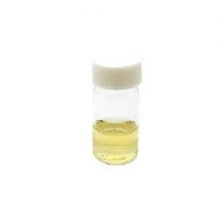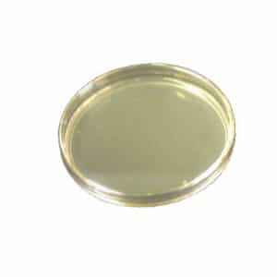

Nutrient Agar
Nutrient agar contains nutrients that suitable to subculture a widea range of microorganisms and makes it an excellent agar media to check on the purity before any biochemical or serological test.
Besides, the addition of agar solidifies nutrient agar, which makes it suitable for the cultivation of microorganisms. .

prepare nutrient agar
- Suspend 28g of nutrient agar powder (CM0003B) in 1L of distilled water.
- Mix and dissolve them completely.
- Sterilize by autoclaving at 121°C for 15 minutes.
- Pour the liquid into the petri dish and wait for the medium to solidify. Be sure that you are preparing the agar in the clean environment to prevent any contamination.
Once the agar solidifies, the agar is ready to use.
.

Nutrient Broth
Basically, the nutrient broth is the nutrient agar that lack of the solidifying agent, agar powder. They remain in liquid form at room temperature and are usually used to maintain the stocks of microorganisms....

prepare nutrient broth
- Add 13g of nutrient broth powder (CM0001B) in 1L of distilled water.
- Mix and dissolve them completely.
- Pour them into the final containers (eg. conical flask)
- Sterilize by autoclaving at 121°C for 15 minutes.

Differences between nutrient agar and nutrient
Nutrient agar and nutrient broth are two types of growths used to grow microorganisms. The main difference between nutrient agar and nutrient broth is that nutrient agar is a solid medium whereas nutrient broth is a liquid medium. Agar is added to the nutrient agar in order to solidify the medium.

How do you make 250ml nutrient agar?

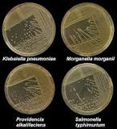
- Suspend 28 g of nutrient agar powder in 1 litre of distilled water.
- Heat this mixture while stirring to fully dissolve all components.
- Autoclave the dissolved mixture at 121 degrees Celsius for 15 minutes. ...
- Once the nutrient agar has been autoclaved, allow it to cool but not solidify.

