Capsule Staining

The main purpose of capsule stain is to distinguish capsular material from the bacterial cell.
A capsule is a gelatinous outer layer secreted by bacterial cell and that surrounds and adheres to the cell wall. Most capsules are composed of polysaccharides, but some are composed of polypeptides.
The capsule differs from the slime layer that most bacterial cells produce in that it is a thick, detectable, discrete layer outside the cell wall. The capsule stain employs an acidic stain and a basic stain to detect capsule production.

Capsules stain very poorly with reagents used in simple staining and a capsule stain can be, depending on the method, a misnomer because the capsule may or may not be stained.
Negative staining methods contrast a translucent, darker colored, background with stained cells but an unstained capsule. The background is formed with india ink or nigrosin or congo red. India ink is difﬁcult to obtain nowadays; however, nigrosin is easily acquired.
A positive capsule stain requires a mordant that precipitates the capsule. By counterstaining with dyes like crystal violet or methylene blue, bacterial cell wall takes up the dye. Capsules appear colourless with stained cells against dark background.
Capsules are fragile and can be diminished, desiccated, distorted, or destroyed by heating. A drop of serum can be used during smearing to enhance the size of the capsule and make it more easily observed with a typical compound light microscope.

Reagents used for Capsule Staining
Crystal Violet (1%)
Nigrosin

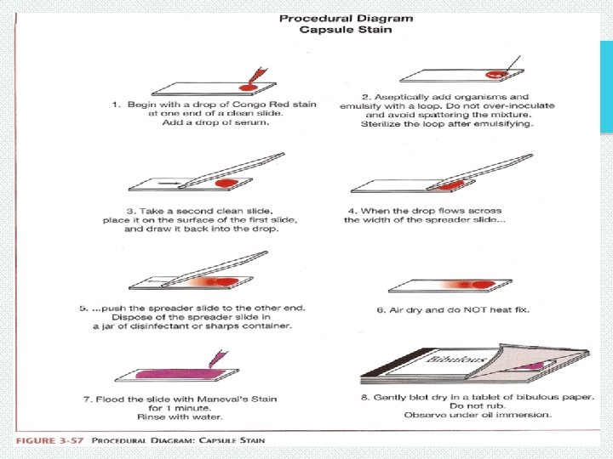

Procedure of Capsule Staining
- Place a small drop of a negative stain (India Ink, Congo Red, Nigrosin, or Eosin) on the slide.
Using sterile technique, add a loopful of bacterial culture to slide, smearing it in the dye.
- Use the other slide to drag the ink-cell mixture into a thin film along the first slide and let stand for 5-7 minutes.
- Allow to air dry (do not heat fix).
- Flood the smear with crystal violet stain (this will stain the cells but not the capsules) for about 1 minutes. Drain the crystal violet by tilting the slide at a 45 degree angle and let stain run off until it air dries .
- Examine the smear microscopically (100X) for the presence of encapsulated cells as indicated by clear zones surrounding the cells.

Result of Capsule Staining
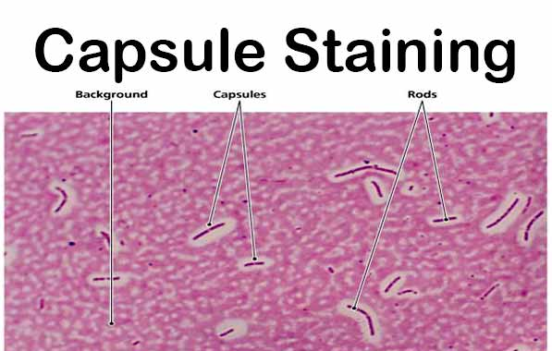
Capsule: Clear halos zone against dark background
No Capsule: No Clear halos zone

Examples of Capsule Positive and Negative
