Endospore Staining:

Most endospore forming bacteria are found in soil or aquatic environments. However, some species of Bacillus and Clostridium .
Clostridium perfringens,
C. botulinum (a potential agent of bioterrorism
C. tetani are the causative agents of gas gangrene

Endospores can form within different areas of the vegetative cell. They can be central, subterminal, or terminal.
Central endospores are located within the middle of the vegetative cell.
Terminal endospores are located at the end of the vegetative cell.
Sub-terminal endospores are located between the middle and the end of the cell.

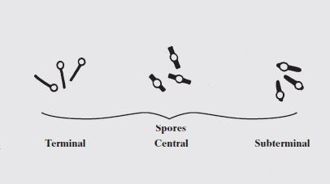

Principle of Spore Staining:
A differential staining technique is used to distinguish between the vegetative cells and the endospores.
A primary stain (malachite green) is used to stain the endospores. Because endospores resist staining, the malachite green will be forced into (i.e, malachite green permeate the spore wall) the endospores by heating. In this technique heating acts as a mordant.
There is no need of using any decolorizer in this spore staining as the primary dye malachite green bind relatively weakly to the cell wall and spore wall. Water is used to decolorize the vegetative cells.
- malachite green dye is water-soluble and does not adhere well to the cell wall
- vegetative cells have been disrupted by heat,
because of these reasons, the malachite green rinses easily from the vegetative cells. )
As the endospores are resistant to staining, the endospores are equally resistant to de-staining and will retain the primary dye while The addition of a counterstain or secondary stain (safranin) is used to stain the decolorized vegetative cells.
Procedure of endospore stain:
- Prepare smears of organisms to be tested for presence of endospores on a clean microscope slide and air dry it.
- Heat fix the smear.
- Place a small piece of blotting paper (absorbent paper) over the smear and place the slide (smear side up) on a wire gauze on a ring stand.
- Heat the slide gently till it starts to evaporate (either by putting the slide on a staining rack that has been placed over a boiling water bath or via bunsen burner).
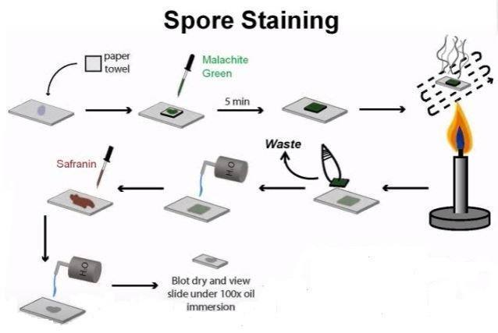Spore staining procedure
- Remove the heat and reheat the slide as needed to keep the slide steaming for about 3-5 minutes. As the paper begins to dry add a drop or two of malachite green to keep it moist, but don’t add so much at one time that the temperature is appreciably reduced.
# DO NOT OVERHEAT. The process is steaming and not baking.
- After 5 minutes carefully remove the slide from the rack using a clothespin
- Remove the blotting paper and allow the slide to cool to room temperature for 2 minutes.
- Rinse the slide thoroughly with tap water (to wash the malachite green from both sides of the microscope slide).
- Stain the smear with safranin for 2 minutes.
- Rinse both side of the slide to remove the secondary stain and blot the slide/ air dry.
Observe the bacteria under 1000X (oil immersion)
Results: The vegetative cells will appear pink/red and the spores will appear green.

