Hanging Drop Method for Bacterial Motility
Hanging drop preparation is a special type of wet mount in which a drop of medium containing the organisms is placed on a microscope slide, often used in dark illumination to observe the motility of bacteria
. 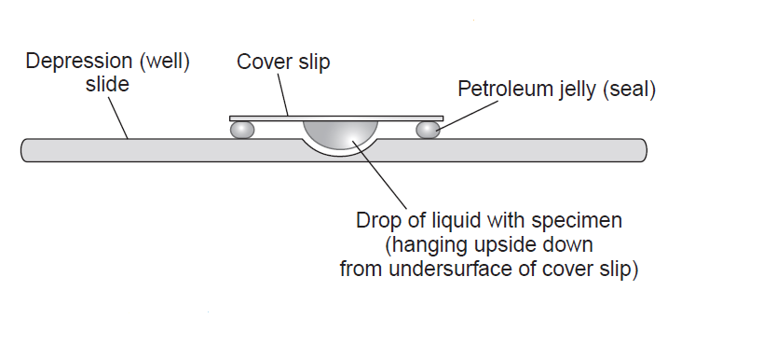

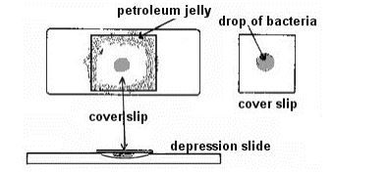Hanging Drop Method Preparation
- Take a clean glass slide and apply a paraffin ring, adhesive-tape ring to make circular concavity. (This step is not needed if a glass slide with depression is available).
- Hold a clean coverslip by its edges and carefully dab vaseline on its corners using a toothpick.
- Place a loopful of the fresh broth culture to be tested in the center of the prepared coverslip. Use a light inoculum (not visibly turbid).
- Turn the prepared glass slide or concavity slide upside down (concavity down) over the drop on the coverslip so that the vaseline seals the coverslip to the slide around the concavity.
- Turn the slide over so the coverslip is on top and allow organisms to “settle” for a minute. The drop can be observed hanging from the coverslip over the concavity.
Brownian movement, which is an oscillatory movement about a nearly fixed point possessed by all small bodies suspended in fluid and due to irregularities in their bombardments by molecules of water.

Uses
Hanging drop preparation is used to study the motility of bacteria



