Determining Age of Horses by Their Teeth
The art of determining the age of horses by inspection of the teeth is an old one. It can be developed to a considerable degree of accuracy in determining the age of young horses. The probability of error increases as age advances and becomes a guess after the horse reaches 10 to 14 years of age. Stabled animals tend to appear younger than they are, whereas those grazing sandy areas, such as range horses, appear relatively old because of wear on the teeth.
Age determination is made by a study of the 12 front teeth, called incisors. The two central pairs both above and below are called centers, pincers, or nippers. The four teeth adjacent to these two pairs are called intermediates, and the outer four teeth are designated as corners.
Canine teeth or "tusks" may appear midway between the incisors and molars at 4 or 5 years of age in the case of geldings or stallions, but seldom appear in mares. Adult horses have 24 molar teeth.
There are four major ways to estimate age of horses by appearance of their teeth:
- Occurrence of permanent teeth
- Disappearance of cups
- Angle of incidence
- Shape of the surface of the teeth
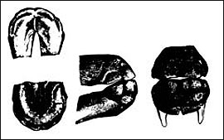
The mouth of a colt at birth. None of the teeth have penetrated the gums.

permanent teeth
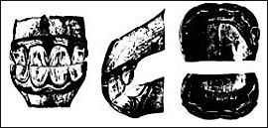
One year of age. All temporary teeth are present. The corners are not yet in wear.
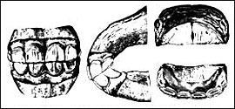
Two-year-old mouth showing corners in wear. Temporary teeth may be identified by the well-defined neck joining root and gum, a lighter color and smaller size than permanent teeth.
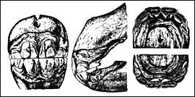
A typical 3-year-old mouth showing the large permanent center teeth, both upper and lower. Contrast these with the small, light-colored temporary teeth shown in the previous figures.
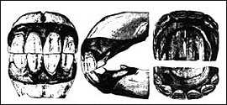
Note the well-developed permanent centers, immature intermediates and milk teeth at the corners in this 4-year-old mouth. Tusks or canines have appeared.
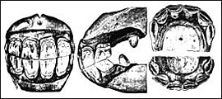
At 5 years, all of the temporary teeth have been replaced by permanent teeth. This is called a “full mouth.” Although the corner teeth are well-matched from a profile view, they show very little wear in the view of the upper jaw. The upper centers are beginning to appear round on the inside back surface. Cups are very plain, both above and below, with little wear appearing on them.
Horses have two sets of teeth, one temporary and one permanent. Temporary teeth may also be called "baby" or "milk teeth." Temporary incisors tend to erupt in pairs at 8 days, 8 weeks, and 8 months of age.
A well-grown 2-year-old may be mistaken for an older horse unless permanent teeth can be accurately identified. Permanent teeth are larger, longer, darker in color, and do not have the well-defined neck joining root and gum that temporary teeth do
The four center permanent teeth appear (two above and two below) as the animal approaches 3 years of age, the intermediates at 4, and the corners at 5. This constitutes a "full mouth."

Disappearance of cups
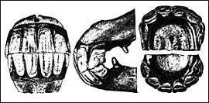
This 6-year-old mouth shows some wear on the corner teeth as viewed from the side. Cups in the lower jaw in the centers should be worn reasonably smooth at this age. They show relatively less wear than is customary in the normal 6-year-old mouth. Note that canines are immature as contrasted to those in Figure 6. The dovetail or notch is apparent, but the angle of incidence shows little change.
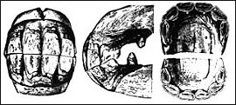
At 7 years, dovetail has usually developed to its maximum. The rounding corner on this picture does not give it the appearance that is ordinarily seen in a 7-year-old mouth. The angle of incidence has not obtained very much sharpness and perhaps is typical for this age. Cups are coming out of the lower centers and intermediates, with very prominent cups still showing in the corners and in all of the upper teeth. Dental stars have not appeared.
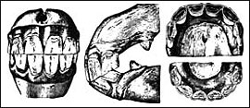
This 8-year-old mouth shows the notch almost completely gone from the upper corner tooth. Cups have all disappeared from the lower jaw, but none in the upper jaw have worn out. The teeth are showing much more ovalness on the back surfaces than at younger ages, and angle of incidence is becoming sharper. Dental stars have appeared in four lower and two upper incisors.
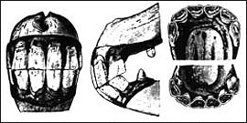
A front view of this 9-year-old mouth shows a tendency toward less width of the teeth and more length. The profile view shows more steepness to the angle of incidence; however, this angle does not appear to show the acuteness of a typical 9-year-old mouth. Cups are gone from the lower jaw and the two centers above. All teeth are tending toward more ovalness except the upper corners. Dental stars are merging with central enamel rings, which are becoming small and round.
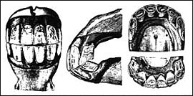
This 10-year-old mouth shows a typical angle of incidence with reappearance of notch on the upper corner. Ordinarily cups are gone from all of the teeth but the upper corners at 10 years of age. Back surfaces of upper centers are changing from ovalness to angularity.
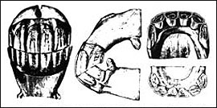
Much length of teeth relative to width can be seen in the front view of this 11-year-old mouth. A profile view shows considerable angle, with the upper corners almost missing the lowers. Cups are all gone, and centers and intermediates are assuming angularity.
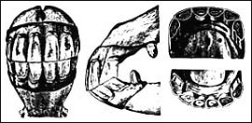
This 12-year-old mouth cannot be differentiated from the 11-year-old mouth in Figure 12 except for cups in the upper corners and a decrease in size of the central enamel rings. When a horse is completely smooth-mouthed, things other than age will determine usefulness. Perhaps the best way to ascertain the physical condition of a horse that is being considered for purchase is to take the horse home on a trial basis.
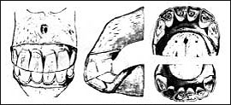
A 15-year-old mouth. All of the cups are gone. The central enamel rings are prominent but are very small and round. All teeth have become angular.
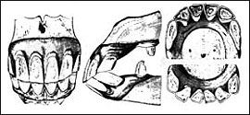
Length of teeth, acute angle of incidence and triangular surfaces characterize this 21-year-old mouth. Spaces have appeared between the teeth.
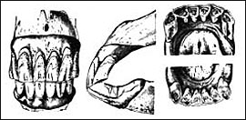
This 30-year-old mouth shows characteristics of extreme age, although spaces between the teeth are absent.

