**Types of drug and routs of drug administration:-**

**Drug** is "a [chemical](http://en.wikipedia.org/wiki/Chemical) substance used in the treatment, cure, prevention, or assist in restoring health to diseased individuals.

**Types of drug:-**

1 - Solid drugs, such as tablets, capsules, vaginal and anal suppositories.  
2 - Semi-solid drugs, such as ointments.  
3 - Liquid drugs, such as eye, nasal drops and lotion.  
4 - Drugs in the form of vapors, such as eucalyptus and menthol vapor.

|  |
| --- |
| **Routes of drug administration** |
| Drugs can be administered to animals by a variety of routes. Which route is most appropriate will vary depending on factors such as the **type and quantity of drug**, **required speed of onset of activity** and **duration of activity**, **number of animals are to be medicated**, **ease of administration**, **safety**, and **cost of the administration method**. |

1. **Oral**

Drug administered through the mouth in the form of a bolus (pill) or liquid

Liquids or pastes can be placed in the mouth and the animal allowed swallowing them or a stomach tube can be used to place the drug directly in the digestive system. Absorption is relatively slow and a long time (an hour or more) may be required for the drug to have the desired effect

1. Drenching is a procedure where fluids or pastes are discharged into the mouth. When drenching or administering any liquid into the mouth of an animal, it is essential that the liquid be administered into the esophagus and not into the lungs.

* This method is used for dosing animals Anthelmintic drugs to large numbers of animals.
* The advantage of this method is the ease use, where possible dosages a large number of animals, as well as control the standard dose.

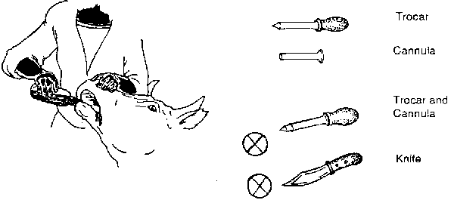

B - (Stomach tube) - a rubber tube length and diameter varies according to animal, stomach tube is inserted through the mouth after open mouth by mouth gage.

Pass the tube  
The animal must be calm enough to allow you to do this without sedation. Lubricate the end of the tube with Vaseline, pass it through the speculum, place the speculum in the animal's mouth, and gently pass the tube down toward the stomach, stopping when you reach the premeasured point.   
Check the Tube  
Check to make sure the tube is in the stomach, not the lungs. You should be able to smell stomach gas coming out of the tube: In addition, you should be able to feel the tube as it runs down next to the trachea.

* **The indications for stomach tube include:**  
  1 - Administration of irritant drugs such as (Hcl) or some foul smell drugs.  
  2 - Ensure reach a whole drugs to the rumen.  
  3 - In case of obstruction of the pharynx and esophagus.  
  4 - Relief of gaseous distension in animals with gastric dilatation.  
  5 - Collect samples of rumen contents.

**2- I.M. (Intramuscularly)**

* This is usually the second fastest route for drugs to reach the systemic circulation.
* Site of injection is important, particularly in food producing animals; when possible use the muscles in the neck. Injection site abscesses can develop.

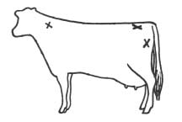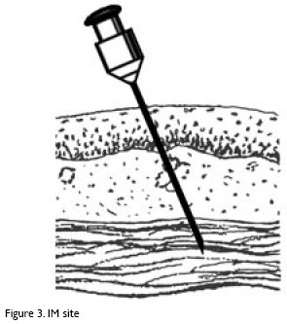

**3- I.V. (Intravenous)**

* Introduce drugs directly into the systemic circulation. This provides the fastest distribution of the drug and ensures that 100% of the drug reaches the systemic circulation.
* In large animals the jugular vein in the neck is most often used
* Always read the label, some drugs cannot be administered I.V.
* Drugs should be close to body temperature before administration
* Drugs should be administered slowly (drip) when given I.V.



**4- Sub-Q (Subcutaneous)**

* Drug administered between the skin and muscle
* Injections or implants
* Provides for a slower , sustained release of the drug
* Less likelihood of causing tissue damage at the injection site in food producing animals.

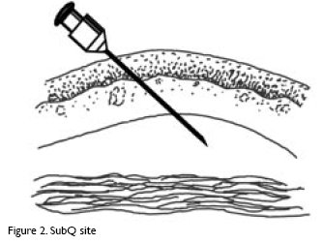

**5- I.D. (Intradermal)**

* Drug injected into the skin.
* Very slow rate of absorption.
* Ex. Tuberculosis skin test.

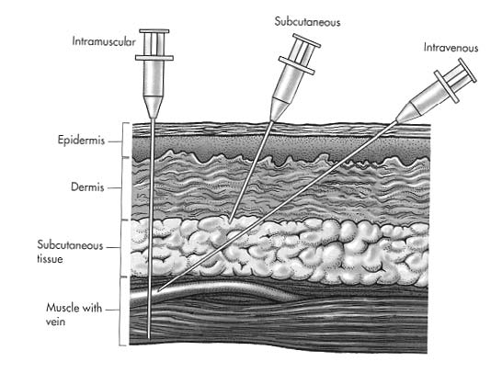

**6- I.P. (Intraperitoneal)**

* Drug injected directly into the peritoneal cavity.
* Slow absorption rate.
* Often used in combination with I.V. injections to prolong the availability of the medication to the animal ex. Milk fever- Cal-Dex given both I.V. and I.P.

**7- I.R. (intrarumenal)**

* Similar to I.P., but into the rumen (1st stomach in ruminant animals).
* When the needle is properly placed gas will flow out.
* Can only be accomplished on the left side of the animal.

**8- I.M.F. (Intramammary infusion)**

* Drug is injected into the teat canal using a plastic teat infusion canula.
* Used in the treatment of mastitis.

**9- I.U. (Intrauterine infusion)**

* Drug in infused into the uterus by passing a pipette through the cervix.
* Often used to treat metritis (uterine infection).

**10- Topical**

* Drug applied to the skin or surface of the body.
* Ex. Salves, ointments, etc.