Animal parasites
A parasite is an organism that lives in or on another and takes its nourishment from that other organism, or “host.” Parasites of animals and humans,
come in many forms, including helminths (worms), arthropods (lice, ticks, mosquitoes, etc.), and protozoa.
There are over 1,000 species of parasites affecting domesticated animals throughout the world. They can be broadly classified as external or internal, depending on where they live on their host.
External parasites often annoy their hosts by biting, embedding, or otherwise irritating the skin. They can cause serious diseases, such as mange and scabies, which affect animals’ health and growth.

Internal parasites live in the blood or tissues inside an animal’s body. Some organisms enter an animal when it swallows contaminated food or water. Others burrow through the skin, reach the blood stream, and settle in a preferred location to mature and reproduce. Internal parasites often interfere with digestion and assimilation of food, causing poor growth, temporary or permanent injuries, or death.

List of parasitic diseases

Ectoparasitic 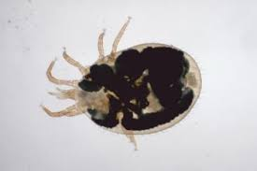
- myiasis
- scabies

helminthic
- ascariasis
- cestodiasis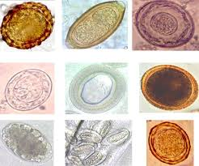
- echinococcosis
- enterobiasis
- fascioliasis
- fasciolopsiasis
- filariasis

- hookworm disease 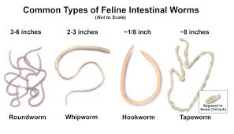

- lungworm disease
- schistosomiasis
- strongyloidiasis
- trichinosis
protozoan 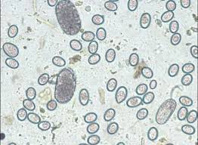
- amebiasis
- avian malaria
- babesiosis
- blackwater fever
- coccidiosis
- enterohepatitis
- giardiasis
- leishmaniasis
- malaria
- sleeping sickness
- toxoplasmosis
- trichomoniasis
- trypanosomiasis

